Why Does Ice Float in Water and not in Alcohol?
Maria C. Simani, Ph.D.
Department of Physics and Astronomy
University of California, Riverside

Why does a cube of ice float in a cup of water, but not in a cup of alcohol?

In order to answer this question, we need to understand the principle by which something may float when placed into a liquid, and then to examine, in detail, why ice, which is frozen water, floats on liquid water instead of sinking to the bottom of the cup.

In general, a substance floats on the surface of a fluid if the substance is less dense than the fluid. That is, the substance must have less mass per unit volume than other components in the fluid. For example, a rock placed on the surface of water in a bucket will sink to the bottom because the rock is denser compared to the water’s density. The water in the bucket, which is less dense than the rock, floats to the top.

When a cube of wood is placed into a bucket of water, the cube of wood will “push” the water out of the way, or displace it, until the cube of wood reaches equilibrium with the water at which point the cube of wood will float. When conducting this experiment, you will notice that the level of the water in the bucket increased when the cube of wood was placed on the water. If you measure the weight of the volume of water that the cube of wood displaced, you will find that it is equal to the weight of the cube. The cube, because of its mass, is pushing the water down, but it also feels an upward force called buoyancy. The buoyancy force is exactly equal to the weight of liquid displaced by the cube. Therefore, the cube of wood floats because it displaces a weight of fluid equal to its own weight. Finally, the volume of the water displaced by the cube is less than the volume of the cube of wood itself; therefore the density of the cube is less than the density of the water. This situation is true also for fluids that may float on the surface of other fluids. For instance, oil will float on water because oil is less dense than the water.

Now, let’s get back to the ice cube in water.

In general, most substances have a lower density when they are in a liquid phase then when they are in a solid phase or frozen. Water, however, is an exception. Water reaches its maximum density at 4°C (approximately 40°F). As it cools down further and freezes into ice, it actually becomes less dense. The reason why an ice cube is less dense than water is found in the molecular structure of the water and because of its hydrogen bonding.
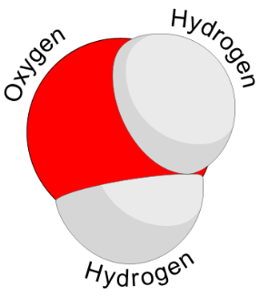
A water molecule is made of one oxygen atom and two hydrogen atoms strongly joined to each other by covalent bonds. The sharing of the negatively-charged electrons among the three atoms creates a feature by which, overall, the charge of the hydrogen atoms become slightly more positive compared to the charge of the oxygen atom that, instead, become more negative. For this reason, water molecules are also attracted to each other by weaker hydrogen bonds between the positively charged hydrogen atoms and the negatively charged oxygen atoms of neighboring water molecules. As water is cooled below 4°C, the hydrogen bonds adjust to hold the negatively charged oxygen atoms apart leaving a space in between these atoms. This effect produces a crystal lattice, commonly known as ”ice.”

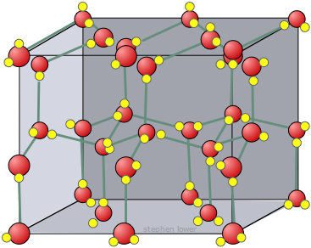
In this configuration, ice is about 9% less dense than liquid water. In other words, ice takes up about 9% more space than water, so a liter of ice weighs less than a liter of water. Thus, ice water is less dense than liquid water.

One fortunate consequence of this physical phenomenon is that lakes and rivers freeze from top to bottom, allowing fish to survive even when the surface of a lake has frozen over. If the ice on top of the lake sank, the water would be displaced to the top and exposed to the colder temperature, forcing rivers and lakes to fill with ice and freeze solid, which would, in turn, kill the fish and other life found in the rivers and lakes.
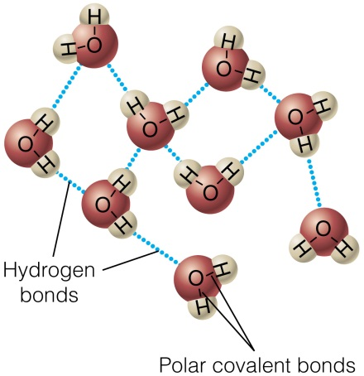
The most energetically favorable configuration of water molecules is one in which each molecule is hydrogen-bonded to four neighboring molecules. Because of the thermal motion of the molecules above the freezing point, this ideal configuration is never achieved in the liquid phase. But when water freezes to ice and thermal energy is removed, the water molecules settle into exactly this kind of an arrangement in the ice crystal.

To make the comparison more explicit, two three-dimensional views of a typical ice (top) and liquid water (bottom) follow.
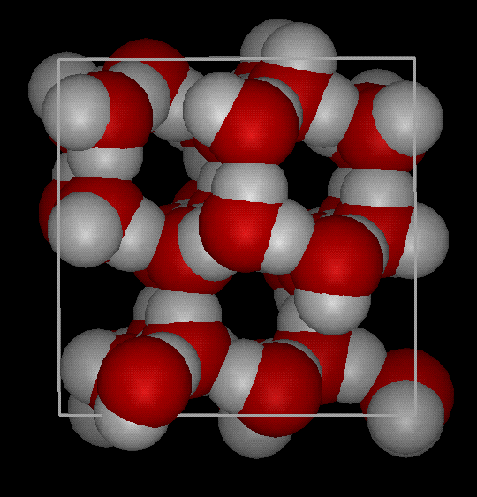
Ice: Notice the greater openness of the inside the ice, which is necessary to ensure the strongest degree of hydrogen bonding in a uniform, extended crystal lattice when the amount of thermal energy available to the molecules is less.

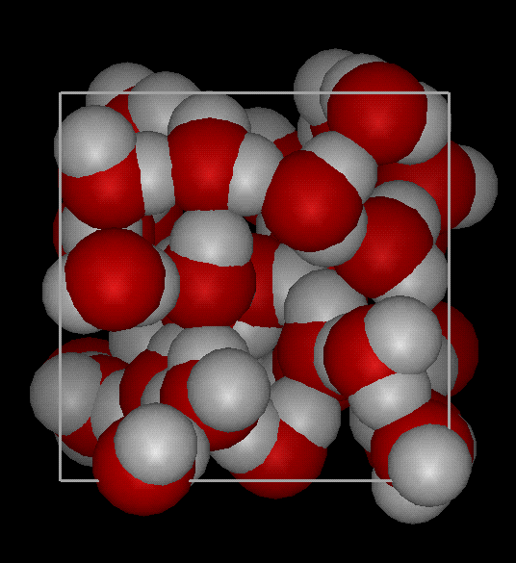
Liquid water: Instead, in liquid water a more crowded and jumbled arrangement of water molecules is possible because of the greater amount of thermal energy available above the freezing point.

The two arrangements show that when hydrogen bonding is at its maximum in ice, ice has a more open structure and thus a lower density than liquid water.

What about a cube of ice into a glass of alcohol?

The molecular structure of liquid alcohol is very different than that of liquid water and more complex. In particular, the spacing between molecules in liquid alcohol is larger per unit volume than that of ice. In other words, the density of alcohol is less than the density of water either as ice or liquid. For this reason, the ice cube will sink at the bottom of a glass of alcohol.

