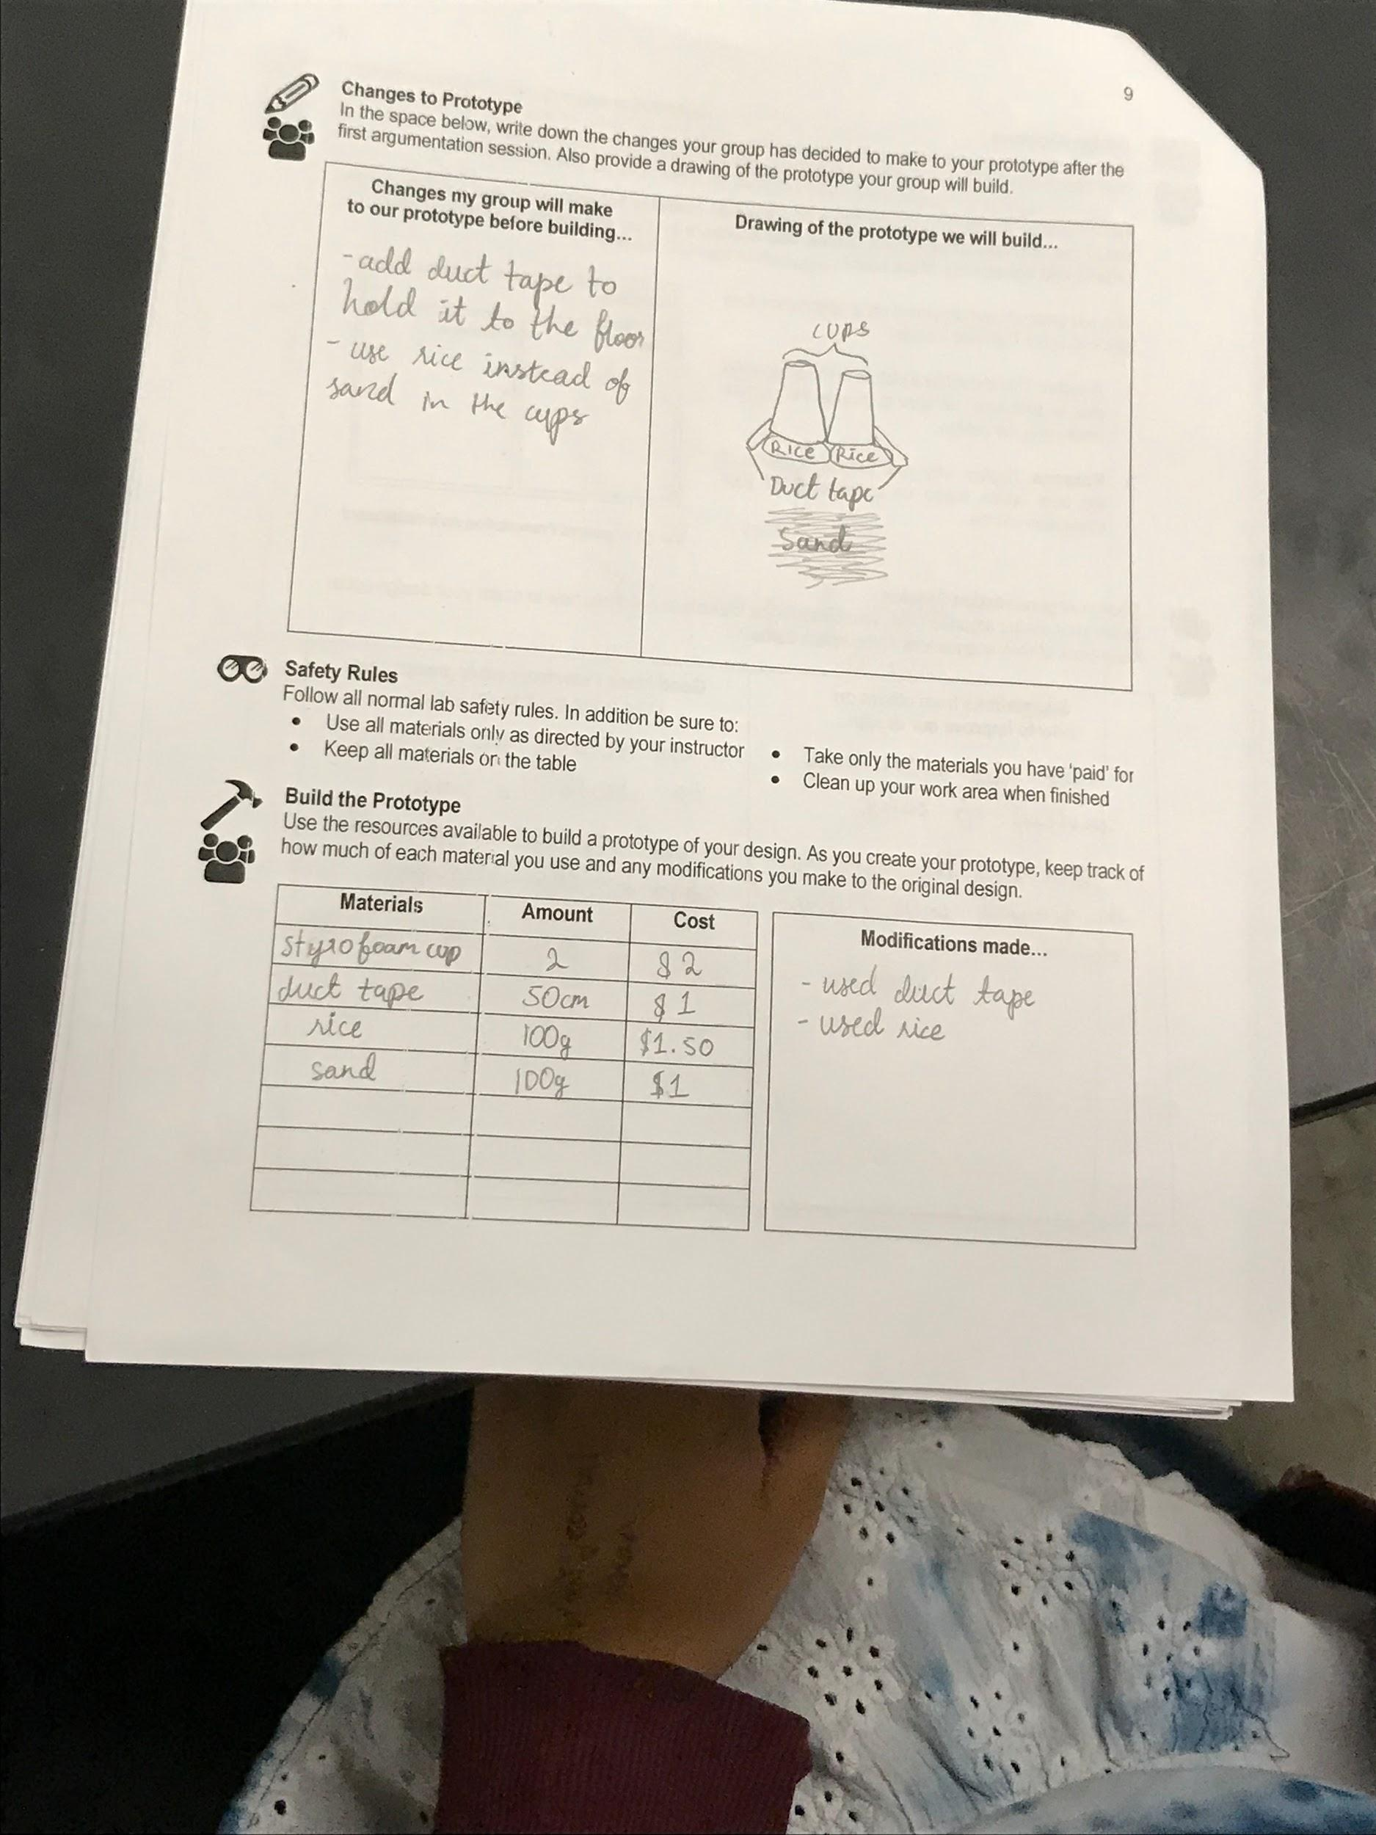
Sample responses from a student ADEU handout showing modifications to the design.

