Display Board Advice

Your Science Fair Display Board!

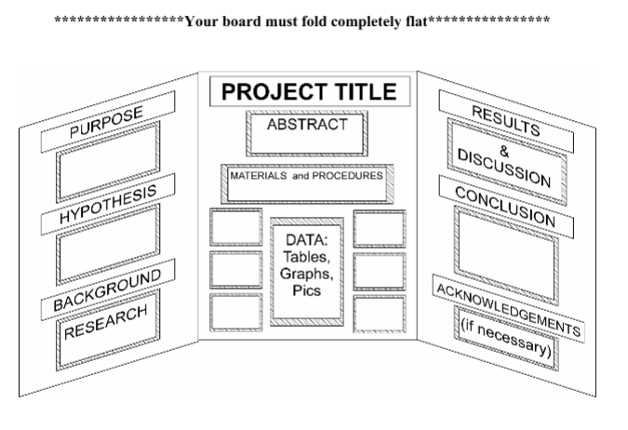
Make it…
…Neat

If your handwriting looks like this, you should type instead.

Font: “My Handwriting” by KlaineBlaine

…Colorful

Use colored paper for backgrounds, or use color for your section titles

…Readable!
- You don’t have to use Times New Roman font for everything, but it’s a good idea to use it for your text.

- Choose one fun or fancy font for your section titles. Using mixed fonts makes text hard to read.

- Make sure your font is big enough!

- Summarize! Don’t put your entire paper on your board

… Interesting & informative Use photos to show your project (but not people!)

…Free-standing

Use (or reuse!) a trifold display board

…Flat!

…The Right Size
- Big enough to show off your project
- Small enough to move, store, and set up
- Maximum size: 30 inches deep, 48 inches wide, 36 inches tall

Purpose

Why did you choose this project?

Hypothesis

A single, testable statement, predicting the outcome of your experiment.

Background Research

Briefly recap the science behind your experiment and hypothesis.

Abstract

A one-paragraph summary of your entire project. It’s OK to copy this directly from your report.

Experimental Design

List your variables, constants, and controls.

Materials

A list of the supplies and equipment you used to perform your experiment.

Procedures

The basic steps you followed in your project – you don’t have to include every detail here.

Results (Data)
Tables & Graphs – you should include at least one of each. It’s OK to show just the summary data here – include all the data in your report.

Analysis

Describe the story your data tells about your experiment.

Conclusions
Was your hypothesis supported? Why or why not?

Acknowledgements

Express your appreciation for the people who helped you with your project.

