Resources:
Resource 1: Density Spheres Available at Educational Innovations: https://www.teachersource.com/product/steel-sphere-density-kit/density
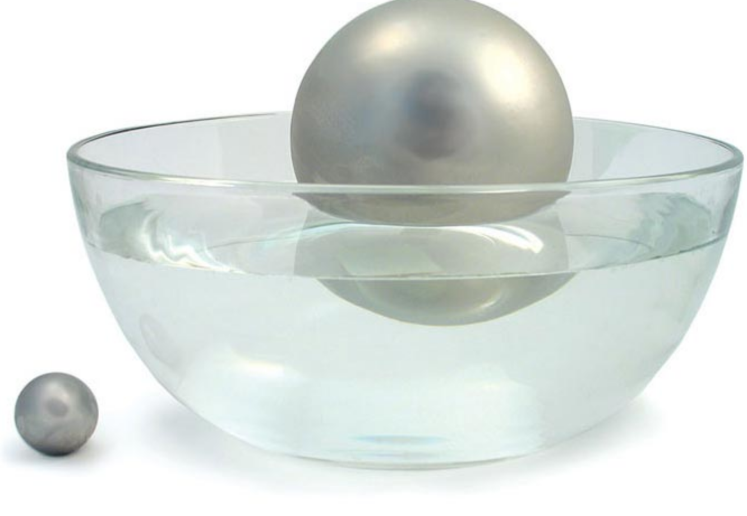

Resource 2: POE Graphic Organizer
P | Students write their Predictions here. They must clearly identify what they think will happen. At this point it is not necessary for them to have an explanation for their prediction. They just need to write down what they think will happen.
O | During the demonstration, students write down what they observe using any of their senses. They must be careful to not add any inferences or explanations at this point.
E | Students individually or in table groups (depending on instructions) write an explanation for the demonstration. Their explanations must address how or why. Additionally they are required to add, revise, or cross out during whole class discussions to make modifications to their explanations based on others’ responses

Resource 3: Share Talk Round Guidelines
- Each table group will make a list of potential ideas to share based on the prompts provided by teacher.
- Each member should be prepared to discuss any of the ideas prepared by the table group. The teacher reserves the right to specifically call on any member of the table group.
- Ideas or points of discussion may not be repeated. Therefore, it is essential that all members of the table group listen to the whole class discussion because anyone in the group may be called on.
- Once sharing begins, each table will share only one idea at a time.
- After an idea or point of discussion is initiated by a table group, other table groups will be permitted to respond to either modify, revise, enhance, or refute the original idea.
- When an idea or point of discussion is initiated by table group, other table groups may not change the topic until all table groups feel satisfied with the discussion.
- Once a topic is full discussed with no table group wanting to add to the discourse, the next table group will initiate a new idea or topic of discussion.
- The process repeats.

Resource 4: The 4 Question Brainstorming Strategy Adapted from Cothran, Geiss, and Rezba, 2000)
Questions | Possible Student Answers
Q1 What happens when I remove my finger from the bottom hole of the various bottles? | When you take your finger off the hole, the water shoots out the bottom hole. The distance decreases after a few seconds.
Q2 What materials are readily available for conducting this experiment? | There are different bottles of different sizes and some have different size exit holes drilled already.
Q3 How can I change the bottles to affect the response of the water in the bottle when I remove my finger off the bottom hole? Independent Variable Options | Height of water in the bottle  Width of the bottle  Shape of the bottle  Size of the bottom exit hole
Q4 How can I measure or describe the response of the water in the bottle when I remove my finger off the bottom hole? Dependent Variable Options | Using a ruler placed in front measure the distance the water shoots out when the hole is first opened.

Resource 5: Experimental Design Diagram (EDD) Adapted from Cothran, Geiss, and Rezba, 2000)

Resource 6: Claim, Evidence, Reasoning Mini-Posters
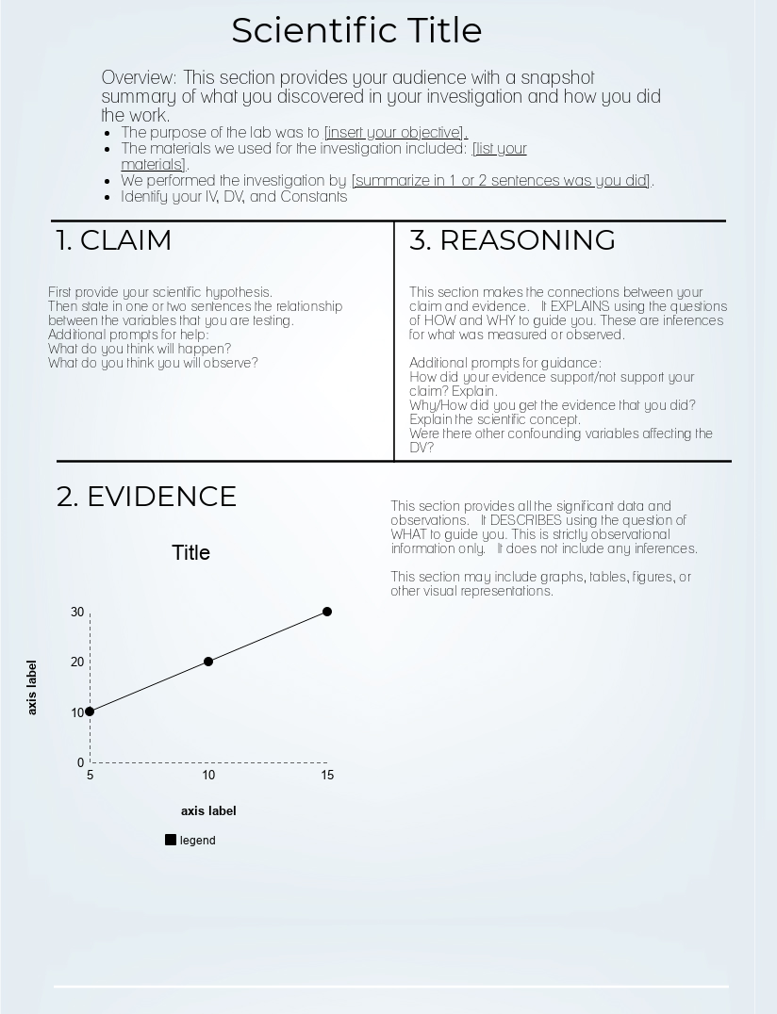

Resource 7: Summarizing Results Prompts
Prompt
In 1-2 sentences describe your experiment identifying your independent and dependent variables.

In 1 sentence state your hypothesis and explain the reasoning.

In 1-2 sentences describe your results. Which level of the IV went the furthest?

1-2 sentences describing anything else. Were there confounding variables?

Resource 8: Analysis Prompts

Teacher Prompts to Guide Student Thinking During Analysis and Reasoning
- Which independent variable had the biggest difference between the different levels?
- Why do you think height of the water has the biggest change in the distance the water squirts out?
- Imagine the water molecules stack on each other. Which ones are pushing on the ones to go out the exit hole?
- What do we call a push or pull in science?
- In the demonstrations what was the difference between holding the spheres in your hand versus holding them in a bucket?
- How does this relate to the 2 spheres, where the small one felt heavier in your hand but when on the same surface area of the bucket they were the same mass?
- What is the term that describes a force on an area?
- For the other independent variables (other than height) why did you not get exactly the same results each time?
- What other confounding variables exist?

