Data Collection Sheet
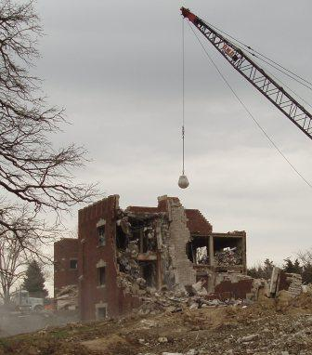
Name ______________________________

Independent Variable: ____________________________________________________

Dependent Variable: Number of blocks knocked down.

Trial 1: Size of the bob

Small: # of blocks knocked down: ___________

Medium: # of blocks knocked down: ___________

Large: # of blocks knocked down: ___________

Trial 2: Angle of the swing

45^{O}: # of blocks knocked down: ___________

90^{O}: # of blocks knocked down: ___________

135^{O}: # of blocks knocked down: ___________

Trial 3 Mass of the bob

Mass 1: # of blocks knocked down: ___________

Mass 2: # of blocks knocked down: ___________

Mass 3: # of blocks knocked down: ___________

Trial 1: Size of the bob

Trial 2: Angle of the swing

Trial 3 Mass of the bob

Spider Web Graphic Organizer: Planning the E-mail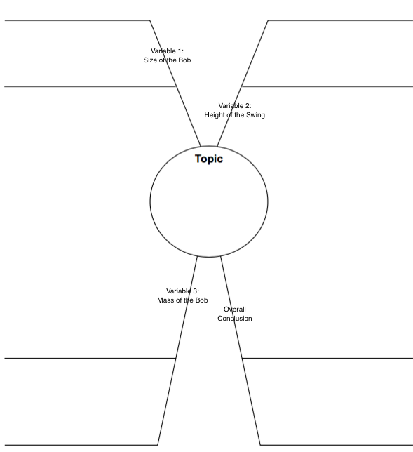

Question: What can you claim about the most effective characteristics of a wrecking ball?

Claim:

Evidence:
Letter to owner of the local stadium

