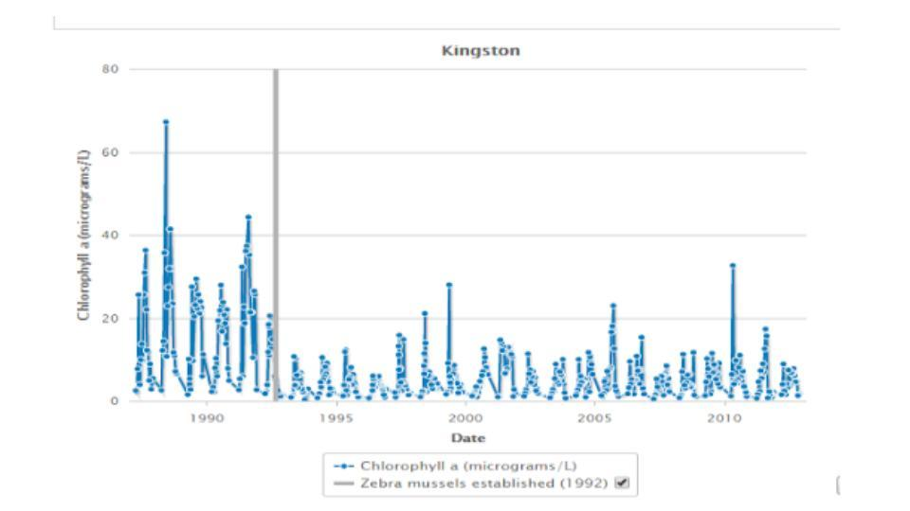
- The above graph tracks the density of chlorophyll found in the Hudson River near the Kingston station over a thirty year period (1985-2015). How does the density of chlorophyll change over the same time period?
- What do you predict will happen to the chlorophyll density in the future? Use the pattern you see in the data to justify your answer.
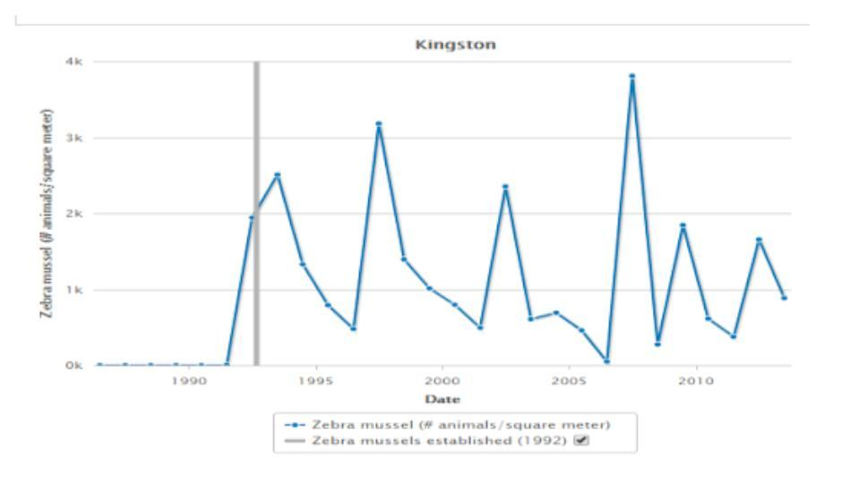
- The above graph tracks the population density of the zebra mussel at the Kingston Station in the Hudson River for a thirty year time period (1985-2015). How does the population of mussels change over time?
- How do you think chlorophyll density responds to an increase in zebra mussel population?
- The introduction of zebra mussels caused changes to the Hudson River ecosystem. Name one non-living factor which causes this system to be unstable.

