PRE-LAB HANDOUT: THE BOLD FOLD

Background: The information to create proteins is stored in the cell’s DNA (which in eukaryotic cells is found in the nucleus). Instructions for each individual protein are stored in a stretch of DNA called a gene. DNA is made up of molecules called adenine, thymine, guanine, and cytosine bases. These bases are abbreviated with the letters A, T, G, and C. The order of these bases will determine what protein will be made, from that particular gene. DNA is double stranded, and the bases in one strand pair up with the bases from the other strand (See figure below).

You can see that A bases pair with T bases, and C bases pair with G bases.

What is mRNA and why do we need it? DNA is extremely important to the cell: if the DNA is changed, the cell will not be able to make proteins. Therefore, DNA must stay in the nucleus where it can be protected. In order to make proteins (which are synthesized outside the nucleus) the cell copies genes into smaller DNA-like molecules called mRNA. mRNA can then travel outside of the nucleus. mRNA molecules contain all the information needed to make a single protein. They are extremely similar to DNA, with all the same bases, except instead of T bases, the mRNA contains a uracil (U) base.

TRANSCRIPTION

Transcription: mRNA molecules are made (or transcribed) by a protein that “reads” the DNA molecules. It does this by “complementing” mRNA bases to one strand of the DNA (called the template strand or antisense strand). As mentioned, DNA bases can pair up. The same is true for mRNA and DNA bases. When a DNA molecule is copied into mRNA, the complement of the DNA base is placed into the growing mRNA strand. For example, during transcription, if the DNA template has a G base, the corresponding mRNA base will be C. Since T bases are replaced by U bases, whenever there is an A base in the DNA, a U molecule is added to the mRNA strand instead of a T. The diagram below shows transcription.

TRANSLATION

After an mRNA molecule has been created, the cell must now use that mRNA to make a protein. Ribosomes (as well as special RNA molecules called tRNA) can “read” the mRNA sequences and use that sequence like a recipe to make the corresponding protein, using building molecules molecules called amino acids.

mRNA bases are read in sets of 3 called codons. Each codon corresponds to a specific amino acid molecule. Translation starts at the “AUG” codon in the mRNA strand, which codes for the amino acid methionine. Therefore, every protein begins with a methionine amino acid. After that start codon, every set of three nucleotides is “read” as a codon, allowing the ribosome to add the next amino acid to the growing protein chain. At this point the growing chain is called a polypeptide (it won’t be called a protein until it is functional!)

The full protein strand will be a long stretch of amino acids. Amino acids have chemical properties that can interact with one another. Also, stretches of a protein, called a domain, are amino acids that will interact with each other and form into a specific shape. The shape of the domain will determine its final function. Below is a basic diagram of translation.

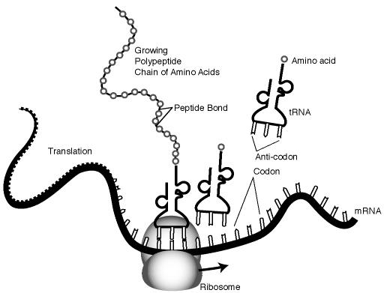

Images Courtesy: National Human Genome Research Institute
https://www.genome.gov/

PROTEIN FOLDING

As the polypeptide assembles during translation, the amino acids can begin to interact along the strand (because each amino acid has specific properties). For example, some amino acids are attracted to one another while others might be repelled. This allows the polypeptide to take on a more defined shape. This can happen in the cytoplasm or sometimes the polypeptide is “fed” into an organelle called the rough endoplasmic reticulum. Either way, it begins to fold.

We call the first organization of the polypeptide its primary structure. This is the unfolded string of amino acids that are covalently linked together. Next, its secondary structure appears when the amino acids begin interacting. Stretches of the polypeptide (called domains) will begin to form spiral shapes (called α-helices; seen in gray and black below) or folded patterns (called β-pleated sheets; seen in orange below).

Next, the protein enters its tertiary structure as the secondary domains begin to interact. The figure below shows secondary form and tertiary form. Notice some areas (pink regions) do not have a defined secondary shape. These are called disordered domains.

If the polypeptide is fully functional, we know called it a protein. Some polypeptides must come together with other polypeptides to create the functional protein. When more than one polypeptide works together to form the functional protein, that is the quaternary structure of the protein.

PROTEIN SORTING

Proteins that fold in the endoplasmic reticulum are then transported to the Golgi organelle. Here proteins receive a special “tag” that determines their final destination. This tag is a small molecule, for example, it could be a strand of carbohydrates. From the Golgi, the protein can be delivered to its final destination!

