Model Testing: Does it fit the data we know?
The following reading on scientific modeling is adapted from Science Learning-- Sparking Learning Hub website-- www.sciencelearn.org
Scientific modelling
In science, a model is a representation of an idea, an object or even a process or a system that is used to describe and explain phenomena that cannot be experienced directly. Models are central to what scientists do, both in their research as well as when communicating their explanations.
Models are a mentally visual way of linking theory with experiment, and they guide research by being simplified representations of an imagined reality that enable predictions to be developed and tested by experiment.
Why scientists use models
Models have a variety of uses – from providing a way of explaining complex data to presenting as a hypothesis. There may be more than one model proposed by scientists to explain or predict what might happen in particular circumstances. Often scientists will argue about the ‘rightness’ of their model, and in the process, the model will evolve or be rejected. Consequently, models are central to the process of knowledge-building in science and demonstrate how science knowledge is tentative.
- Focus Question: Do you believe that the models you developed help you in the knowledge-building process? If so how?

- Focus Question: How did your models illustrate that the Nature of Science is tentative?

Think about a model showing the Earth – a globe. Until 2005, globes were always an artist’s representation of what we thought the planet looked like. (In 2005, the first globe using satellite pictures from NASA was produced.) The first known globe to be made (in 150 BC) was not very accurate. The globe was constructed in Greece so perhaps only showed a small amount of land in Europe, and it wouldn’t have had Australia, China or New Zealand on it! As the amount of knowledge has built up over hundreds of years, the model has improved until, by the time a globe made from real images was produced, there was no noticeable difference between the representation and the real thing.
Building a model
Scientists start with a small amount of data and build up a better and better representation of the phenomena they are explaining or using for prediction as time goes on. These days, many models are likely to be mathematical and are run on computers, rather than being a visual representation, but the principle is the same.
Using models for predicting
In some situations, models are developed by scientists to try and predict things. The best example is climate change. Humans don’t know what effect they are having on the planet, but we do know a lot about carbon cycles, water cycles and weather. Using this information and an understanding of how these cycles interact, scientists are trying to figure out what might happen.
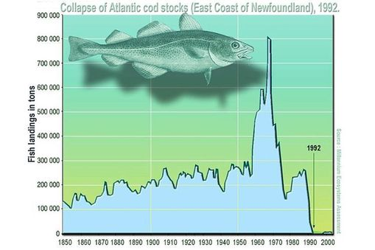
For example, they can use data to predict what the climate might be like in 20 years if we keep producing carbon dioxide at current rates – what might happen if we produce more carbon dioxide and what would happen if we produce less. The results are used to inform politicians about what could happen to the climate and what can be changed.
Another common use of models is in management of fisheries. Fishing and selling fish to export markets is an important industry for many countries including New Zealand (worth $1.4 billion dollars in 2009). However, overfishing is a real risk and can cause fishing grounds to collapse. Scientists use information about fish life cycles, breeding patterns, weather, coastal currents and habitats to predict how many fish can be taken from a particular area before the population is reduced below the point where it can’t recover.
How do we know if a model works?
Models are often used to make very important decisions, for example, reducing the amount of fish that can be taken from an area might send a company out of business or prevent a fisherman from having a career that has been in their family for generations.
The costs associated with combating climate change are almost unimaginable, so it’s important that the models are right, but often it is a case of using the best information available to date. Models need to be continually tested to see if the data used provides useful information. A question scientists can ask of a model is: Does it fit the data that we know?
For climate change, this is a bit difficult. It might fit what we know now, but do we know enough? One way to test a climate change model is to run it backwards. Can it accurately predict what has already happened? Scientists can measure what has happened in the past, so if the model fits the data, it is thought to be a little more trustworthy. If it doesn’t fit, it’s time to do some more work.
- Focus Question: If you could go back in time and collect data from the nuclear explosion of Little Boy, what data would you collect? Be prepared to share your answer.

The process of comparing model predictions with observable data is known as ‘ground-truthing’. For fisheries management, ground-truthing involves going out and taking samples of fish at different areas. If there are not as many fish in the region as the model predicts, it is time to do some more work.
Models have always been important in science and continue to be used to test hypotheses and predict information. Often they are not accurate because the scientists may not have all the data. It is important that scientists test their models and be willing to improve them as new data comes to light. Model-building can take time – an accurate globe took more than 2,000 years to create.
Collaboratively you have been developing a model nuclear fission and what this process can cause. To better understand how models can be used to make prediction, you will be ground-truthing your model. We are not able to go back in time and collect the data discussed. However, there were scientists that did collect data after this disaster. The longest ever medical research study conducted by Radiation Effects Research Foundation, is still collecting data from survivors and their kids.
Your group will use your models to predict what happed to residents that were present about 1 kilometer from the hypocenter. What type of injuries should you expect to see and what factors will affect their survival rates? You will use the app Explain Everything to make a short video that explains what your model predicts. Then you will be given actual published data from the Hiroshima disaster and will need to explain what parts your model predicts correctly and incorrectly. The data was published in the book The impact of the A-Bomb: Hiroshima and Nagasaki, 1945-85, edited by The Committee for the Compilation of Materials on Damages Caused by the Atomic Bomb in Hiroshima and Nagasaki.
Explain Everything Video Outline (Everyone group member must complete at least 1 slide).
Slide 1- Picture of your group members
Slide 2- Take a video of a group member showing what your model predicts.
“Our model predicts residents that were outdoors and unshielded about 1 kilometer (0.6 miles) from the hypocenter will…”
“Our model predicts residents that were outdoors but shielded about 1 kilometer (0.6 miles) from the hypocenter will...”
“Our model predicts residents that were inside a wooden house about 1 kilometer (0.6 miles) from the hypocenter will...”
“Our model predicts residents that were inside a concreate house about 1 kilometer (0.6 miles) from the hypocenter will...”
Slide 3- Take a video of a group member explaining what information is given in Table 12.
Slide 4- Take a video of a group member explaining what information is given in Table 13.
Slide 5- Take a video of a group member answering the following question.
What injuries did you model correctly predict?
What injuries did you model does not predict correctly, what should happen to your model?

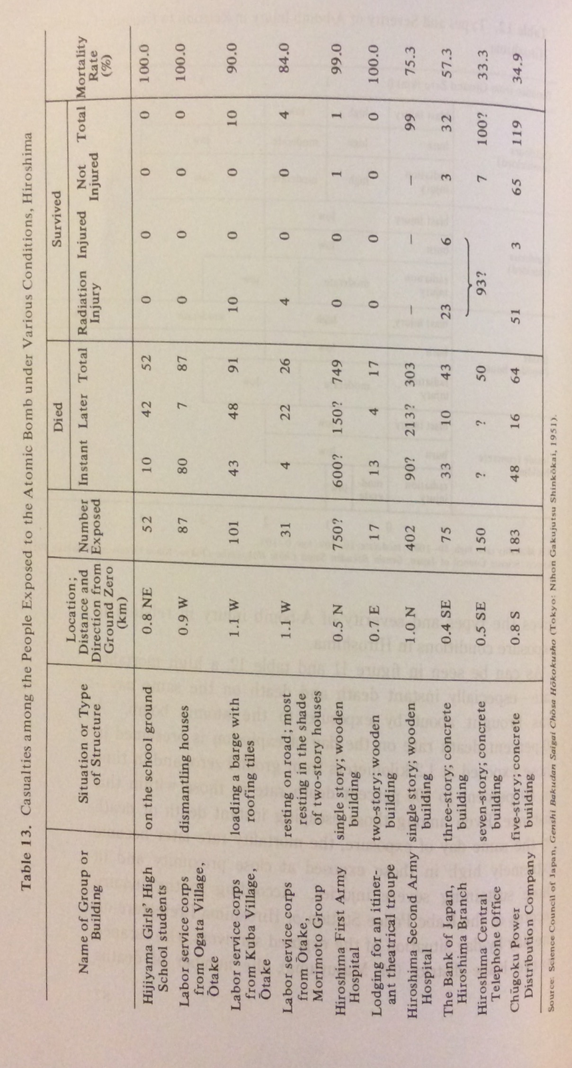

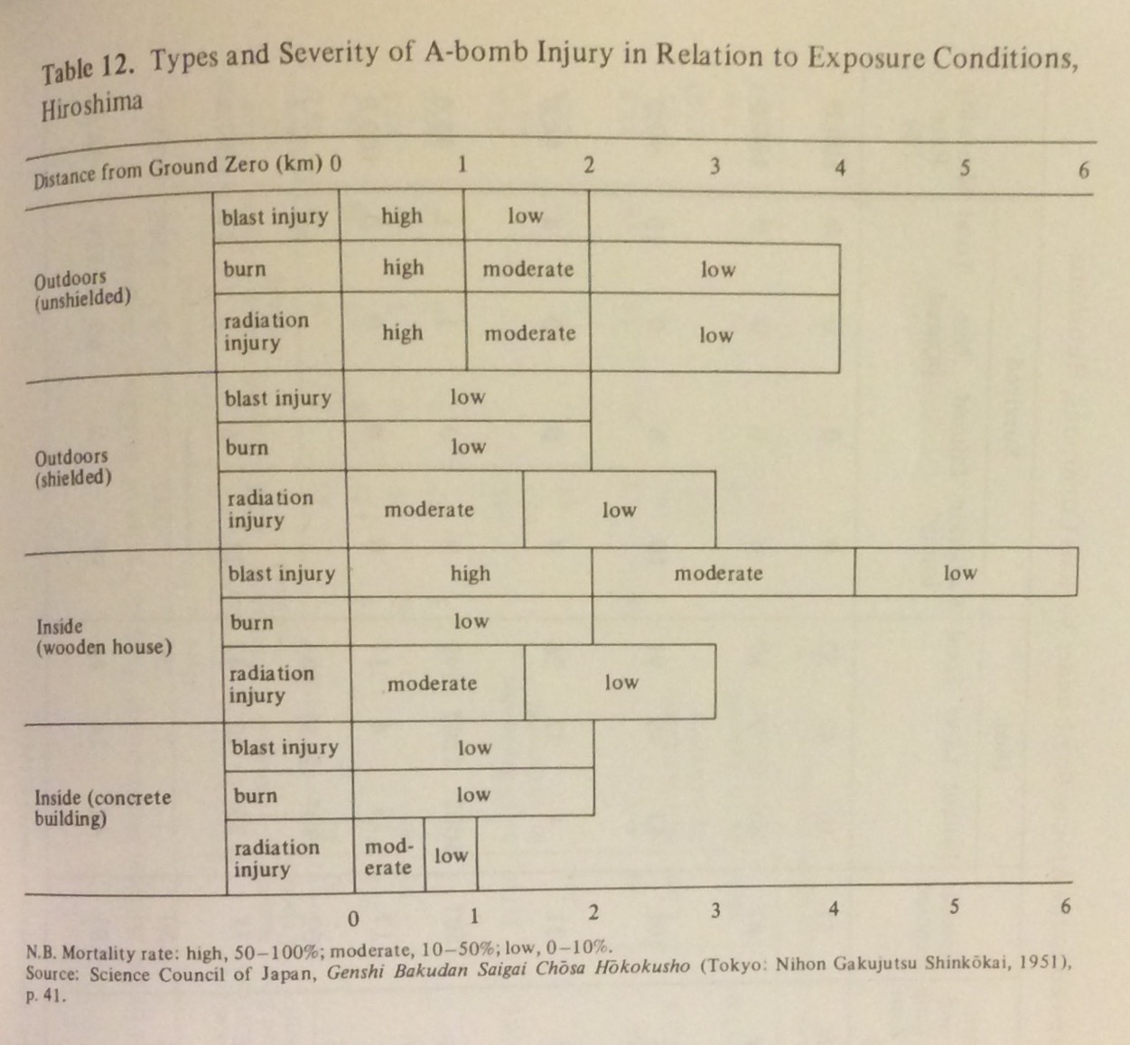

Data Citation
Ishikawa, E., & Swain, D. (Trans.). (1985). The impact of the A-Bomb: Hiroshima and Nagasaki, 1945-85 (The Committee for the Compilation of Materials on Damages Caused by the Atomic Bomb in Hiroshima and Nagasaki, Ed.). Tokyo: Iwanami Shoten.

