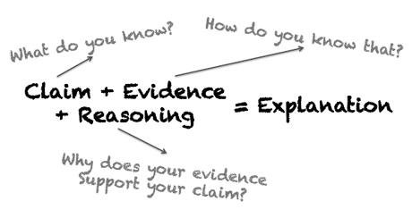
Claims, Evidences, and Reasoning

For the unit exam you will need to compose a final evidence based explanation that completely and correctly answers our driving question. This final explanation will be turned in Friday and must be nicely hand written or typed in MLA format. You are also required self-evaluate your final explanation using the provided rubric and staple it to your paper.

The nuclear bomb Little Boy, dropped on Hiroshima, killed an estimated 90,000 Japanese citizens. It was the first weapon used that continued to kill people decades after the explosion.
What made the nuclear bomb Little Boy, dropped on Hiroshima, different from all
previously used bombs (Part 1), and how did it cause a loss of life after detonation and for decades to come (Part 2)?
Using your “Caused Statements”, handout will be helpful to answer Part 2 of the phenomena. Take each of your discovered causes and write it as a claim. Then discuss as a group what activity, reading, demo, simulation, or lab we did that you can reference as evidence to support your claim.

Claim:

Evidence:

Reasoning:

