On the Web: Example of Class Diatom Identification Guide

“The Double-Ended Bowling Pin”
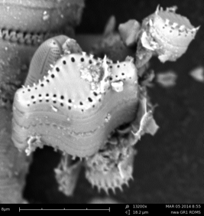
This SEM image is at 13,200x magnification and is from the Reed Campus Lake (Collected March 2014). The diatom is pennate and a fusiform shape. It is wide in the middle and gets gradually thinner towards both ends. There is a line of pores or aerola bordering the face of the diatom, set in slightly from the center. On one side, there is a double line of aerola. These lines are called stria. It looks like there are about five fusiform diatoms snapped together by silica spines that are located around the edges of the diatom. All of the edges are rounded, and the overall shape looks like a UFO, double ended bowling pin or a lantern sitting on its side. The widest part of the diatom (the center) is hyaline, as well as the tips of each narrow end. This diatom has a shape similar to that of Staurosira construens, yet this species has lines instead of aerola, and is much wider and less round in the center.

“The Sarcophagus”
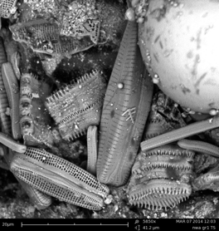
Using a scanning electron microscope (SEM), we were able to look at a diatom at 5850x magnification from Tanner Springs, a small urban “pond” in the Pearl District. In this image, the diatom is pennate, which means it is long and narrow like a canoe. The diatom’s shape is long and slender like a coffin or a sarcophagus. The scientific term for the diatom’s shape is lanceolate because it is an elongated shape that is widest at the middle with smaller ends. The width of the diatom is 41.2 um. The diatom is Biraphid because there are two raphe located on the seam connecting the two halves of the diatom. The diatom is also biseriate because it has two rows of pores on either side of the raphes. The apical axis of the diatom is estimated to be approximately 130um.

“The Short, Round Vase”
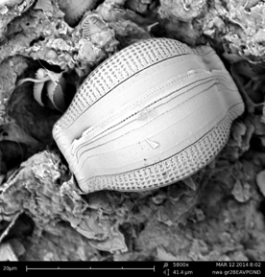
The diatom is found in water from a manmade pond in Beaverton, Oregon. The diatom is shaped similar to a short, round vase. Widest in the middle, this diatom has a centric shape with a length of 28 um. There are pores or aerola surrounding the diatom, however, there is a hyaline stripe down the middle of the diatom. It can be inferred that the hyline appears on the diatom in the same area on the other face that cannot be visualized with this image. The diatom has no raphe, but it does have slits through the hyaline exposing more aerola. This diatom does not have a central node or spines, resulting in a smooth appearance. It is possible that the diatom is actually two separate diatoms that are attached together.

“The Roll of Paper Towels”
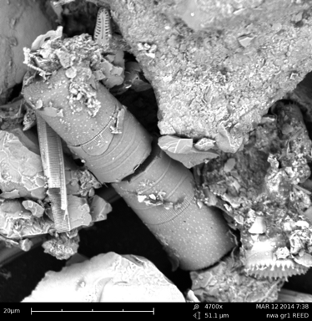
The diatom is cylindrical, or centric, and appears to have snapped in two or be two individuals. The longest diatom is 20.7um in length and 11.5 um in width. The shorter portion is 19.23um in length and 10.25 um in width. The diatom can be compared to a roll of paper towels of a water bottle in shape and form. The diatom is greater in length than in width, making it an elongate shape. It does not have an aerola in the surface. Rather than pores, the lower sample’s frustule appears to have a hyaline area that is smooth with no pores or perforations. Both parts of the diatom do not contain spines or valves, but they contain grooves or striations, which could possibly be locations where the diatom breaks into two pieces. No stria, lineola, or linking spines are present on either part of the sample because it has no pores or spines. The valve face has little to no ornamentation on top of the diatom. This diatom may be Melosira because of its shape and texture.

“The Squashed Basketball”
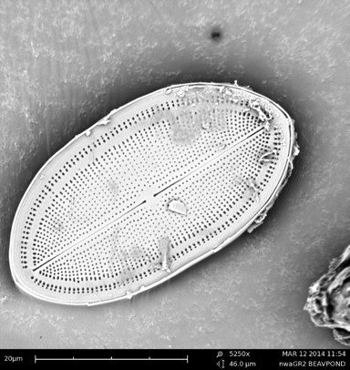
This species of diatom is centric because it has large, arched sides, with dull ends. It resembles a squashed basketball that is very symmetrical, or a wide rowboat with two pointed ends. That means that this diatom is a lanceolate shape. The length of the species at its longest point is 44um and its width is 23um. On the valve of the diatom, it has stria, which are rows of pores, also known as aerola. They extend from the raphe in the middle. The raphe is a slit in the face that helps the diatom to move over a surface. The raphe has a stigma, so there are two slits in the middle, oriented along the length of the diatom. All of the pores extend from the spine in curves, following the shape of the diatom. It looks like they are stretched out arches coming from the middle of the diatom. The outermost pores are slightly biseriate, so they have two rows, and there is a small space in between the rest of the stria. After doing some research, I came to the conclusion that the diatom in the image was Cocconeis fluviatilis. This species is in the larger morphological category of Monoraphid. The image matched this species because it shared the skinny raphe with two stigmas, as well as the biseriate pores.

“The Spiny Tire” or “Roll of Ribbon”
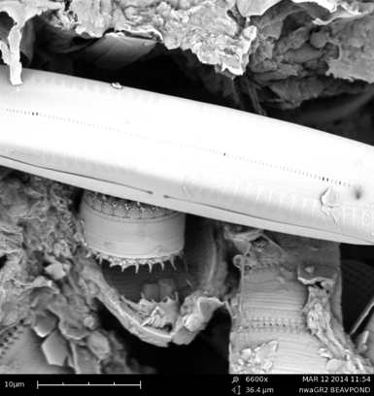
The diatom in the SEM image is a centric diatom. It is about 10 micrometers in diameter, which is a relatively small diatom. It looks a bit like a car tire with a band around it where the tire would touch the ground if it were rolling. There is a smooth section around its midriff that appears to have a few ridges in it, but very subtly. This section if the diatom is called hyaline. On the face of the diatom, on the other hand, it is very rough and spiny with many pores. These pores make up a pore field, where the diatom attaches to a surface. The diatom has many pores, or aerola, on the top and bottom surfaces. The pores do not appear to be in stria; they are more or less randomly placed. The pores are, for the most part, circular dots and not lineola. This diatom does have linking silica spines on the edges, but it is isolated by itself (not a colony). It has very thin spines coming out of it around the circumference of both the top and the bottom of the diatom.

The diatom found in the Beaverton pond sample and magnified at 6600x, is centric and wheel-shaped. In comparison to the other debris in the sample, the diatom is fairly small. Using the measurement tool on the SEM, the length is 15 um and the width is 5um. The diatom resembles a circular lid or a roll of ribbon. Along the outer edges of the diatom, there are silica spines, giving the diatom a stellate shape. Along the top edge of the diatom are aerola, or small pores. Other than those small perforations, the diatom is mostly smooth along the face.

“The Watermelon Seed”
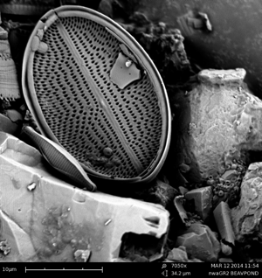
On March 12th, 2014, Group 2 took an SEM picture of a diatom from a sample from a manmade Beaverton pond at a magnification of 7050x. The diatom is a centric species because of its circular structure. The length of the diatom is 25 micrometers, and the width is 17.5 micrometers. The diatom has a gibbous shape (exceeding a semi circle, but less than a circle) with a thin raphe in the middle that divides the face of the diatom. On either side of the raphe are semi circular porous fields that resemble small watermelon seeds. A thick hyaline strip that holds the diatom together like an eggshell contours the perimeter of the diatom. It appears that this diatom has been broken up into two pieces and that on the other side of the diatom may be the valve.

“The Footprint of Baby Bigfoot”
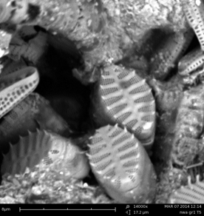
On March 7th, 2014, Group 1 took an SEM picture of a couple of diatoms of the same species from Tanner Springs, an urban pond in the Pearl District. The photo is at a magnification of 14,000x! The diatoms are a centric species because of their circular structure. The lengths of the diatoms are 8 micrometers and their widths are 4 micrometers. The diatom has a lanceolate shape (an elongated shape, widest in the middle and tapering at both ends) with aerola (perforations of pores), stria (stripes or rows of aerola), and lineola (little lines of pores). There are 8 pore fields divided on the left side of the diatom by areas of hyaline, and on the right side there are 6 pore fields. My teacher thinks that this diatom looks like the footprint of baby bigfoot.

“The Bar of Soap”
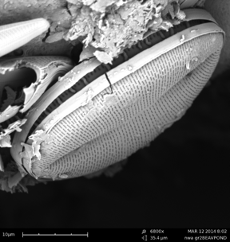
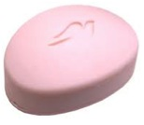
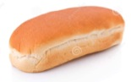
My diatom is a pennate diatom. It is 30.857 um long at it is approximately 12 um long. It has the appearance of a hotdog bun that has been squished flat a bit. It is wider however than a normal hotdog bun, and the sides are not as long (see figure 1). It is Elongate, meaning that the length of it is greater than the width, but it is not slender, it is still wide, like a fat oval. The edges are rounded, so it is not Lanceolate, but it is widest in the middle. The diatom has perforations or pores all on the Face, or the Valve, of it, and these perforations are called Aerola. The Aerola are in neat horizontal rows that stretch across the width of it. This is called Stria. The Aerola in the Stria that stretch across the width of the diatom are little lines, which are also horizontal pointing from one side of the width to the other. There is not a Raphe, a slit though the face, visible on this diatom. The Raphe is the structure that the diatom uses to move over surfaces, and there is not one visible on this particular image of this diatom. The Apical Axis, the long axis of the valve face of the diatom, is indented, as if it were pushed in, and so is a grove in the middle of the Face of the diatom. There is also no pore field, spine, or stigma visible on this diatom. The diatom is
Figure 1:
Hot Dog Bun
by itself; it is not in a colony. The side, or the Hyaline of the diatom, is flat. There are no pores on it, and the shape of it does not come together like a clam does where it is rounded yet pointed on the sides. The sides, rather, are flat. The diatom somewhat resembles a bar of soap when it is clean out of the box. It is rounded at the top, but when it comes to the sides they are flat (See figure 2). Unlike figure 1 however, the base of the diatom is not curved like a banana, but rather flat, just like the base of figure 1. The diatom is split on the side and exposes some silica spine-like objects inside of the Frustule.
Figure 2:
Bar of Dove Soap
I hypothesize that these spines hold each side of the frustule together.

“The Jewelry Box” or “The Four-Leaf Clover Pillow”
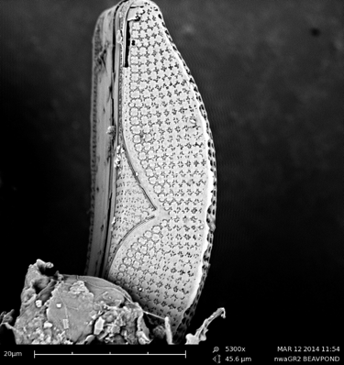
This diatom is pennate and at the same time it is also gibbous. The shape of the diatom is long and fairly narrow, although one edge is circular and would fit on the inside contour of a circle. The edge on the other side is flat. The diatom is elongate as well, because it has a considerable amount more length than width. The diatom is widest at the center and then decreases in width and tapers as it elongates. At either end, the diatom is very narrow. This is what makes the diatom lanceolate. Three dimensionally the diatom is like a pennate shaped box. From the photo, it looks like maybe the other side that is not visible in the photo is the same as the topside. The lengths of the rectangular plane side that connect the two pennate sides are all the same and so if this diatom was hollowed out and a lot larger, one could open the top side like a lid to a fun-shaped jewelry box.
The entire diatom is not contained in this picture but is cut off and covered by another particle at about three quarters of its length. With this in mind in order to measure the true length of the diatom, a measurement of one end to the middle (half of the length of the diatom), will be taken. Then, this length will be doubled and therefore reveal the true length of the diatom. The length of the field of vision of the photo is 45.6 um (micrometers). Because the top of the diatom is at the very top of the photo and it exceeds the other edge of the photo, it is inferred that the diatom’s length will be longer than 45.6 um. The length of the diatom is around 111 um. The width at the middle of the top surface of the diatom is 13.5 um.
It is concluded that this diatom does have aerola, or pores. However, these pores are very interestingly shaped. They are not circular pores like one would see on a person’s skin; they look like stria that have been shaped into short rounded segments of squares. That means that these pores are most likely lineola. This diatom does not have a visible or obvious spine.

The diatom in this image has a unique shape and structure. One of the diatoms has a pennate shape; more specifically it belongs to the gibbous category. The gibbous shape looks like a semi-circle, but with slightly more of the angled mass on either side. There is a phase of the moon that is shaped like this diatom and it shares its name (Gibbous). In regards to size, the image of this diatom is zoomed into 5300x on a scanning electron microscope. What can be seen of the diatom would suggest that it is approximately 45.7um in length, and 16.6 um in width. Which would mean that when taking into account the fact that the diatom is not a perfect square, it is roughly around 303 square micrometers. This diatom looks like the side view of a pillow laid flat on a bed. It has several bend- lineola, which form an almost complete circle, with small spaces in between the end of each line. At first glance, these look like the outline of a four leaf clover, but if a closer look is taken, it can be seen that the ends aren’t bend inward. The collection of these lines all making these circles together look like sequins on a piece of fabric. The hyaline is at the base of the diatom and it looks like smooth, sculpted plastic, wrapping around the bottom of the diatom. Adjacent to the hyaline is the stigma, the long slit that extends about a third of the length of the diatom along the hyaline.

