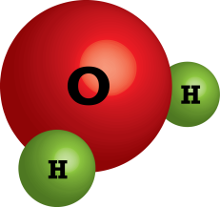
Many take for granted that water’s formula is H₂O, two hydrogen atoms bonded to one oxygen atom. All semester we have treated water as one particle and not as three atoms in a group. Regardless, you came to this class with previous knowledge and have heard of this formula before (Key Question 1). The historical discovery of water’s formula and the way atoms combine at the simplest level is an interesting story about two scientists, John Dalton and Joseph Louis Gay-Lussac, struggling to discover what atoms do when they combine at the simplest level.
Key Question 1: What background do you have with water? In what other classes have you heard or worked with water as H₂O?

Name _______________________________________

Coming to Understand Simple Combinations
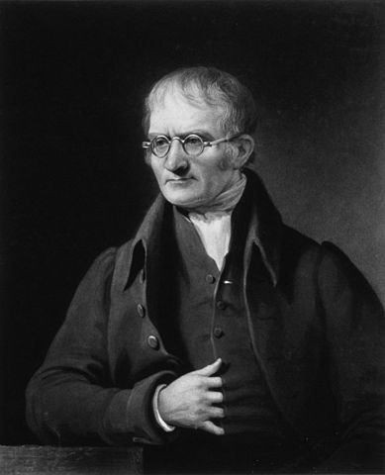
We start this story in 1766 (Key Question 2). A boy named John Dalton was born in England to a poor but devoted Quaker family. He was a genius. He acquired most of this education through his own efforts and, at the age of 12, was put in charge of his local school. We know from his diaries that in his free time, he read the original works of many scientists, such as Newton, in the original Latin. In 1793, Dalton became a professor of mathematics and natural philosophy in Manchester, England, where he spent the rest of his life. Besides his work in trying to understand how atoms behave at the simplest level, Dalton produced books and papers that spanned many subjects, from grammar to meteorology. Color blindness, from which he suffered, is also called Daltonism; the condition got this name due to his work in the field.
Key Question 2: Let’s set the stage historically: What happened in our nation’s history 10 years later?

Key Question 3: What do you remember about this scientist?

Near the end of the century, Dalton became interested in the nature of the atmosphere. He discovered that the amount of water vapor in the air increases with temperature. He also took air samples from various locations and showed that it is composed of 21% oxygen and 79% nitrogen. In an entry in his notebook dated September 6, 1803, he described his earliest efforts to create a table of comparative atomic weights. His calculations were based upon the analyses of scientists, such as Lavoisier (Key Question 3). Chemistry was not Dalton’s cup of tea. He was interested in atmospheric gases. This interest led him to a philosophy of gases that stemmed from a concept of atomic weights. Learning about Lavoisier’s philosophies and other theories led Dalton to one of the most important concepts in chemistry.
Dalton’s idea about the nature of atoms appears to have developed rapidly following the autumn of 1803. It became known as the atomic theory. He believed that all matter is made of small indivisible particles called atoms. The atoms of a given element are identical, but different elements’ atoms vary in mass. At the simplest level, atoms combine when two or more elements form a “firm union” (Key Question 4).
Key Question 4: How would you illustrate an element “joining a firm union with element”?

It is obviously impossible to weigh a single atom; therefore, Dalton wanted to develop a system of atomic weights based on comparison. Dalton selected hydrogen and assigned it a weight of 1. Dalton believed that determining the atomic weight of oxygen could be done in two ways:
Option 1: Comparing the weight of equal volumes of oxygen and hydrogen atoms.

Option 2: Experimentally determining the combined weights of oxygen and hydrogen in water.
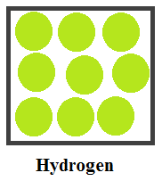

Dalton believed that gas atoms are similar to a pile of shot and concluded that atoms of different gases have different diameters. For example, a bucket of baseballs contains fewer balls than an identical bucket of marbles. Dalton knew this was true in the macroscopic world, so why wouldn’t it be true in the submicroscopic one? At right is a simple representation of what Dalton believed hydrogen looks like at the simplest level. In the second box, draw what you believe Dalton thought oxygen would look like. (Remember, different atoms have different diameters.) Dalton thought that the first option of comparing the weight of equal volumes of oxygen and hydrogen atoms was impossible, as there was no way to know how many atoms were in a given volume (Key Question 5). Dalton decided to focus his efforts on the second option—looking at how much oxygen combined with hydrogen. Dalton assumed that the combination of atoms would always be of the simplest form; therefore, he believed that the formula for water was HO, a one-to-one ratio. Building on Lavoisier’s analysis that water is composed of 85% oxygen and 15% hydrogen, Dalton calculated the atomic weight of oxygen to be 5.99. Later, after getting more accurate calculations and retesting, he finally assigned oxygen’s atomic weight: seven times heavier than hydrogen.
Key Question 5: Count the number of particles in each of the drawings and describe why the first approach would not work.

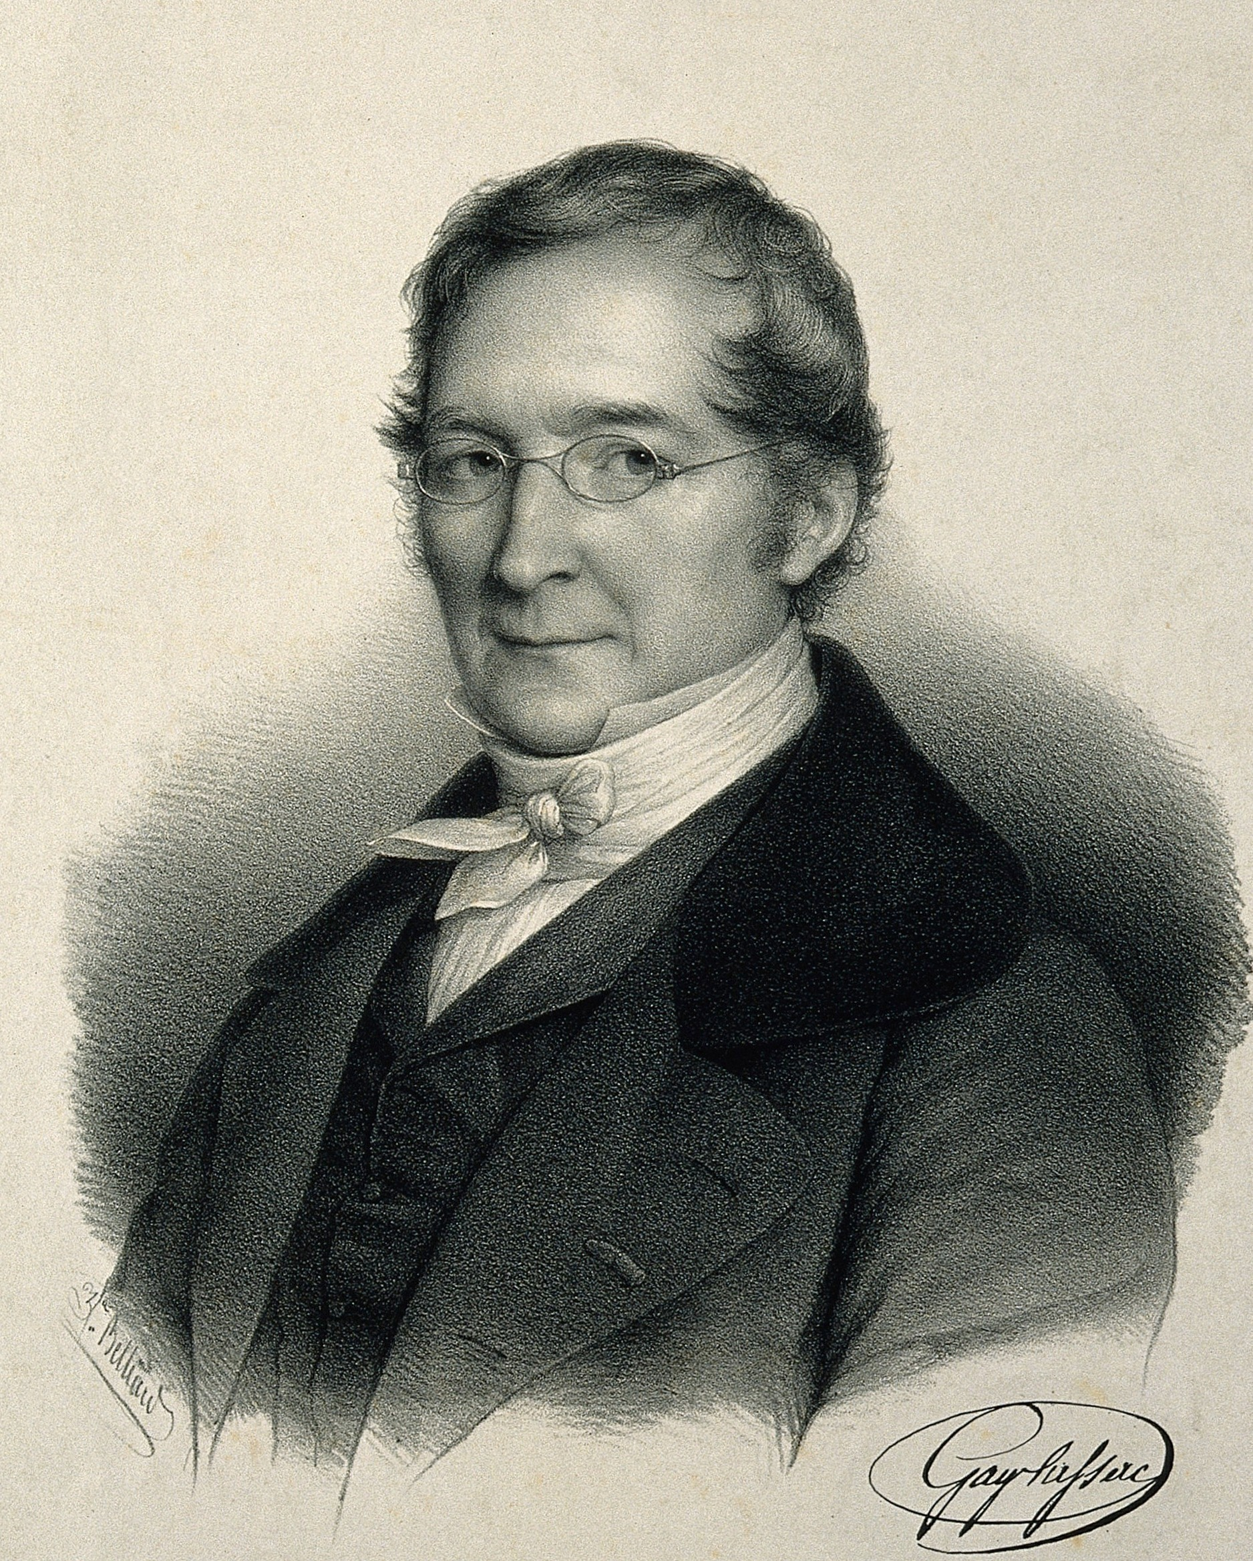
Historically, there were other scientists contemplating the idea of how particles combine at the simplest level; they also asked how hydrogen and oxygen combine to form water. One important scientist was Joseph Louis Gay-Lussac (Key Question 6), who was born in 1778 and studied at the Ecole Polytechnique in Paris, France. There, Gay-Lussac investigated the expansion of gases with changes in temperature, a study that he published in 1802. In 1808, he published a paper on combining volumes of gases. In this study, different mixtures of gases were combined in a device called a eudiometer. A spark caused a reaction during which some gases would combine to form new gases. When hydrogen and oxygen gases were combined, Gay-Lussac found that the combining ratio of hydrogen to oxygen was extremely close to two-to-one (H₂O) (when both were at the same temperature and pressure). This made him wonder whether there is a whole-number relationship in the combining volumes of all gases. After looking at others’ experimental results, he consistently found that the volume ratios in gaseous reactions are whole numbers.
Key Question 6: What do you remember about this scientist?

Here’s where Dalton comes back into the story:
“The law of combining volumes was well received in some quarters but not in others. [Other scientists] used it in determining such formulas as H₂O for water and NH₃ for ammonia. Dalton was so vigorously opposed to it that he never admitted its validity. He recalculated some of Gay-Lussac’s ratio and accused the French chemist of rounding off figures when it suited his purpose. It is true that Gay-Lussac did so on occasion, but he made no effort to hide the fact. His paper mentioned cases in which the volume ratio are close to whole numbers and suggested that better analyses and density values would definitely show that they were whole numbers” (Ihde 1964, p. 118).
The implications of Gay-Lussac’s law of combining volumes suggest that equal volumes of different gases contain the same number of particles. Below is a simple representation of what Gay-Lussac believed hydrogen looks like at the simplest level. In the second box, draw what you believe Gay-Lussac thought oxygen would look like.
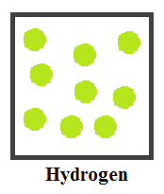

Similar to Gay-Lussac, Dalton had at one time examined the idea that equal volumes of different gases contained equal numbers of particles (remember his first option), but he could not figure out how this related to the known density of gases (Key Question 7). Dalton knew that the density of water vapor is less than that of oxygen. But if Gay-Lussac were correct, a gas whose particles consisted of atoms of hydrogen and oxygen would have to be more dense than atoms of only oxygen. It is well documented that water vapor is less dense than oxygen gases. Therefore, Dalton rejected Gay-Lussac’s law. He held on to the idea that particles of a compound gas would occupy a greater volume than particles of an elemental gas, and therefore the concept that equal volumes contain an equal number of particles could not be valid.
Now back to Gay-Lussac. He had experimental evidence that illustrated that two volumes of hydrogen gas react with one volume of oxygen gas to produce water. The conclusion that two particles of hydrogen combin with one particle of oxygen to form water works only if we assume that each volume of gas contains the same number of particles. Represent particles of hydrogen and oxygen in the containers below. React these particles to form water using the formula that Gay-Lussac believed, H₂O. Remember there can be no leftover particles of gas.
Key Question 7: What is density?

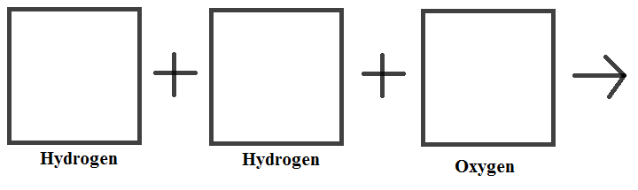

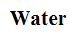

As a group, create a whiteboard or poster that summarizes the arguments that Dalton and Gay-Lussac gave to support their positions. Dalton believed that the chemical formula for water is HO, and Gay-Lussac believed that water is H₂O. We will then have a board meeting and take a quick poll on whose argument the class believes is supported by more evidence.

Reference
Ihde, A. (1964). The development of modern chemistry. New York, New York: Harper & Row.

Resources
Bowler, P., and I. Morus. 2005. Making modern science: A historical survey. Chicago: University of Chicago Press.
Bryson, B. 2003. A short history of nearly everything. New York: Broadway Books.

