Landscape Drawing
Artists use many different techniques to create the illusion of space in a landscape drawing. Some of the techniques included are:
Foreground- objects closest to the viewer, in the front of the composition
Middle ground- objects in the middle of the composition
Background- objects farthest from the viewer, in the back of the composition
Horizon line- where the sky meets the land, also known as eye level
Size- objects are larger in front and get smaller as they go back in space
Placement- objects closer to the viewer are lower on the composition; objects farther away are higher on the composition/ closer to the horizon line
Overlapping- objects in the foreground overlap objects in the background
Atmospheric perspective- a gradual decrease in intensity of color, and less contrast of value, as space recedes into the far distance in a landscape. Often, this far distance will be represented by a light, cool, bluish-gray (also known as aerial perspective).

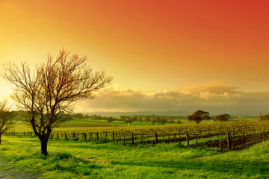
In this traditional landscape, the artist follows the above mentioned techniques to create a realistic illusion of space and depth.

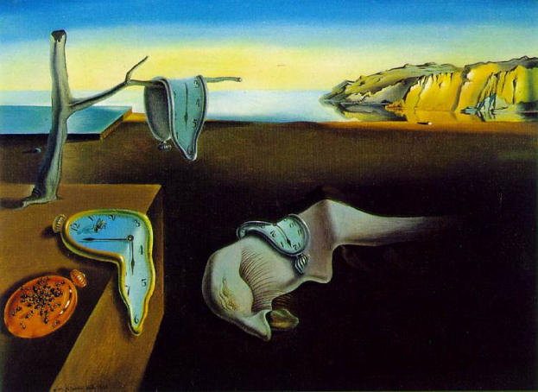
In this surreal landscape, Dali uses the above mentioned techniques to create an accurate sense of space and depth but he adds surreal happenings and objects which occupy the real space.

In your landscape drawing you must include the following:

- SPATIAL ILLUSIONS: size, overlapping, and placement
- SPATIAL PLANES: including obvious foreground, middle ground, and background
- One of the structural molecules that the chemistry student introduced to you either in the skeleton structure, Lewis structure, ball and stick structure, or 3D structure. The molecule should appear in your landscape where the actual molecule would exist.
- Value shading including at least six or more shades in the value scale.

