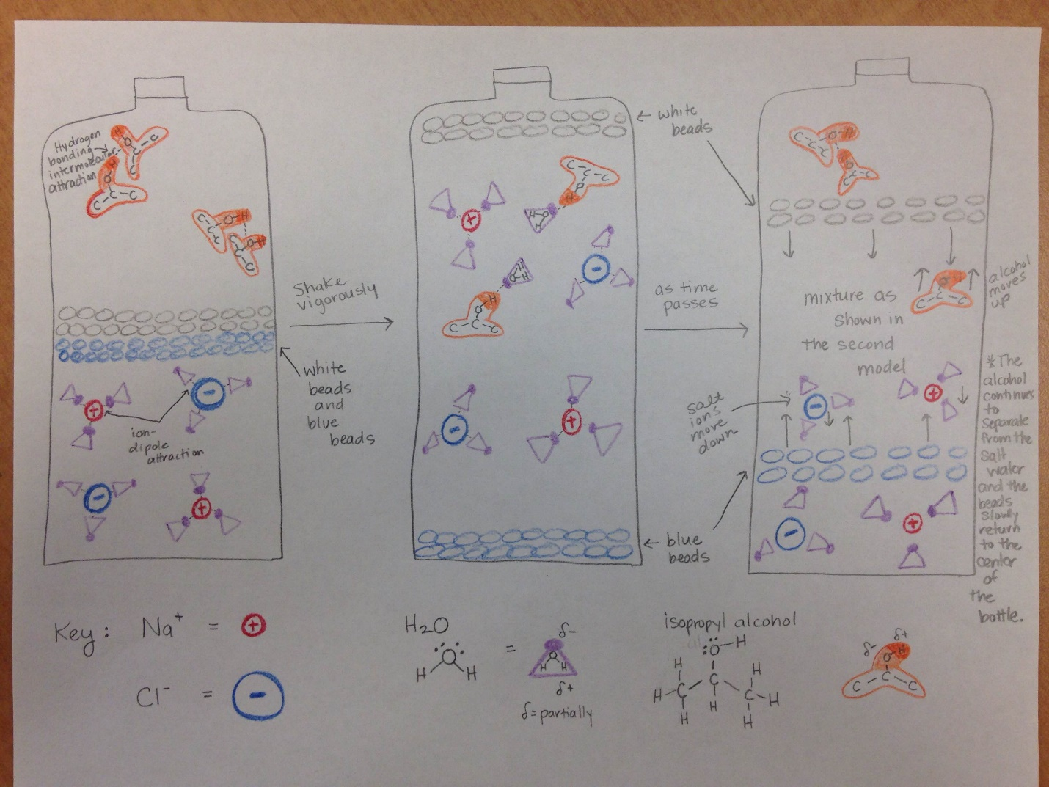

Final Teacher Model
Observations: The system starts out with the beads and liquid layers arranged as shown in the left hand drawing. When the bottle is shaken, the liquids and blue and white beads mix as expected. Then the beads separate, white at the top and blue at the bottom, as shown in the middle drawing. Finally, the two separated colored beads slowly come together and they move to the center of the liquid, as shown in the right hand drawing, thus restoring the original conditions.
Explanation: When I began thinking about how to draw a particulate level model of the Poly-Density bottle, I first thought about making a key for each of my molecules/ions that would show the polarity/charge of the substances. Sodium chloride is an ionic compound that dissociates into positive and negative ions as it dissolves in water. I represented the sodium ion as a red circle with a plus sign and the chloride ion as a blue circle with a minus sign. Water is a molecular substance with a bent geometry which contributes to making the water molecule polar. I represented water with a purple triangle with a purple shaded circle at one point to represent the oxygen side. Since the water molecule is polar, it has partially positive and negative ends. Oxygen is more electronegative than hydrogen so the electron density is pulled towards the oxygen making the oxygen end of the water molecule partially negative and the hydrogen end partially positive. Lastly, I represented isopropyl alcohol using orange, and I shaded the –O—H group of the alcohol to highlight the polarity of that bond.
I drew three separate models in order to explain the demonstration. In the first model (left), I show the bottle before any shaking occurs. In this model, the water molecules are attracted to the ions of sodium and chloride through an ion-dipole attractive force. The partially positive hydrogen end of the water molecule is oriented towards the negative chloride ion and the partially negative oxygen end of the water molecule is oriented towards the positive sodium ion. This process is called hydration and occurs when ionic compounds dissolve in water. The salt water solution is at the bottom of the bottle because it has a greater density than both the white and blue the beads and the isopropyl alcohol. The less dense isopropyl alcohol is at the top of the bottle and I showed how the –O—H dipole of one alcohol molecule is attracted to the –O—H dipole in another alcohol molecule through a hydrogen bond attractive force.
The second model (middle) represents the contents after the bottle is shaken. The white beads go to the top of the bottle and the blue beads sink to the bottom as the alcohol, salt and water are mixed to produce a temporarily middle layer of salt, water, and alcohol that is more dense than the white beads and less dense than the blue beads. In this mixture, I show the attraction between the water and the alcohol dipoles. This attraction is a hydrogen bonding attractive force. The last model (right) shows the contents as time passes and the bottle sits. During this time, the white beads begin to sink and the blue beads begin to rise as the “salting out” process occurs. The alcohol separates out from the salt water mixtures because the attractive ion-dipole force between the ions and the dipole of water is greater than the hydrogen bonding attractive force between water and alcohol. In order for particles to mix, they must interact through an attractive force. The stronger the attractive force, the more soluble the substances will be.
Note that similar models can be used to explain the students’ observations using water, isopropyl alcohol, salt, and green food coloring (Figure 2.)

