Derivation of Balance Board Equation

Method 1. Thought experiment using algebra basics
- What proportion of the weight is directly over scale #1? Scale #2? (Ans.: Scale #1 = 100%, Scale #2 = 0) Note: Teacher could mark measurement arm on each scale’s face.
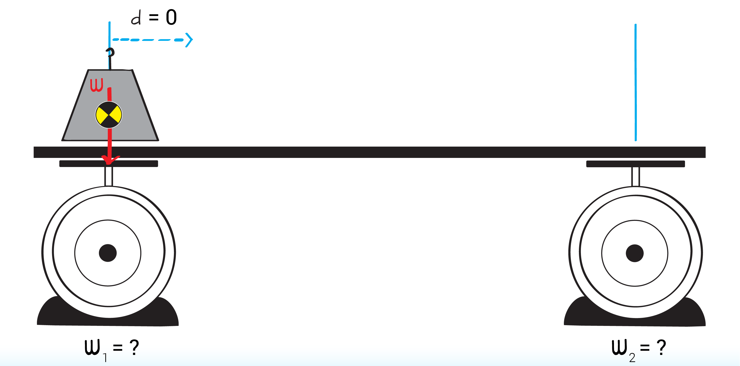

- What if the weight is placed over scale #2? (Ans.: Scale #1 = 0, Scale #2 = 100%)\
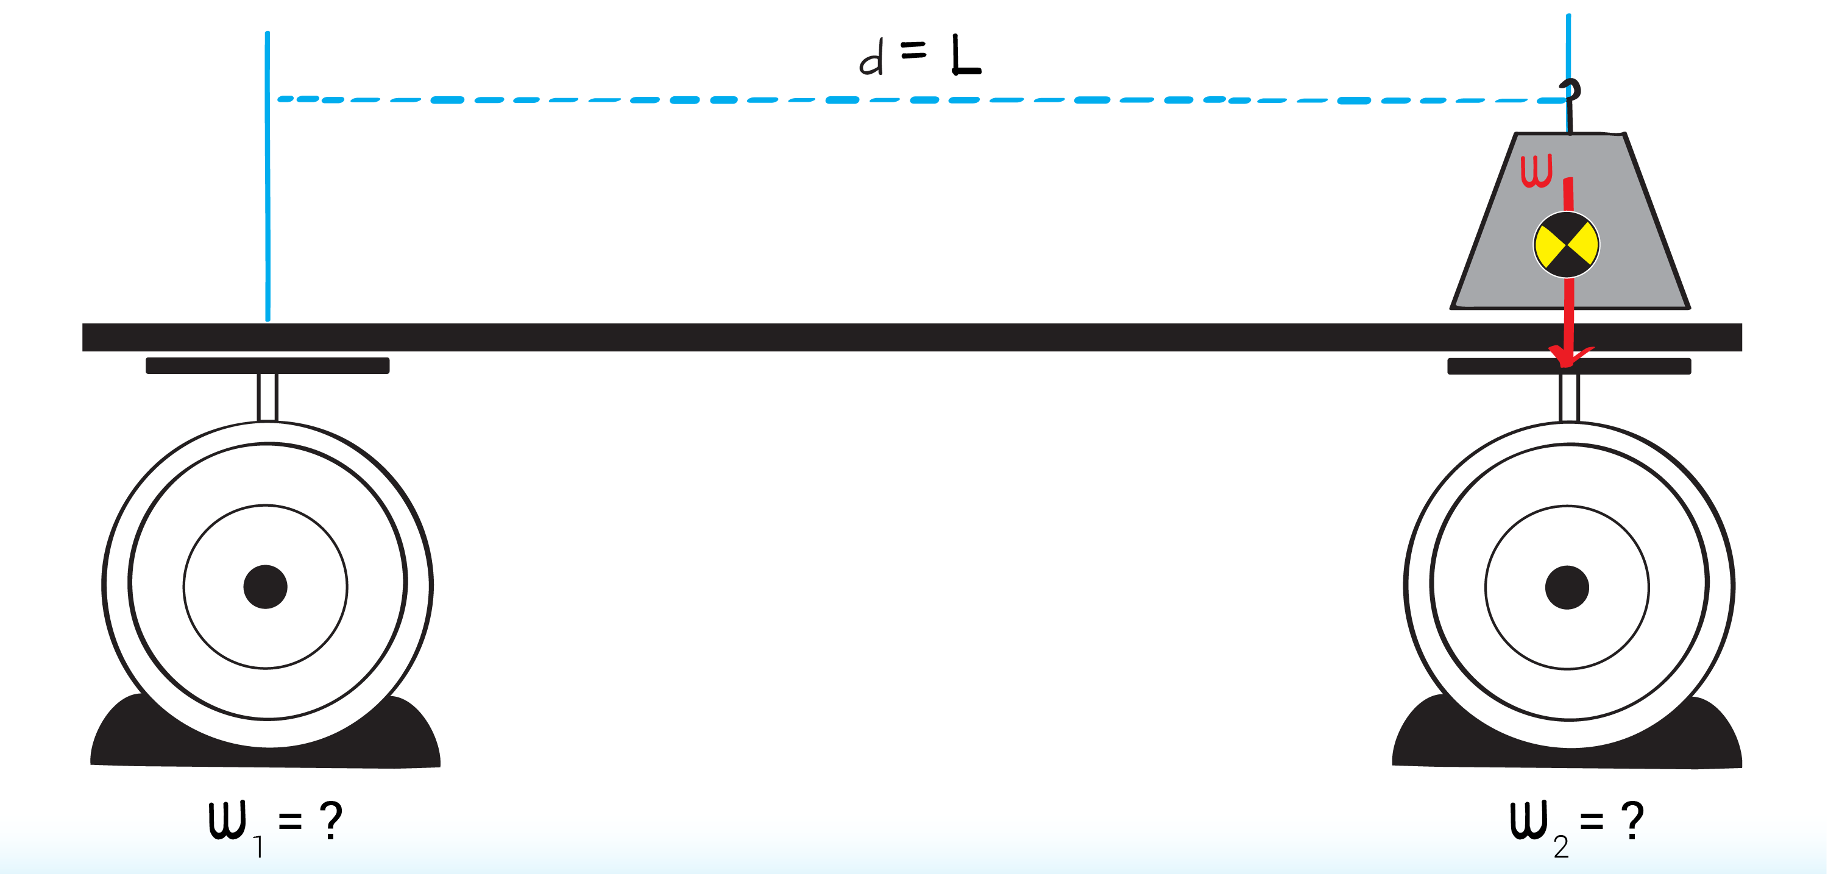

- What if the weight is placed half way between scale #1 and scale #2? (Ans.: 50% on each scale)
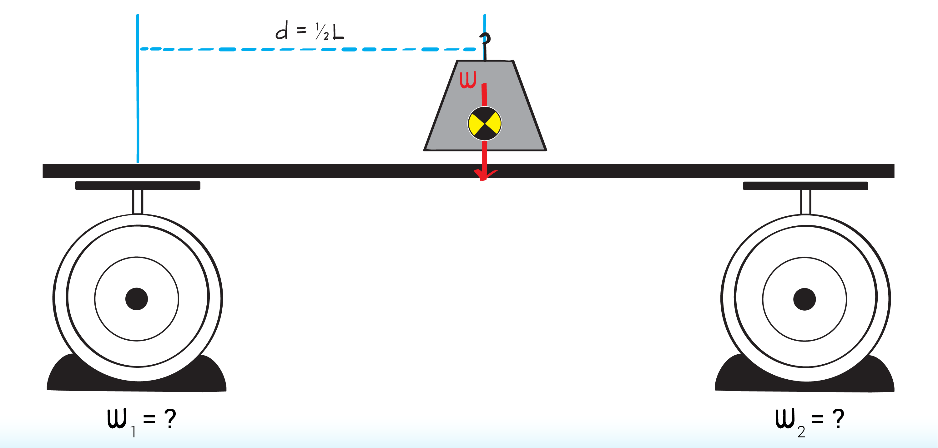

- How about if the weight is placed slightly closer to the first scale? (Ans.: 66% on scale #1 and 33% on scale #2)
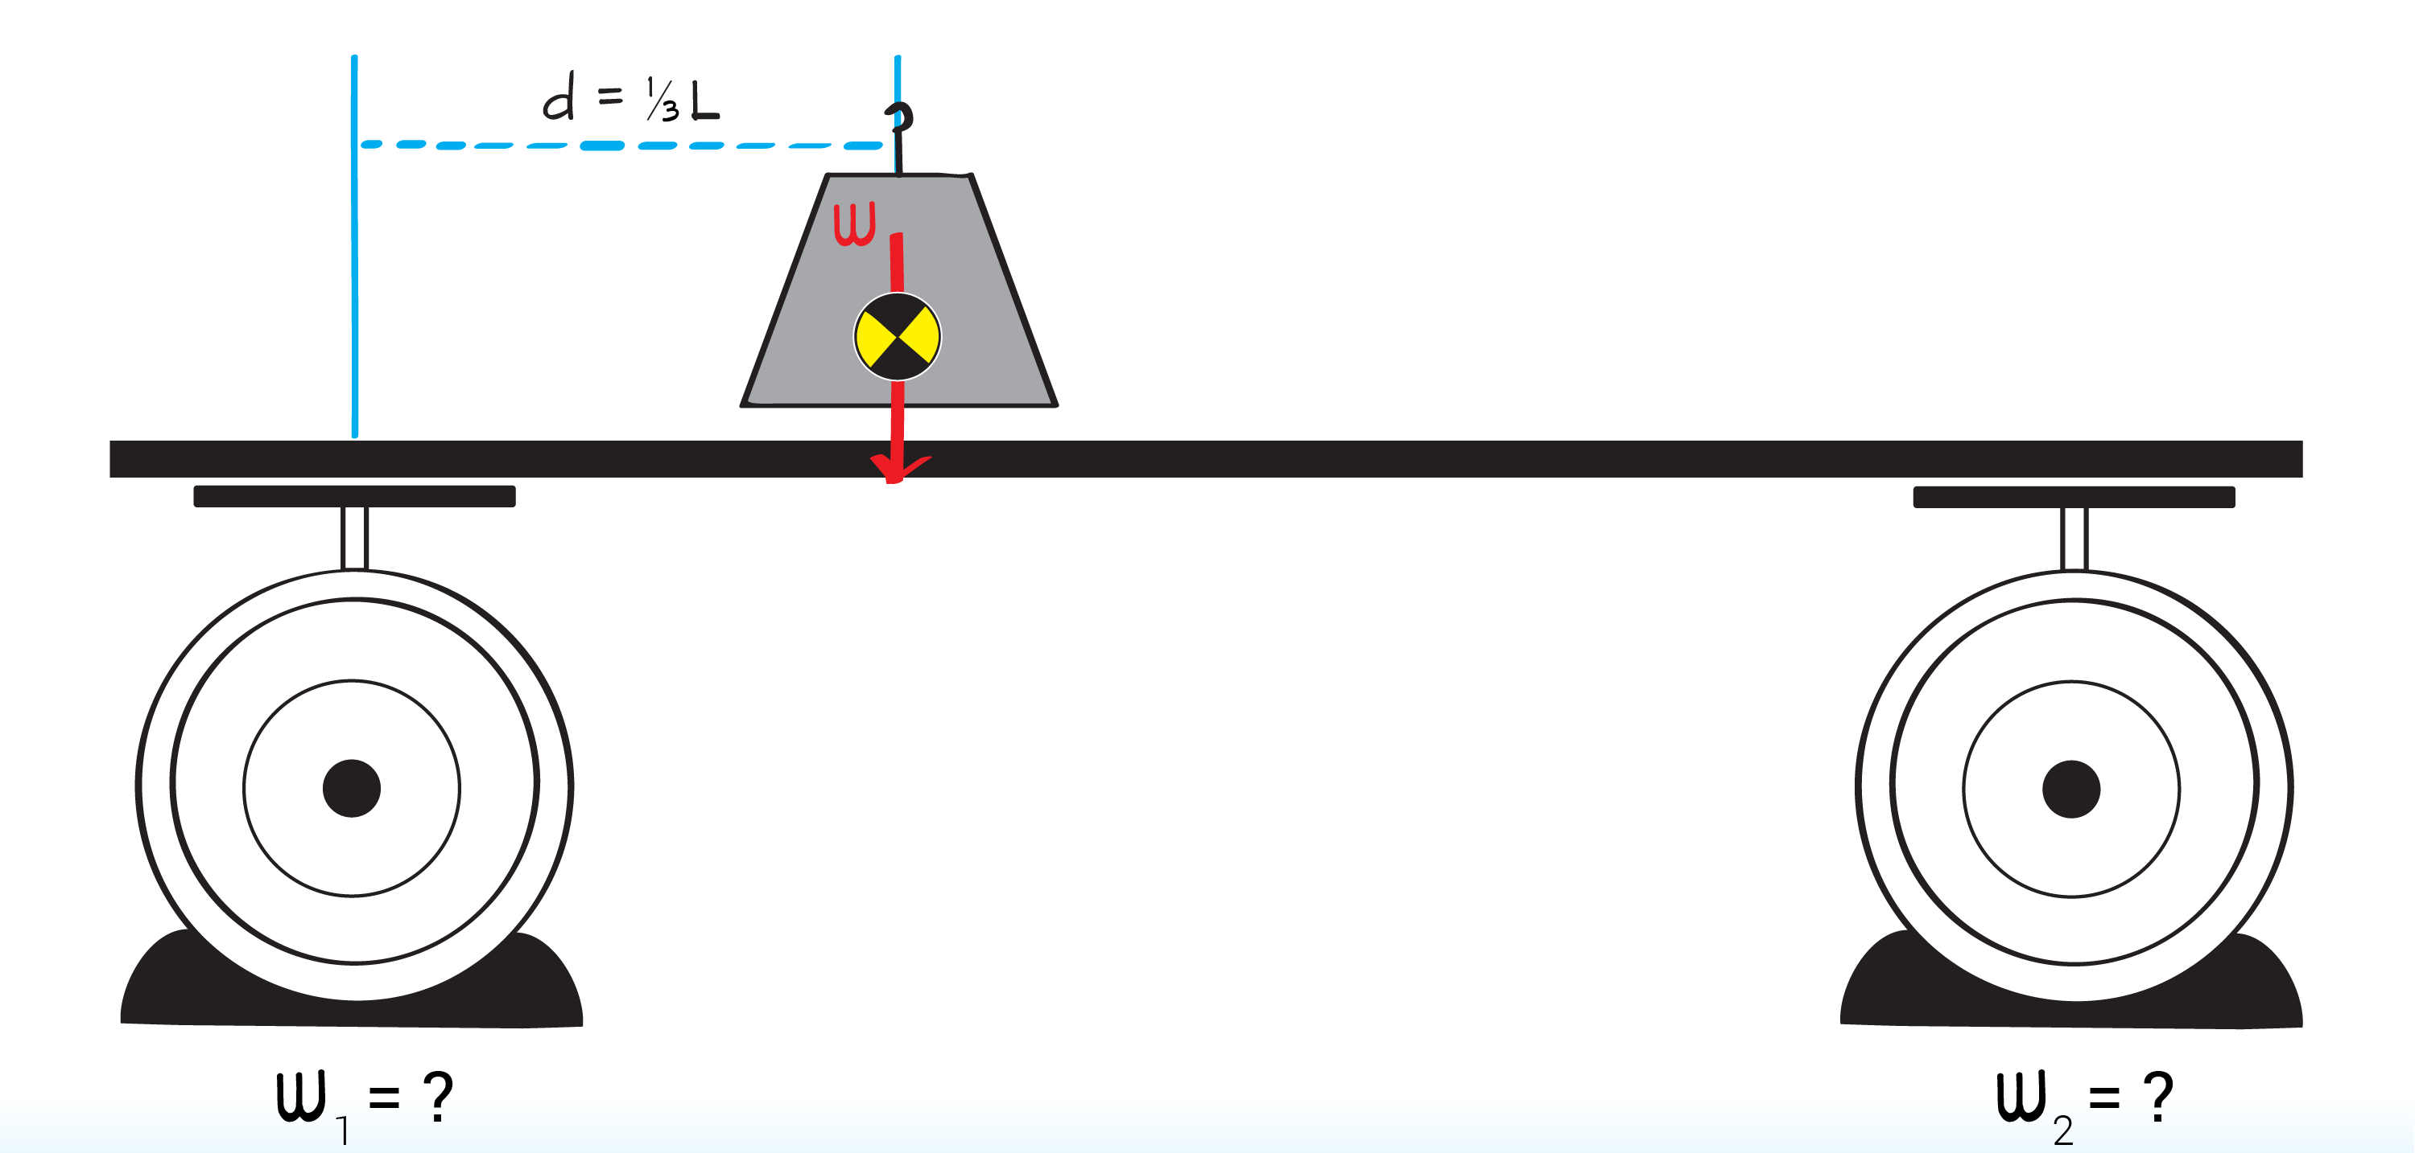

- How about if the weight is placer closer to scale #2? (Ans: 25% on scale #1, 75% on scale #2)
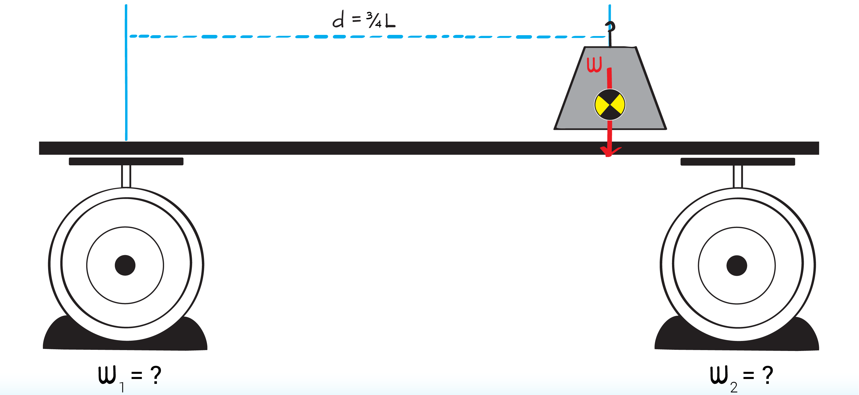

- Using this information, we can derive a mathematical relationship among the variables in this system.
d | W₁ | W₂
0 | W | 0
L | 0 | W
½ L | ½ W | ½ W
¹/₃ L | ²/₃ W | ¹/₃ W
¾ L | ¼ W | ¾ W
Sum of the readings on the scale is equal to the total weight: W = W₁ + W₂

- The reading on scale #2 is directly proportional to COM location: W₂ = a.d
For example, ½ W = a . ½ L and ¾ W = a . ¾ L
So if a = W/ L, then W₂ = (W/L) . d

d | W₁ | W₂
0 | W | 0
L | 0 | W
½ L | ½ W | ½ W
¹/₃ L | ²/₃ W | ¹/₃ W
¾ L | ¼ W | ¾ W

- Using the two equations, W = W₁ + W₂ and W₂ = (W/L) . d, we can substitute the first into the second to get: W₂ = (W₁ + W₂) . d/L and using algebraic reasoning to solve for d, we get: $d=\frac{W_{2}}{W_{1}+W_{2}}L$

- Using this equation, we can solve for COM location, d, knowing only W₁, W₂, and L.
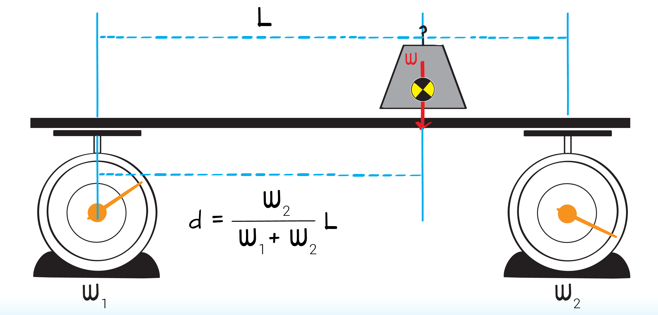

Method 2. Equation derivation
- When an object of unknown weight, W, is placed on the balance board, we can measure its position, d.
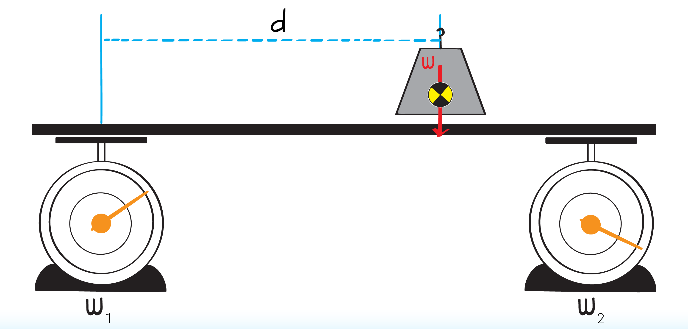

- Draw a free body diagram of the balance board.
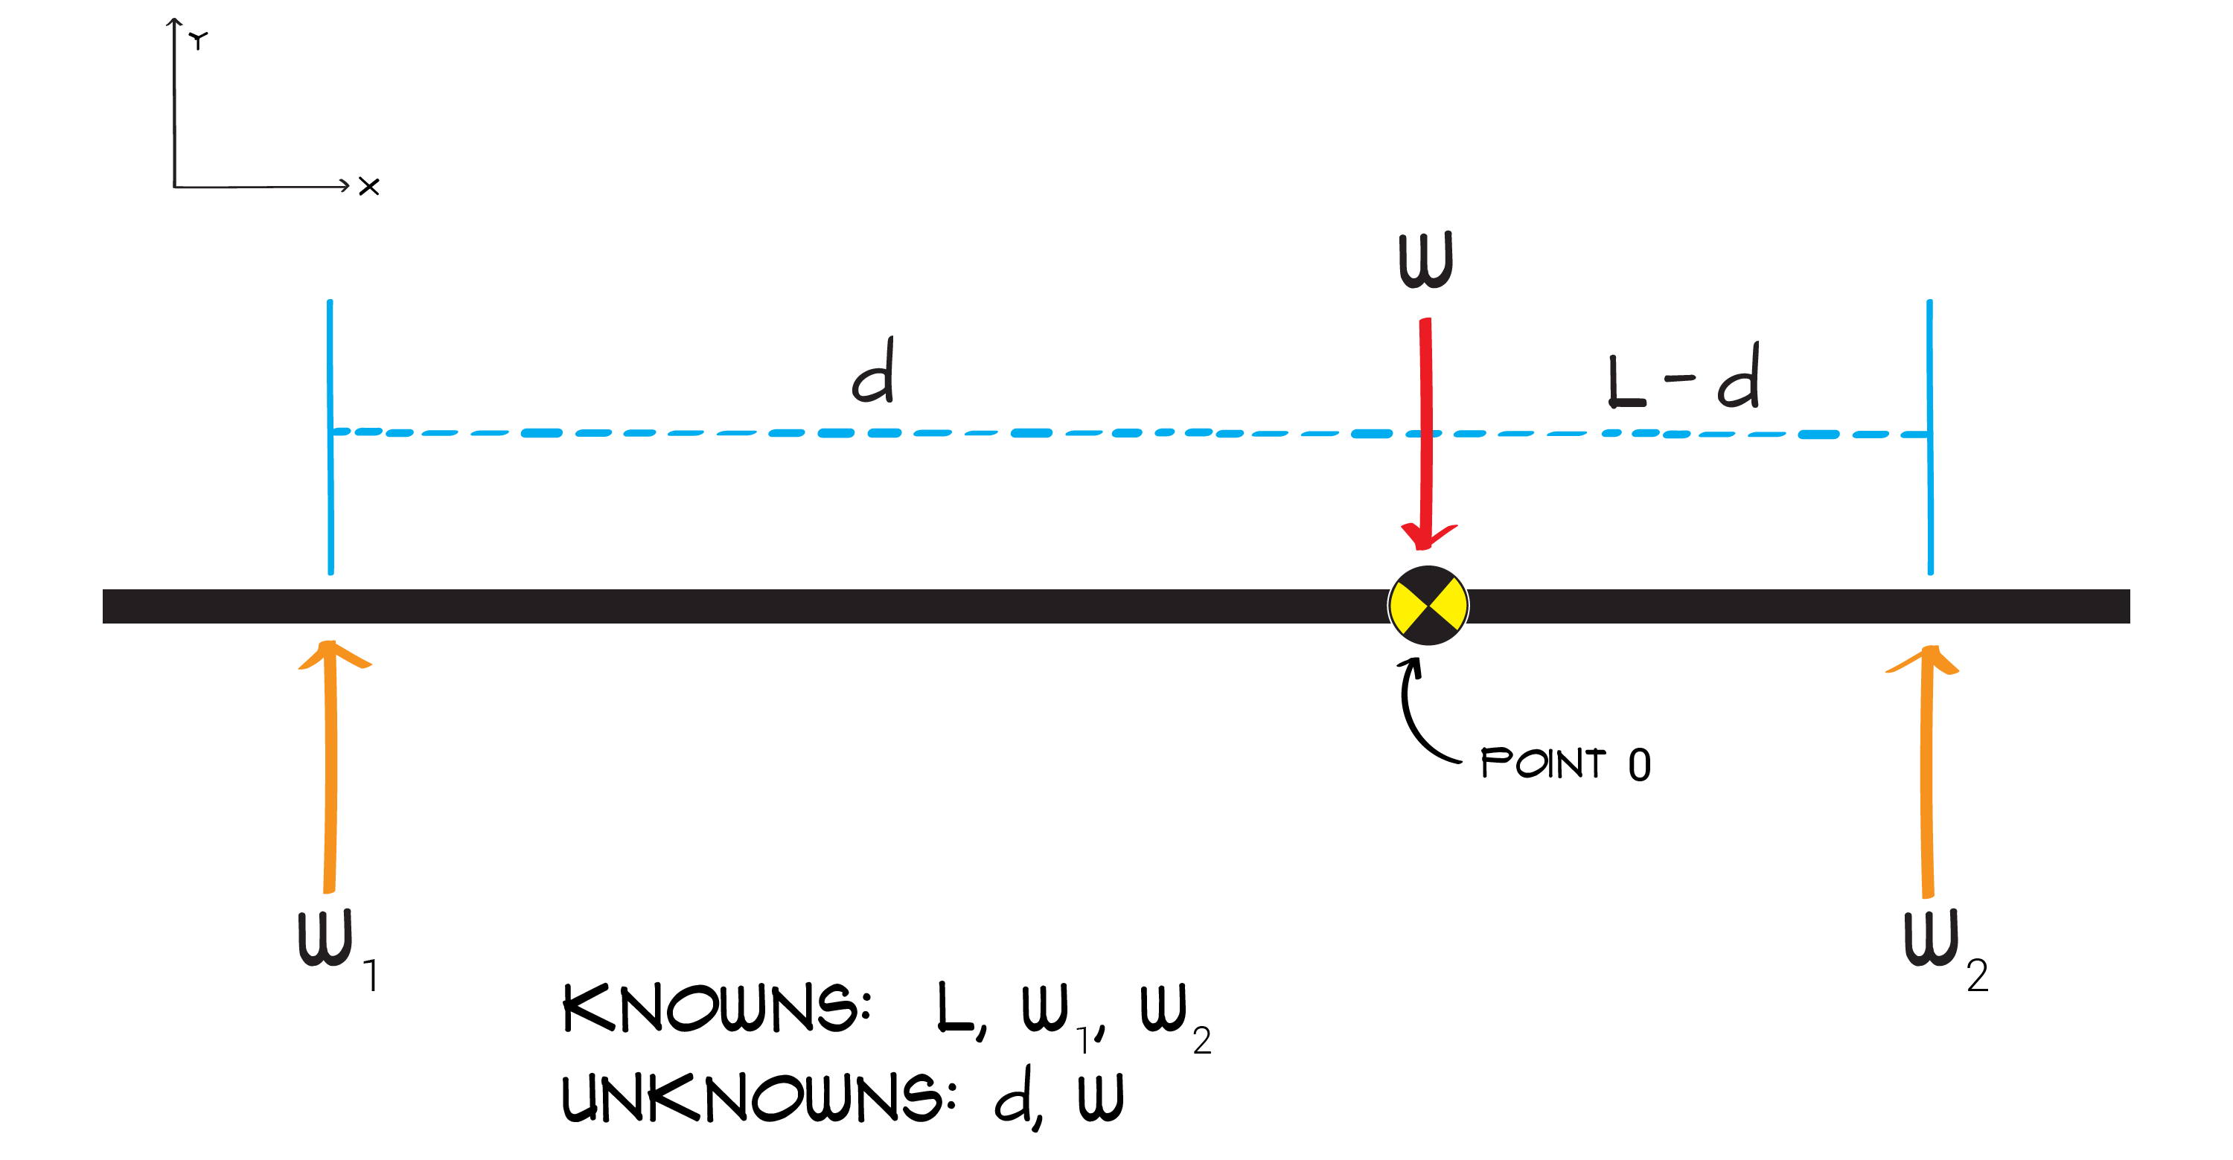

- Write out equations of equilibrium.
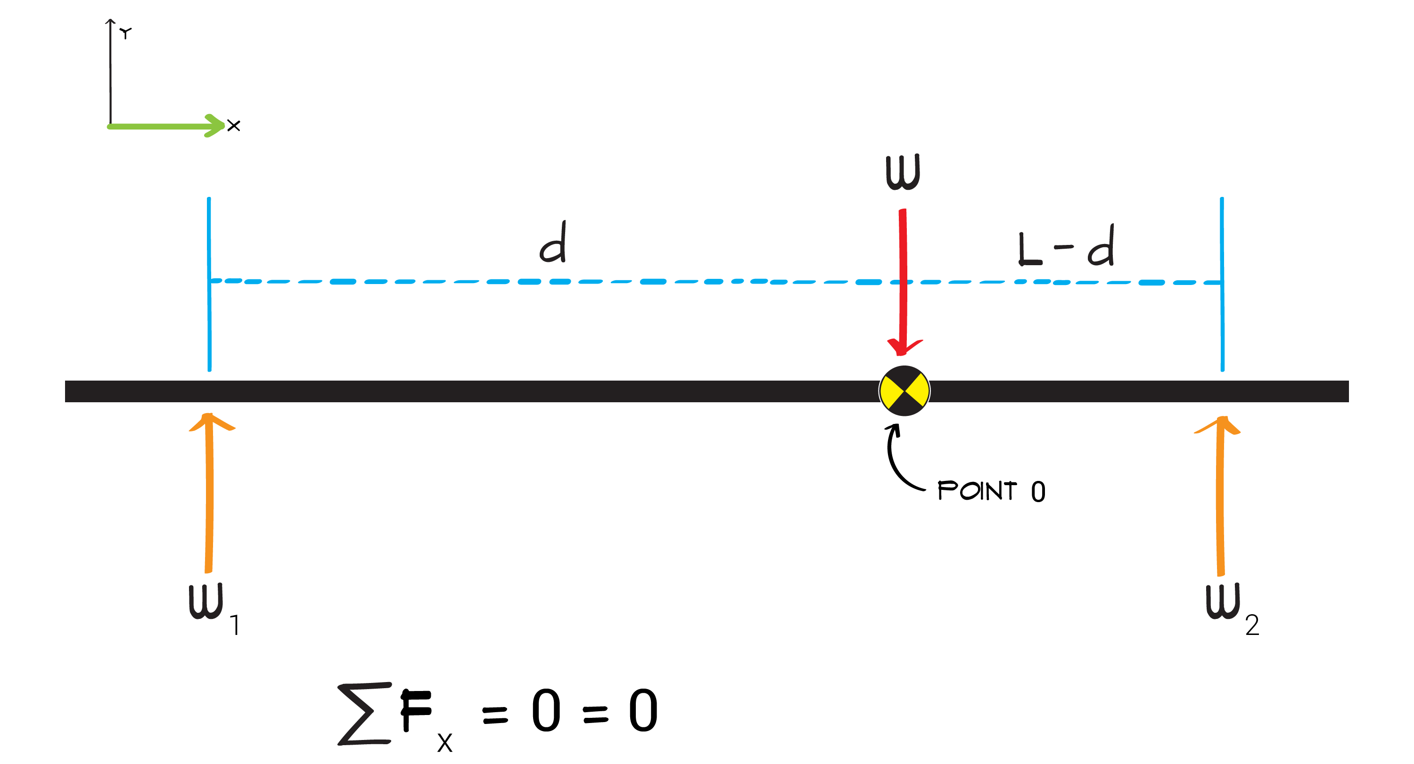

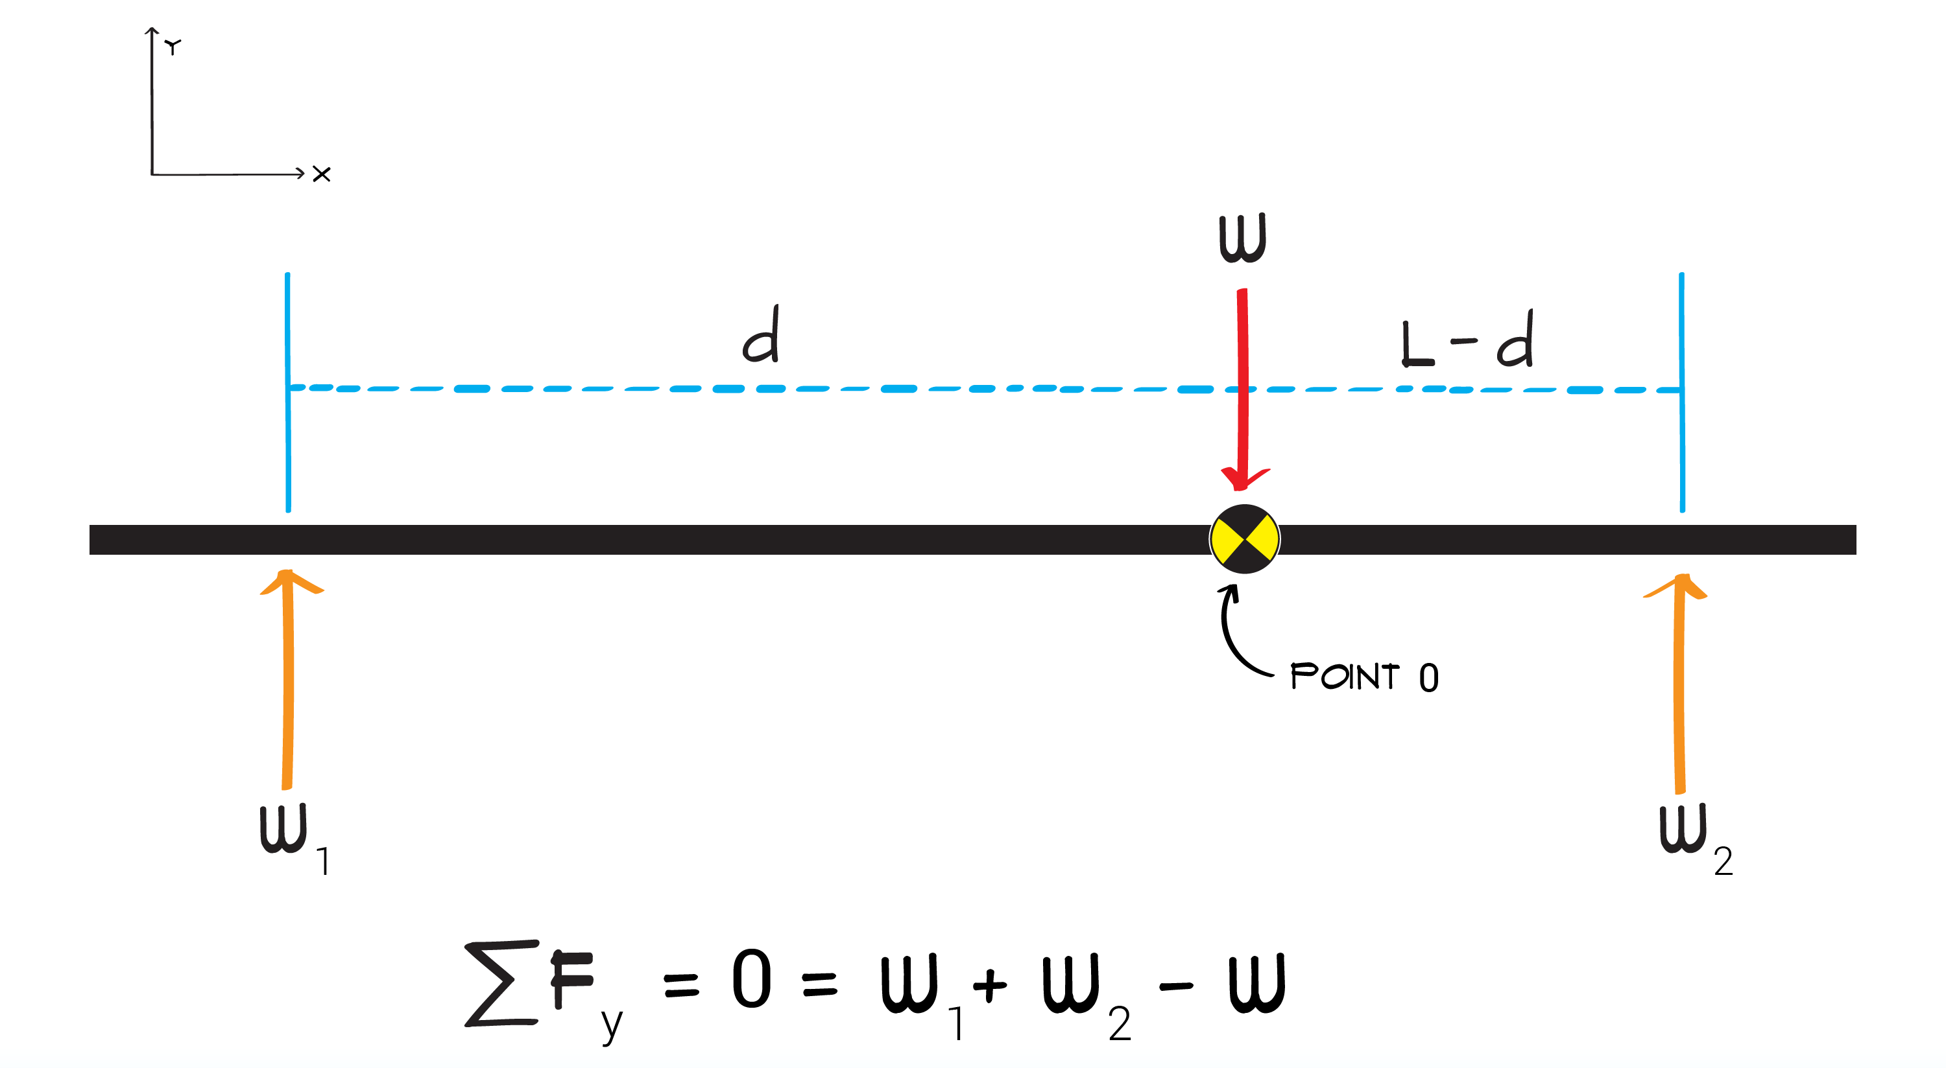

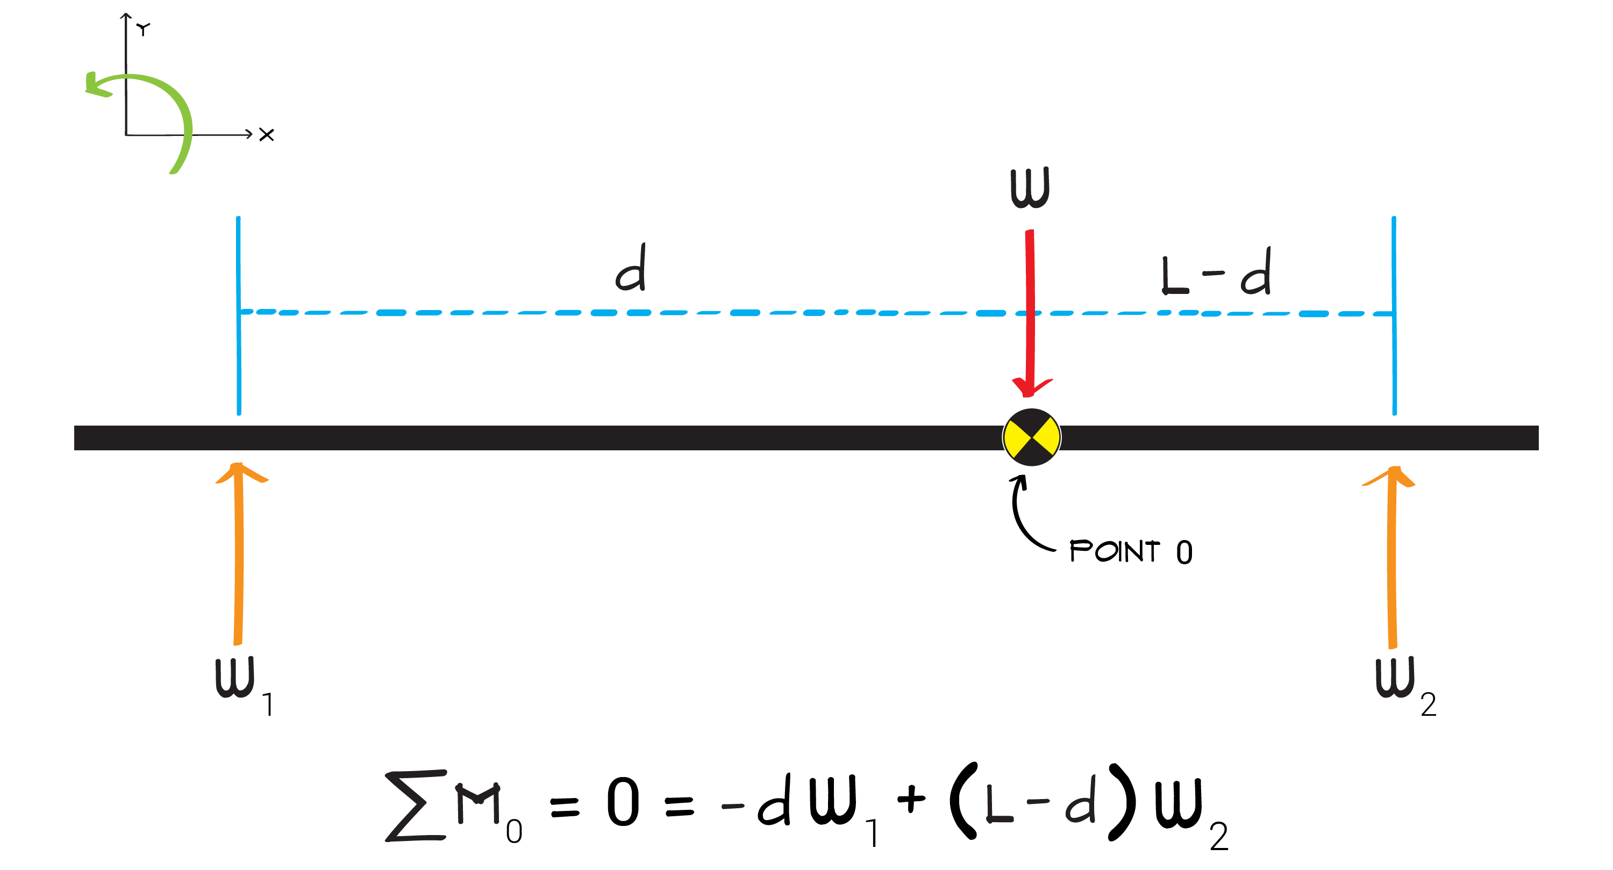

- Solve the equations of equilibrium for the unknowns, d and W.
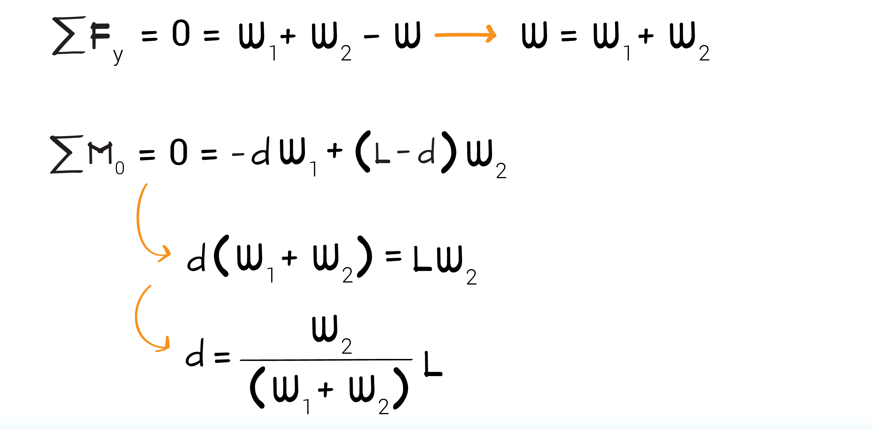

- Using this equation, we can solve for COM location, d, knowing only W₁, W₂, and L.

