If Only These Bones Could Talk
by
Ashley E. Rhodes
Division of Biology
Kansas State University, Manhattan, KS
It had been an unusually cold, dry, and prolonged winter. Forage for wildlife had disappeared months ago as the severe summer drought extended into fall and winter. The harsh wind blowing over the landscape highlighted the absence of sustenance with each gust revealing continuous batches of dried seed hulls and deeply cracked earth. Adding to the harshness was the intense light of the winter sun which seemed to shine a spotlight on the lack of familiar winter sounds... no birds calling, no squirrels scolding me as I walked by, and no deer rustling through the tall grass of the native prairie.

As I continued walking along the familiar, albeit eerily quiet path with my dogs, something instantly caught their attention. My scent-driven Labrador Retriever took a hard right and bounded over to a pile of bones, likely revealed by the drought and unrelenting winter winds. Approaching the remains to retrieve my Retriever, something caught my eye. Sticking out of the dried, crusted earth was a jumbled collection of bones. They were large bones, too large to be from a burrowing mammal or migrating bird. Given the numbers of white-tailed deer that used to roam this area, I wondered if the bone was a left-over from a herd mate that was unable to keep up. After my Labrador dug up part of a hoof nearby my hunch was confirmed.

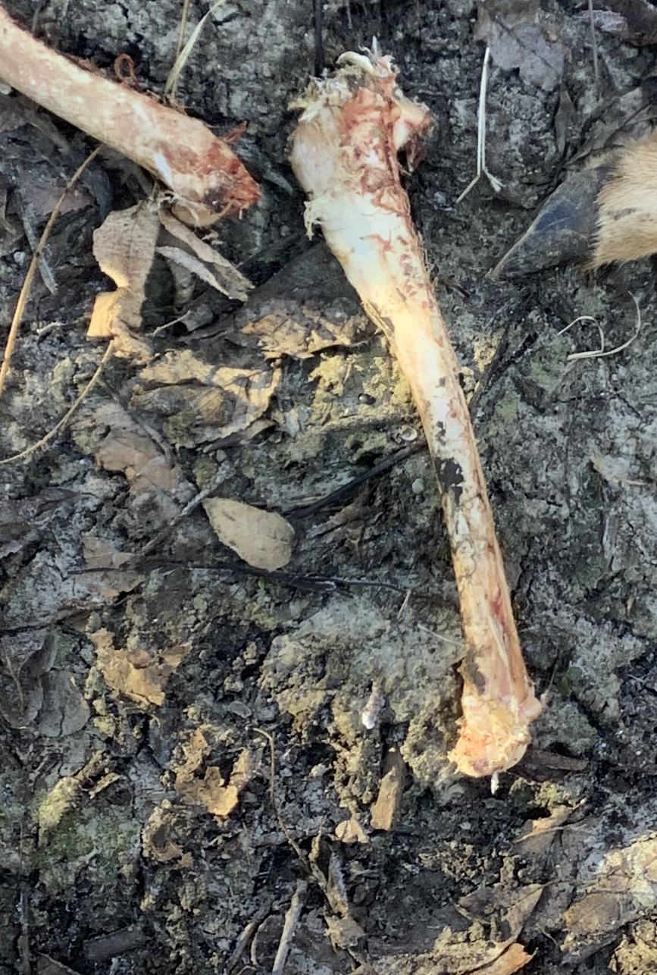
With a little more investigating and the help of my canine companions, I soon discovered more leg bones and an intact hoof from an artiodactyl. With these remains it became clear the bones belonged to an adult deer. But what would have led to its demise? Furthermore, how old was this animal and what challenges did it face during its life? Was this another victim of the drought? Without any organs or soft tissue left, few clues remained to solve the mystery. Could the leg bones be of any use given their freeze-dried status which had made them too difficult for even the wiliest of coyotes to crack open and eat? To the delight of my dogs, I collected some of these leg bones and carried them back with us for further investigation.
Figure 1. Fresh deer bones. The upper right-hand corner reveals a hoof in the leaf litter.
Discussion Question 1: Can bones provide clues about how an animal lived? Hypothesize what particular bone tissue components could reveal about an animal’s life or even cause of death.
The next day I selected the largest of the leg bones, a femur I believed, and took it to a colleague who was a vertebrate physiologist at the university where I worked. Upon cutting into the still-frozen bone with a powerful bone saw, making a cross section along the mid-sagittal plane, we saw the following:

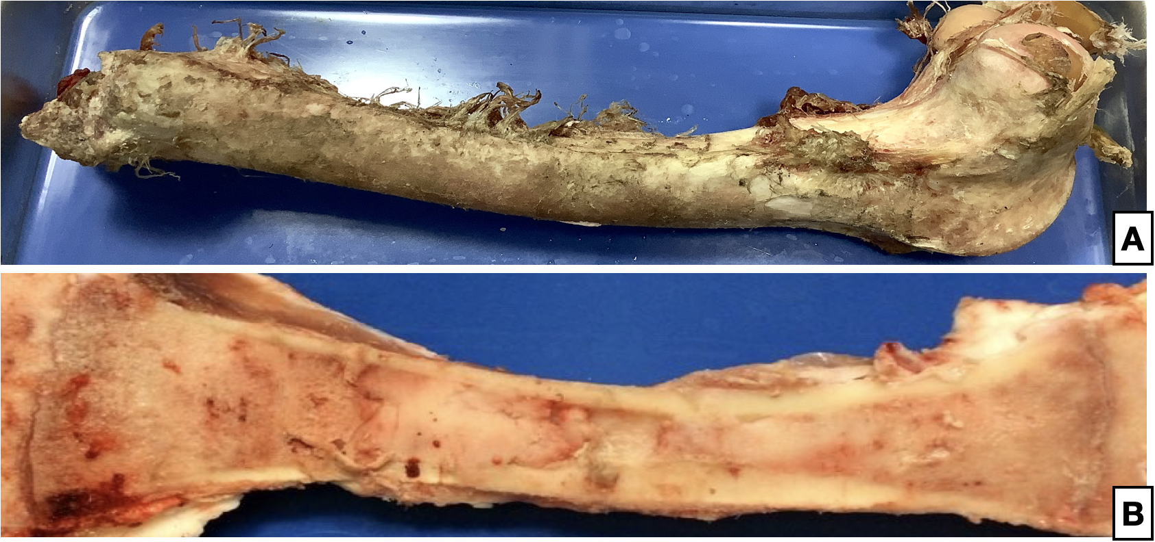
Figure 2. Panel A shows gross anatomical details of a deer femur. Panel B reveals inner details of the bone.

Activity 1

A. Identify the following on Panel B in Figure 2:

- Epiphyses, diaphysis, and metaphyses
- Examples of compact and spongy bone
- Epiphyseal plate or remnants of this plate
- Medullary cavity
- Areas & types of bone marrow present

B. After examining and labeling Figure 2, what clues are revealed about the animal? Can you make a rough estimate about this animal’s age? What clues exist? What about its nutritional plane? Is it possible to see evidence of disease from a sample like this?
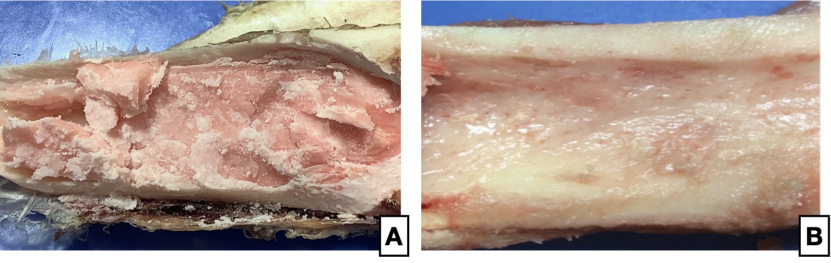
Once the specimen fully thawed, my colleague and I noticed some oddities about the cross-sectioned femur as we inspected it more closely. For starters, the medullary cavity had pockets where bone marrow was absent or was an unusual consistency. In fact, the bone marrow was watery and gelatinous instead of a typical waxy texture. The images below highlight differences between marrow from a healthy animal and from an unhealthy animal.
Figure 3. Comparison of healthy marrow (A) depicting a typical waxy texture with unhealthy marrow (B) depicting the watery, gelatinous texture. Both images show the same area within a diaphysis from similarly aged animals.

This was an unexpected finding for sure, and not something that is normally seen in healthy animals. My physiologist friend explained that bone marrow of this consistency usually indicates prolonged starvation but not necessarily malnourishment. Given the extremely tough environmental conditions lately this seemed like a possibility to me.

Discussion Question 2: What is the difference between malnourishment and starvation? Can an animal have access to and consume an adequate number of calories yet still be malnourished?

I began to wonder how starvation could lead to changes in bone marrow or even in ossified bone tissue and if these changes could provide more in-depth clues about larger issues facing other deer in the region. Was this bone a sentinel of larger health issues in local herds? Should I be worried?

Digging deeper into the issue, I removed a small sample from the diaphysis of the femur making sure to get osseous tissue, both compact and spongy, from the rim of the medullary cavity. I specifically wanted to examine the trabeculae with a dissecting microscope. I removed most of the marrow from the medullary cavity so that I could see the structure of the trabeculae more closely although some marrow was left filling the spaces of trabeculae as it was difficult to remove. Figure 4 reveals what I found:

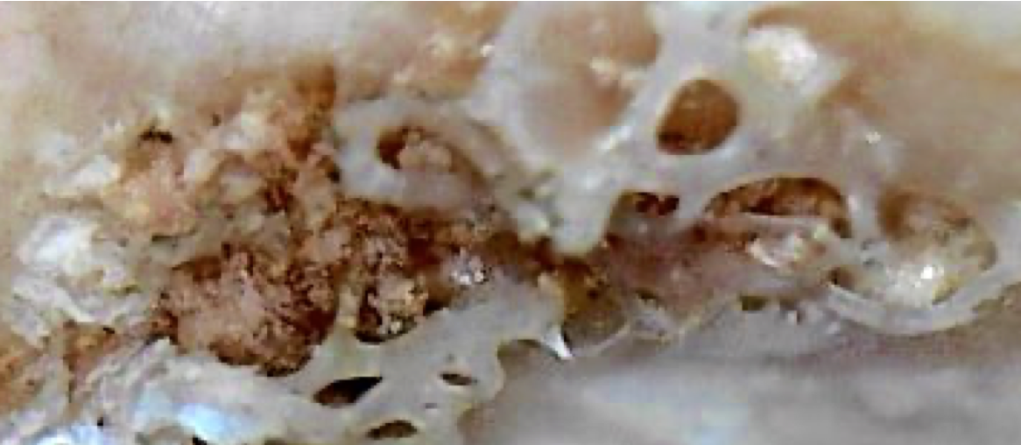
Figure 4. Details of spongy bone with marrow as seen with a dissecting scope.

Activity 2

Using Figure 4 above, identify the following regions and structures on the bone:

- Areas of compact or cortical bone
- Areas of spongy or cancellous bone comprised
- Trabeculae
- Bone marrow

To my surprise, some of the marrow was not only watery, but also had a red tinge to it, indicating that something was abnormal about the marrow of this adult animal. Before getting too carried away with the details of the marrow itself, however, I removed a small sample of bone from the rim of the medullary cavity and carefully cleaned and inspected the structure of the trabeculae to see if there were any obvious signs of disease. Sometimes chronic mineral deficiencies can be discovered by carefully examining the structure of trabeculae with a microscope and looking for thinned or shrunken trabeculae. In Figure 5 below, Panel A shows the details of trabeculae taken from my sample in the rim of the medullary cavity. Panel B shows idealized healthy trabeculae. Panel C depicts thinned trabeculae due to elevated bone degradation such as would occur with a chronic calcium deficiency.

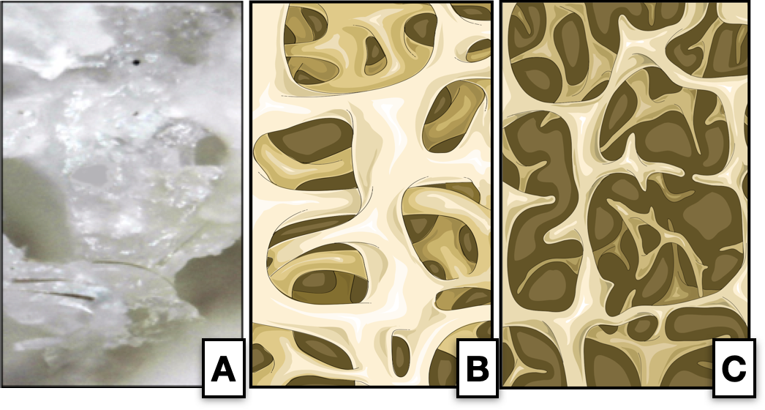
Figure 5. Panel A depicts trabeculae from the medullary cavity using a dissecting scope. Panels B and C are idealized pictures comparing healthy and unhealthy trabeculae, respectively. (Panels B and C by Laboratories Servier, CC BY-SA 3.0, https://commons.wikimedia.org/w/index.php?curid=82640931.)

In a healthy animal, trabeculae appear as robust columns or spicules of ossified tissue with an open, lattice-work organization that collectively makes them appear porous or spongy. Because of this structure, trabeculae have a lot of surface area compared to volume and this provides an ideal place for bone cells, stem cells, and blood vessels to reside. Additionally, the open spaces of trabeculae house bone marrow, which is created by stem cells clinging to the surface of trabeculae. The large surface area also makes it possible for bone deposition and bone degradation to occur relatively quickly, which is critical for maintaining blood calcium levels. In fact, spongy bone has the most “bio-available” areas of ossified tissue that can be used for blood calcium homeostasis. Thus, examining trabecular structure can reveal clues about an animal’s diet and if it had enough calcium. Because calcium is so critical for so many physiological processes such as muscle contraction and communication between neurons, a chronic lack of this mineral in the diet can be disastrous for animals. Could a careful examination of trabeculae provide the clue I was searching for? Was this animal and its herd mates suffering from hypocalcemia? Did its trabeculae resemble image B or C more closely?

To answer this question, I first had to refresh my memory about what healthy trabeculae should look like on a cellular level so that I would be able to correctly identify structural defects indicative of disease.

Discussion Question 3: Describe trabecular tissue. Identify the types of bone cells found in trabeculae and describe their functions.

Each trabecula (sing.) is a column of bone made from an amalgam of three different bone cells: osteocytes, osteoblasts, and osteoclasts. Comprising the actual bony tissue of a trabecula are osteocytes, which are mature cells. These cells live in a fluid-filled environment called lacunae and communicate via signaling molecules that travel through canaliculi, which are fluid-filled channels. On the surface of each trabecula are osteoblasts that produce and secrete soft osteoid in response to bone stress, damage, regular remodeling, or even elevated blood calcium. Osteoblasts have a unique ability to pull calcium and phosphorus from the blood and mineralize soft osteoid providing a hardened tissue and a sink for extra blood calcium. When activated, osteoblasts work in groups and form a mineralization front on the trabecular surface. Also on the trabecular surface are osteoclasts that degrade old and damaged bone. Osteoclasts can degrade healthy bone as well to liberate the calcium stored within should blood calcium levels drop. Activated osteoclasts are multinucleated and form small pits called Howship’s lacuna on the surface of trabeculae as they degrade the ossified bone. In healthy bone, osteoblast activity is carefully matched with osteoclast activity, which prevents either too much bone deposition or too much bone degradation from occurring.
Activity 3
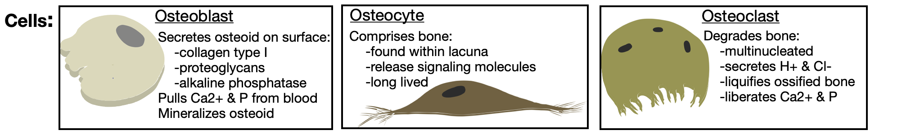
A. Carefully read the text description above and bone cell descriptions in the chart below. Then, using the cells provided in the chart, click and drag them into the space below to build a detailed depiction of the cellular construct of a trabecula in healthy bone. The cells can be resized and rotated as needed to depict the spatial relationships of the cells to each other.
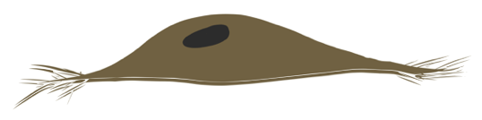

B. If this animal suffered from hypocalcemia due to a chronic lack of calcium in its diet, how would the structure of its trabeculae change? Use the cells provided above in the chart to construct a model by clicking and dragging them into the box below.

C. After observing the trabeculae from my sample (Figure 5, Panel A) and comparing it to two idealized images of trabeculae (Panels B and C), do you think the sample of trabeculae being studied was normal or indicative of an animal suffering from thinned trabeculae due to a chronic calcium deficiency (hypocalcemia)?

Having satisfied my curiosity about the bone specimen’s trabecular structure, my curiosity quickly turned to the odd consistency and color of the marrow. Something was definitely different here and if I was observant enough I might just find the clue I was looking for. But what exactly was it trying to tell me? If only this bone could talk.

While pondering details I should be noticing about this bone, I remembered attending a seminar years ago about wild ruminants and how analyzing bone marrow could provide insight about the health of the animal. I furiously started digging for my old seminar notes but only found a reference for Cheatum (1949). That. Was. It. 1949? This would not be the easiest article to find. Google Scholar was no help but thankfully our science librarian was. With what seemed like superhuman speed, our librarian quickly dug up the article and I was intrigued to find the following statements by Cheatum (1949):

- The bone marrow of a normal healthy adult animal is solid, white, and waxy due to the high fat content.
- In a state of malnutrition, the bone marrow is red, solid, and slightly fatty to the touch.
- In an advanced state of starvation, bone marrow is reduced in volume, red to yellow in color, gelatinous, glistening, and wet to the touch due to the high-water content.

Looking for more recent publications to verify, support, and advance the work of Cheatum (1949) I found the following statements that seemed to highlight clues I should be looking for:
- The amount of fat in femur marrow of ungulates in northern areas is used to indicate nutritional status although elevated levels do not always reflect good condition (Mech & Delguidance, 1985; LaJeunesse & Peterson, 1993)
- Low levels of fat in femur marrow reflect poor condition (Bishcoff, 1954; Kistner et al. 1980).
- Bone marrow fat is the last fat reserve used for energy by calorie-deprived animals during a state of emaciation; post-mortem, bone marrow fat has been quantified to help demonstrate ante-mortem body condition, especially when the whole carcass is unavailable (Raglus, et al. 2019)
- Adipocytes shrink and there is an atrophy of stem cells within bone marrow of starved animals; overall hypocellularity is common (Beeler-Marfisi et al., 2010)

Discussion Question 4: Given the clues far provided so far in this case study, what was likely the nutritional plane of this animal ante-mortem?

With these details fresh in my mind, I wondered if comparing a bone sample from a known healthy animal to my mystery bone sample would provide more clues about what direction my investigation should take next. The following image shows the comparison:

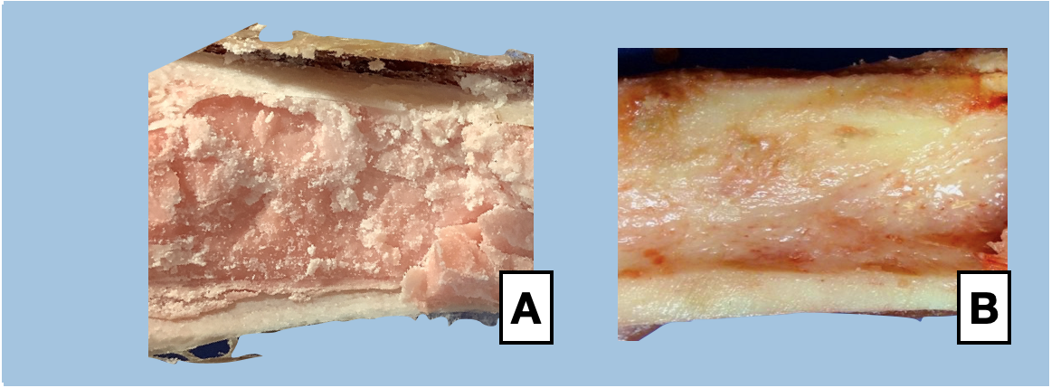
Figure 6. Differences in bone marrow composition and volume in a healthy animal (A) and a severely malnourished or starving animal (B).

While the comparison was convincing from a visual perspective, I wanted to dig a little deeper and systematically compare the bone marrow from these two samples. I was curious about the cellular differences between them and the broader implications these differences may have had on the physiology of the animals.

In my histology course I remember discussing the cellular composition of bone marrow and the cells responsible for producing it: hematopoeitc and mesenchymal stem cells. Hematopoietic stem cells (HSCs) give rise to erythrocytes, white blood cells such as neutrophils and lymphocytes, as well as megakaryocytes, which later become platelets. Mesenchymal stem cells (MSCs) give rise to a variety of cells such as adipocytes, osteoblasts, and fibroblasts. HSCs are very prevalent in all bone marrow at birth through the juvenile period. Because HSCs produce a lot of erythrocytes, all marrow appears red in juveniles, even in the medullary cavity of long bones. However, after puberty as the animal nears adulthood, HSCs are mostly found in bones like vertebrae and flat bones. These details can provide clues about the age of an animal. In contrast to HSCs, MSCs are active throughout life and their products far outnumber that of HSCs in an adult, especially in the medullary cavity of long bones. This is one reason why marrow within the medullary cavity of long bones from a healthy, adequately fed, adult animal should appear as a yellow, fatty, waxy substance. It truly is packed with adipocytes produced from MSCs.

Helping support, protect, and nourish MSCs and HSCs are trabeculae and a blood rich tissue called endosteum. Endosteum clings to the surface of trabeculae and is an amalgam of different structures and cells. For example, sinusoidal blood vessels made of fenestrated endothelial cells can be found here as well as reticular cells which provide support to the vessels. Stem cells like MSCs and HSCs are also found within the endosteum. Stem cells rely on sinusoidal blood vessels for nutrient delivery and the small openings or fenestrations of these sinusoidal vessels provide a mechanism for picking up stem cell products and distributing them to the rest of the body via the blood stream. Because stem cells often produce more products than are currently needed in the body, they often accumulate within spaces between trabeculae as well as within the medullary cavities of long bones. This is what forms marrow.

Figure 7 shows a comparison between red marrow, which would have a large proportion of active HSCs, and yellow marrow, which would have a large proportion of active MSCs.
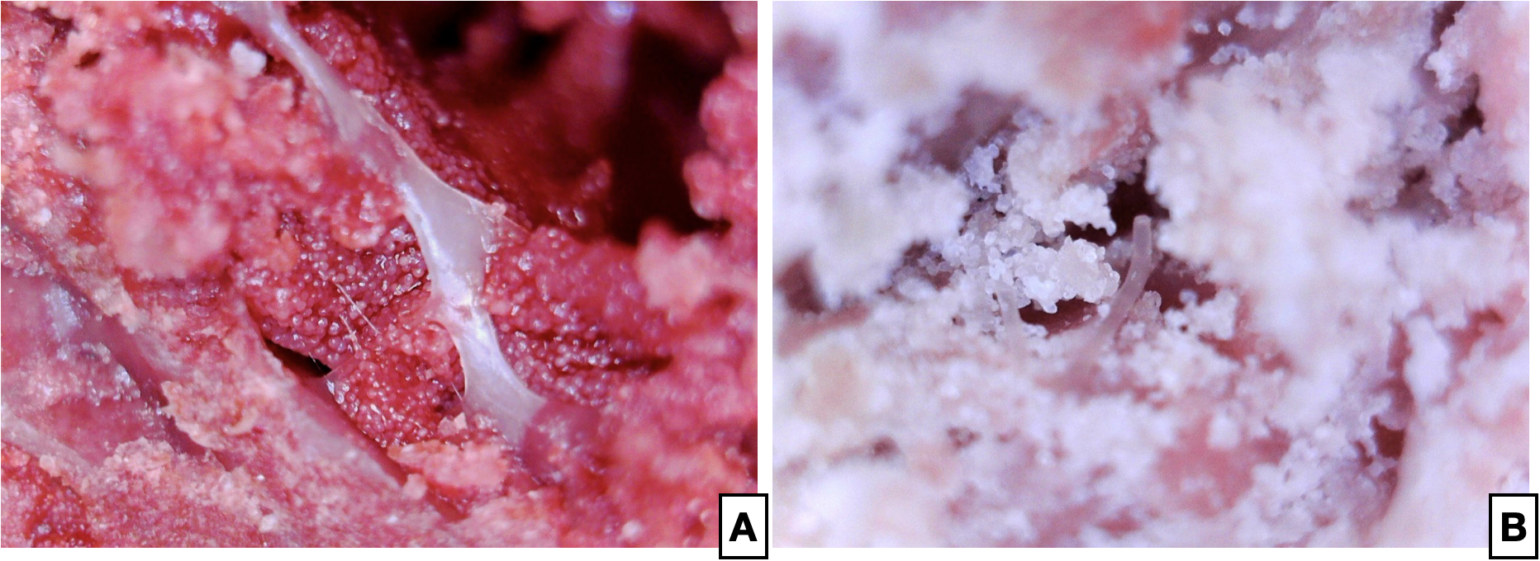
Figure 7. Comparison of bone marrow composition; red marrow (A) and yellow marrow (B).

Activity 4
Using Figure 7 above, identify the following structures and cells:
- Trabeculae
- Endosteum areas
- Areas where sinusoidal blood vessels can be found
- Areas containing dense collection of active HSCs
- Areas containing dense collection of active MSCs

Activity 5
Using the text above describing stem cells and endosteum as well as the chart below showing cellular details, construct a sample of bone marrow to reflect the scenarios described in A, B, and C below. The cells can be moved, resized, and rotated as needed.

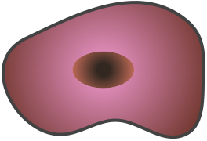
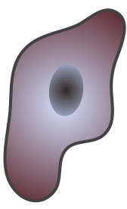
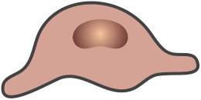
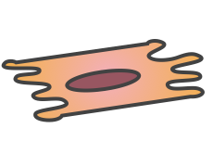
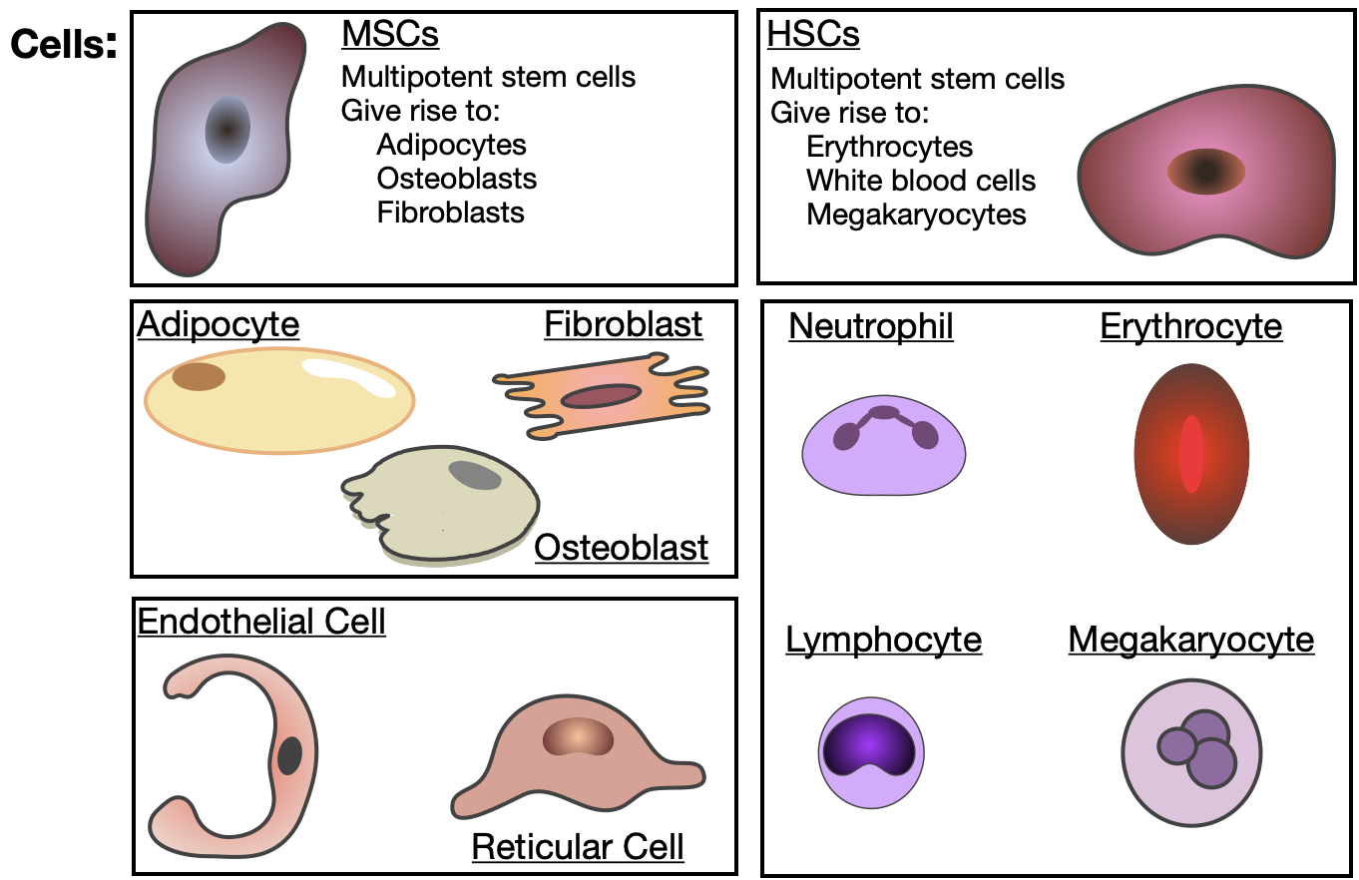

A. Construct a sample of bone marrow within the medullary cavity of a long bone from a healthy, pre-pubescent juvenile. An outline of trabeculae has been provided for spatial reference. Overlay the stem cells, their products, and blood vessels on the trabeculae.

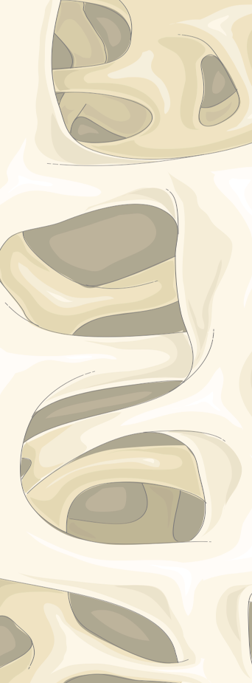

Laboratoires Servier, CC BY-SA 3.0, https://commons.wikimedia.org/w/index.php?curid=82640931

B. Construct a sample of bone marrow within the medullary cavity of a long bone from a healthy adult animal. Overlay stem cells, their products, and blood vessels on the trabeculae.
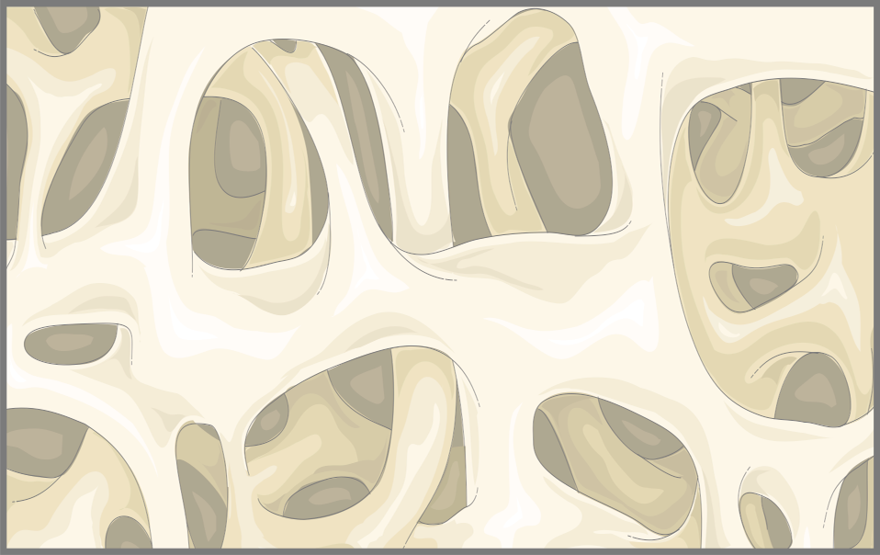

Laboratoires Servier, CC BY-SA 3.0, https://commons.wikimedia.org/w/index.php?curid=82640931

C. If an adult animal died from severe starvation, how would this marrow sample change? In the box below, construct a sample using the cells provided at the top of this activity.

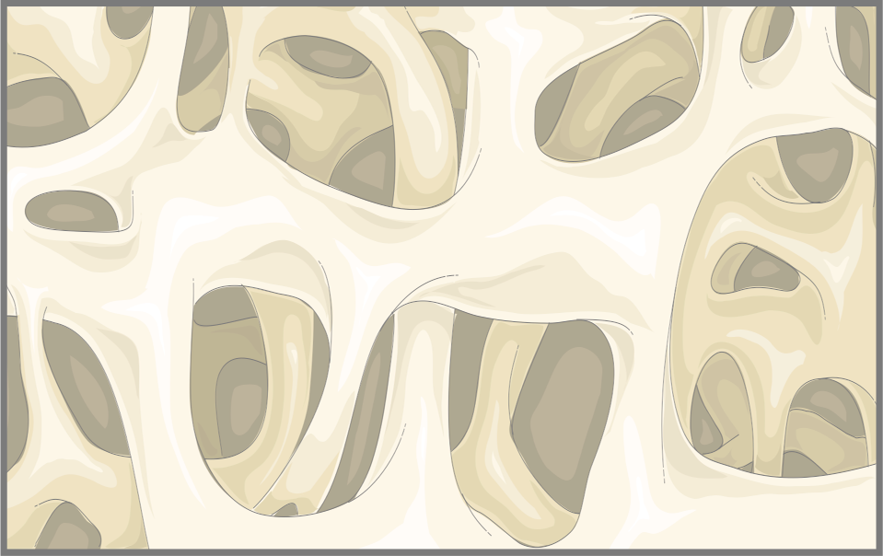

Laboratoires Servier, CC BY-SA 3.0, https://commons.wikimedia.org/w/index.php?curid=82640931
Activity 6.
Summary questions:

A. Likely cause of death for this animal:
B. Beyond limited access to adequate nutrition, what anatomical or physiological factors could contribute to or directly cause starvation in a wild ruminant such as a deer?

C. Can diseases lead to starvation in deer? Using reputable online sources, search for endemic diseases in your area that could contribute to starvation.

D. If you were a wildlife biologist in charge of the area from which this specimen came from, what recommendations would you make in regards to managing this herd of deer so that others do not befall the same outcome?

Thinking back over the information revealed during my investigation of this bone specimen, I realized that a lot about an animal’s life could be unraveled by closely and carefully examining the clues nature left behind. This animal had reached adulthood. It likely managed to reproduce over several seasons but something ultimately led to its untimely death. Was it predation? Was it a lasting wound that just couldn’t heal? Or was it an accumulation of many negative environmental factors that eventually became too much for this animal? As this bone specimen gave up its secrets I realized that death had likely not come quickly for this animal. Instead, it had slowly wasted away, using the very last of his energy reserves, the fat in his bones.

As it turns out, this bone could talk... I just had to figure out how to listen.

References:

Beeler-Marfisi, J., A.G. Menoyo, A. Beck, J. König, J. Hewson,& D. Bienzle. (2010). Gelatinous marrow transformation and hematopoietic atrophy in a miniature horse stallion. Veterinary Pathology 48(2): 451-5.
Bischoff, A.I. (1954). Limitations of the bone marrow technique in determining malnutrition in deer. Proc West Assoc State Game and Fish Commissioners 34: 205-10.

Cheatum E.L. (1949). Bone marrow as an index of malnutrition in deer. NY State Conservationist 3(5): 19-22.

Kistner, T.P., C.E. Trainer, & N.A. Hartman. (1980). A field technique for evaluating physical condition of deer. Wildlife Society Bulletin 8(1): 11-7.

LaJeunesse, T.A., & R.O. Peterson. (1993). Marrow and kidney fat as condition indices in gray wolves. Wildlife Society Bulletin 21(1): 87-90.

Mech, L.D., & G.D. Delguidance. (1985). Limitations of the marrow-fat technique as an indicator of body condition. Wildlife Society Bulletin 13(1): 204-6.

Raglus, T. I., B. De Groef, S. Rochfort, G Rawlin, & C. McCowan. (2019). Bone marrow fat analysis as a diagnostic tool to document ante-mortem starvation. The Veterinary Journal 243: 1-7.

Tamma, R., & D. Ribatti. (2017). Bone niches, hematopoietic stem cells, and vessel formation. International Journal of Molecular Sciences 18(1): 151-64.

Veldhuis-Vlug, A.G., & C.J. Rosen. (2017). Clinical implications of bone marrow adiposity. Journal of Internal Medicine 283(2): 121-39.

