Name___________________________________ Date________________ Period_______

Get a Handle on Candles!
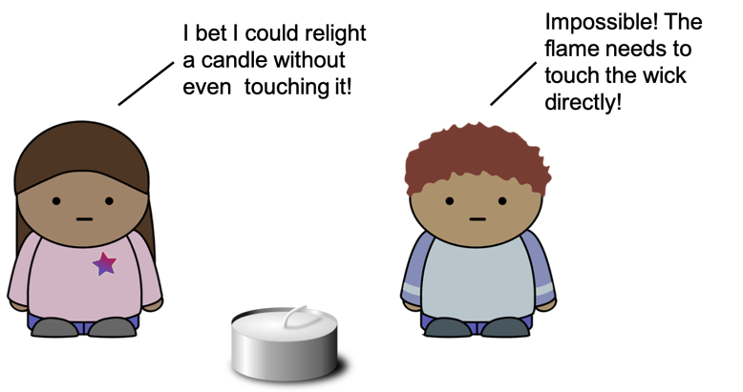

An Experiment
Your teacher is going to blow out a candle and then try to relight it with the lighter at different positions around the candle. Let’s see what makes the candle re-ignite!

Predict
Will the candle relight if the flame of the lighter is put…
- Directly on the candle wick? [Y/N]
- Above the candle wick? [Y/N]
- To the side of the candle wick [Y/N]

Observe
Let’s try it! What happens? _______________________________________________________ ______________________________________________________________________________ ______________________________________________________________________________

Explain
Try to explain what happened. ____________________________________________________ ______________________________________________________________________________ ______________________________________________________________________________

Thar she blows!
Candles will often be blown out by the wind. Why might “too much air” make it impossible for a candle to burn?
___________________________________________________________________
______________________________________________________________________________ ______________________________________________________________________________

