Meeting Notes
MEETING 1:
MEETING 2:
Exhibit Planning
Room Map for Exhibit
STATION 1: The Language of Chemistry
STATION 2: The Raw Materials of Computing
STATION 3: Manufacturing Circuit Boards
STATION 4: Disposal: E-Waste & E-Plastics
STATION 5: Final Projects
Greeter Speech

Meeting Notes
Volunteers: | Meeting Times / Dates | Groups / Roles
- STATION 1: The Language of Chemistry
- STATION 2: The Raw Materials of Computing
- STATION 3: Manufacturing Circuit Boards
- STATION 4: Disposal: E-Waste & E-Plastics
- STATION 5: Final Projects

GREETERS:

MEETING 1:

Date: | Attendance:
AGENDA: | NOTES:
Vision:
Discuss structure of the celebration (Museum Exhibit)
Discuss schedule of the day, event
Students select their exhibits.
Review exhibit design expectations.
Media to Prep:
*Review invitation
*Review program contents
Invitations, Guests:
*Discuss whom to invite from within school community.
*Assign students to personally invite specific faculty.
GROUPS

- The Language of Chemistry: Leader 1, Leader 2
Peer 1 | Peer 2 | Peer 3

- The Raw Materials of Computing: Leader 1, Leader 2
Peer 1 | Peer 2 | Peer 3

- Manufacturing Circuit Boards: Leader 1, Leader 2
Peer 1 | Peer 2 | Peer 3

- Disposal: E-Waste & E-Plastics: Leader 1, Leader 2
Peer 1 | Peer 2 | Peer 3

- Final Projects: Leader 1, Leader 2
Peer 1 | Peer 2 | Peer 3

OTHER ROLES: Tour Guides & Greeters
GREETERS: | TOUR GUIDES
*Greeters serve as tour guides to younger students when not stationed to greet guests.

CLASSES REQUESTING CHAPERONES

TOUR GUIDES:
(Prep tasks for Friday: Gallery walk images, folding programs, rehearsing speeches, etc.)

MEETING 2:

Date: | Attendance:
AGENDA: | NOTES:
Exhibit Planning:
*Time to work on exhibit design, conference with teacher, gather materials.
*Review classroom map, begin to get situated around how to set up station.

Exhibit Planning

Room Map for Exhibit
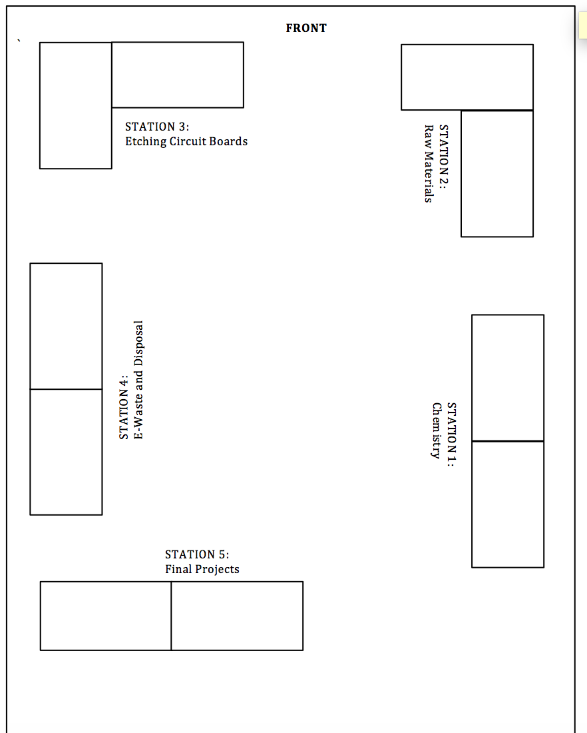

STATION 1: The Language of Chemistry
Work to Display  What student work will you display at this table? | Interactive Activity  What interactive activities will your visitors engage in at this station? | Visuals  What visuals (diagrams, posters, etc.) will you include at your station to make it engaging and informative?
Station Speech

STATION 2: The Raw Materials of Computing
Work to Display  What student work will you display at this table? | Interactive Activity  What interactive activities will your visitors engage in at this station? | Visuals  What visuals (diagrams, posters, etc.) will you include at your station to make it engaging and informative?
Station Speech

STATION 3: Manufacturing Circuit Boards
Work to Display  What student work will you display at this table? | Interactive Activity  What interactive activities will your visitors engage in at this station? | Visuals  What visuals (diagrams, posters, etc.) will you include at your station to make it engaging and informative?
Station Speech

STATION 4: Disposal: E-Waste & E-Plastics
Work to Display  What student work will you display at this table? | Interactive Activity  What interactive activities will your visitors engage in at this station? | Visuals  What visuals (diagrams, posters, etc.) will you include at your station to make it engaging and informative?
Station Speech

STATION 5: Final Projects
Work to Display  What student work will you display at this table? | Interactive Activity  What interactive activities will your visitors engage in at this station? | Visuals  What visuals (diagrams, posters, etc.) will you include at your station to make it engaging and informative?
Station Speech

Greeter Speech

Hi,

Welcome to the (redacted) School Museum of Art, Science, and Nature. Thank you for coming!

The exhibit we have on display for you today is about the social and environmental impacts of manufacturing electronics.

There are five stations in our exhibit, and you should visit them in order. Please take time to visit each station to learn about the different steps required to create electronics, and the ways that each step can impact our world. The exhibit designers will have student work on display as well as activities to help teach you about manufacturing electronics and the waste produced. At the final station, you will get to see our final projects, where we created infographics about electronics and the environment.

At the back of your program, you can find suggested questions to ask the students at each station.

Thank you again for coming.

