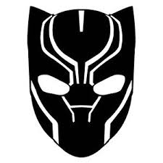
Black Panther

(2018, Rated PG-13)

EQ: Explain energy transfer and transformation within a system.

My Energy

Synopsis: After the death of his father, T'Challa (Chadwick Boseman) returns home to the African nation of Wakanda to take his rightful place as king. When a powerful enemy suddenly reappears, T'Challa's mettle as king -- and as Black Panther -- gets tested when he's drawn into a conflict that puts the fate of Wakanda and the entire world at risk. Faced with treachery and danger, the young king must rally his allies and release the full power of Black Panther to defeat his foes and secure the safety of his people.

Cinema Science Focus: The Black Panther suit is an engineering design of T’Challa’s sister Shuri. The suit is made from fictional substance, vibranium, and it can absorb energy and then transfer it back; as Shuri explains in the clip, bullets being shot at Black Panther are “charging” the energy of his suit. There’s no vibranium in the real world, but energy can be changed from PE to KE within a system. Develop a lesson, investigation, or demonstration that models how energy transfers in a system. Make an argument that a substance in the real world might cause energy to behave in the same manner it behaves in the Black Panther suit.

Concepts to Master:
- Energy Transfer and Transformation
- Mechanical Energy
- Kinetic Energy
- Potential Energy
- Law of Conservation of Energy

Vocabulary: energy, ME, PE, KE, transfer

Possible Resources:
- Duncan Lake Middle School Science: Energy Transfer (website/slideshow)

- NeoK12 “Law of Conservation of Energy and Mass” (Videos and Games)

- HuffPost “Black Panther’s Powerful Vibranium Suit Explained with Real Science” (Andy McDonald, 2018)

- CK-12.org “Energy Conservation” Read

- _______________________________________________________

- _______________________________________________________

