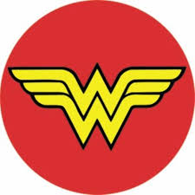
Wonder Woman

(2017, Rated PG-13)

EQ: How does momentum affect the movement of objects?

No Man's Land

Synopsis: Before she was Wonder Woman (Gal Gadot), she was Diana, princess of the Amazons, trained to be an unconquerable warrior. Raised on a sheltered island paradise, Diana meets an American pilot (Chris Pine) who tells her about the massive conflict that's raging in the outside world. Convinced that she can stop the threat, Diana leaves her home for the first time. Fighting alongside men in a war to end all wars, she finally discovers her full powers and true destiny.

Cinema Science Focus: First things, first-- Diana Prince is a goddess and is, as such, immortal, so bullets probably wouldn’t hurt her. That said, Wonder Woman wears special bracelets that absorb impact force. Bullets seem to ricochet off of them. For obvious reasons, they come in handy; especially when you’re walking across a battle front. Develop a lesson, investigation, or demonstration that models how momentum--the quantity of motion of a moving body-- relates to Wonder Woman’s bracelets. Make an argument that similar devices could be created out of existing materials.

Concepts to Master:
- Momentum
- Newton’s Second Law
- Net Force
- Directional Force

Vocabulary: momentum, net force, directional force, applied force, mass, weight

Possible Resources:
- The Physics Classroom, “Momentum”

- Wired, “The Physics of Bullets vs. Wonder Woman’s Bracelets” (Rhett Allain, 2017)

- Ted Ed, “If Superpowers Were Real: Immortality” (Joy Lin)

- CK-12.org “Metals” Read; “The Wonder Metal” Real World Application, “Stronger Than Steel” Real World Application

- _______________________________________________________

- _______________________________________________________

