A screenshot of a cell phone

Description generated with very high confidence

Site landing pages for instructional guides.

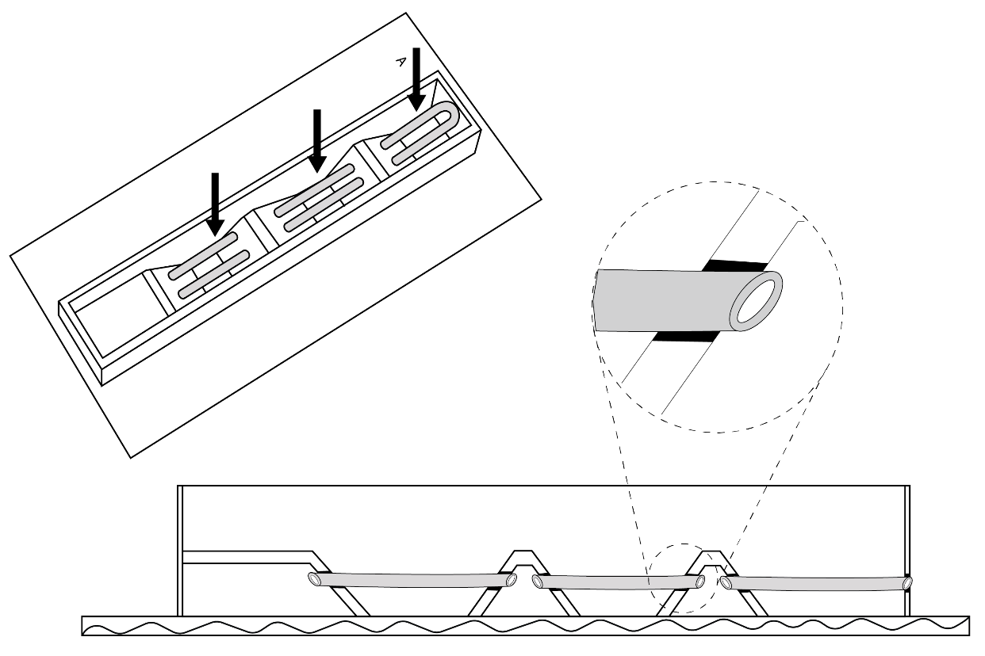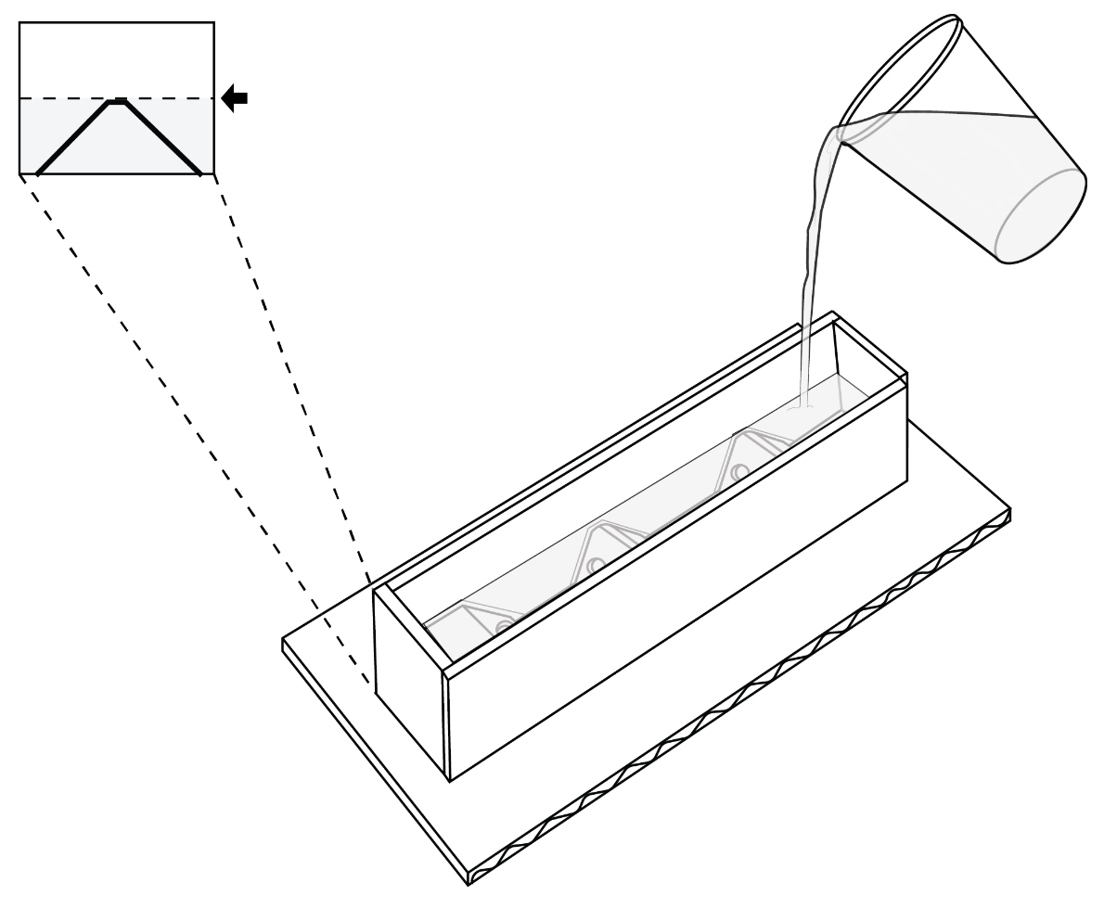

The molding process of each finger involves building an internal geometry for the silicone to be formed around.