Direction sheet for practice day (coding robot to move forward, backward, and turn 90°)
- Pick up a tablet. Go to Settings, select Bluetooth, and connect the tablet to the assigned Sphero. Open the Sphero Edu App and pair the robot by holding it close to the device.
- Tap the green dot in the lower right corner. Type in your name for the program’s name. Press “Create.”
- In the top right corner of the screen is the “Aim” button. Tap on it.
- With the robot on the starting point, move the blue dot on the screen around until the robot’s tail light is facing you (aimed at your feet).
- Press the first tab, “Movement.” Then, drag up a roll command (heading, speed, time). These three variables will be changed as you practice. Keep the speed under 50.
- Click on controls, drag up “Delay,” and add one second.
- Press “Start” at the top of the screen.
- Practice coding to move the robot forward and come to a complete stop. Next, move it forward and then backward. Finally, move the robot forward, turn it 90°, and then backward.

Direction sheet for students: Elements of the periodic table meet Sphero robots
Part 1: Getting the robot connected and coding
- Go to Settings, select Bluetooth, and connect to the assigned Sphero. Open the Sphero Edu App and pair the robot with the device by holding the two close together.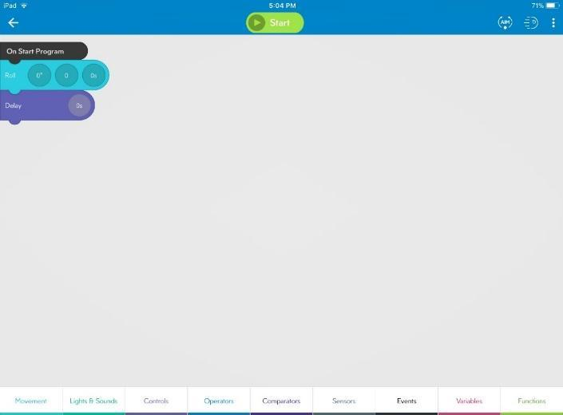

- Tap the green dot in the lower right corner. Type in your name for the program’s name. Press “Create.” Place the robot on the starting line.

- In the top right corner is the “Aim” button. Tap on it.

- With the robot on the starting point, move the blue dot around the ring until the robot’s tail light is facing you (aimed at your feet).

- Press the first tab, “Movement.” Then, drag up a roll command (heading, speed, time). Experiment with these variables, keeping speed under 50.

- Click on controls, drag up “Delay,” and add one second.

- Press “Start” at the top of the screen and observe your robot.

Part 2: Let the games begin!
Find another student to work with. One person will draw a card from the basket; the other person will identify the element and drive the Sphero to the desired location.
After you program and land on the correct element, program the Sphero to turn green when it lands on the correct square (click on “Lights & Sounds” and drag up “Main LED.” Select a shade of green). Once the element has been verified, change roles. Pull another card and continue coding, adding three more lines of code for reaching the second element. Now change the Sphero robot to a different color as it lands on the second element. Continue this procedure of adding to the lines of your code. How many elements can you reach?

Winning the game
The winning team will reach the most elements in the period given. You must show the picked cards and your program to an adult. Good luck!

