Statement | BEFORE READING –  Your Initial Thoughts | AFTER READING –  Your Final Thoughts
After it rains, sunrays soak up the water in puddles.
The sun is the driving force for the movement of water around the earth.
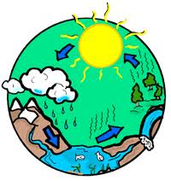
This model accurately shows the driving forces for how water cycles through earth.
Water, minerals, and other nutrients move into plants from the soil.
Salt found in the ocean can be easily separated through a physical process.
Water we use to flush the toilet comes from the pipes, goes down the drain, and then goes back to the treatment plant for us to reuse.
The water we use to flush the toilet comes from the same pipes that go to our tap.
It’s okay if someone pours some chemicals down the sink, because it gets dumped into the creek, not our drinking water.
Ice found in glaciers, tundra, etc. are not part of the global water cycle because it is mostly inaccessible for humans.

