Consider the water source.
 | Where do you think this water originates? | What is your opinion about drinking water from this source? | Were you correct about its’ origin? Did this change your mind?
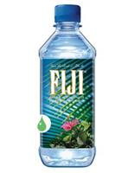
(Fiji)
(Poland Springs)
(Dasani)
(Aquafina)
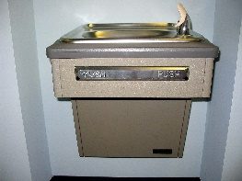
(Water Fountain)
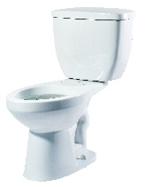
(Toilet Water)
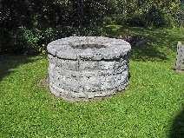
(Well Water)

- Of these sources, which do you think is more sustainable? Explain your thinking.
(Sustainable?: https://www.merriam-webster.com/dictionary/sustainable)

- If you wanted, could your family switch to well water?
Initial Claim: _______________________________________________________
___________________________________________________________________
NEXT STEPS:
- Obtain information about our region’s four major aquifer systems.

As you prepare for more detail oriented reading, obtain and record the following information:

Resource 1: https://pubs.usgs.gov/ha/730g/report.pdf

- In our tri-state region, how much water is withdrawn from the aquifer systems?
- What percentage of the population depends on this ground water as their water source?
- Which aquifer system experiences the most water withdrawal?
- This report is somewhat outdated. The authors continuously remind you that this water usage/data is expected to increase. In these areas, what factors contribute to an increase in water use?

Resource 2: http://www.georgiawatercouncil.org/Files_PDF/plan_6-28-07_overview.pdf

- This report is more recent than the last and concentrates on Georgia, rather than all of the states. What water source do the authors spend most of the space discussing?
- What does this imply?
- How many river basins remain within the state boundaries? What does this mean?
- How many river basins cross state boundaries? What does this mean?
- How is water used in these basins?
- Fast forward to page 34 of 38: How is ground water different from surface water?
- What factors impact availability of ground water?
- On page 34, read about the Crystalline Rock Aquifers. It states,
“The large cities across this region, including the bulk of the metropolitan Atlanta area, rely on surface water. These aquifers are unconfined, and groundwater levels vary considerably in response to rainfall.”
What does this mean?

- Organize the information obtained in a graphic. Suggestion:
 | Piedmont and Blue Ridge | Southeastern Coastal Plain | Floridian | Surficial
Uses

Thickness

Lithology (Type of Rock)
Hint: use Fig 5 & Fig 6
Quality of Water
Groundwater Flow
How does it enter the system?
Where does the water typically flow once it enters the system?

- Choose one of the four systems to become an expert.
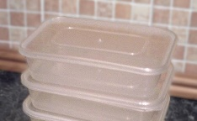
- Create a model of that region’s aquifer system.
Choices of models:
Draw a visual representation
Create a 3D model in one of the clear shoeboxes

- Discuss with your partner the potential to make well water your primary source of fresh water (if you lived here). Outline pros and cons.

- Revisit your initial claim. If your family lived in this region, could you switch to well water as your primary source of fresh water? If yes, What would be the advantages?...disadvantages?
(Additional Resource: https://www.cdc.gov/healthywater/drinking/private/wells/treatment.html)

Revised Claim:

Possible Advantages: | Possible Disadvantages:

Reflections/Connections to Water Wars:
Think about the availability of fresh water via aquifers.
- Which aquifer system supplies the most freshwater to our state?
- What factors contribute to the ground water levels in this system?
- What other state(s) use this aquifer system?
- How is this water used?
- Think back to the different sources of bottled and other drinking water from the very beginning of his station. Which source of drinking water is the most sustainable? Explain your thinking.
- How does what you have learned impact your thinking about the water wars?

