Robot arm sequencing

Group 1 member names:
______________________________________ ______________________________________
______________________________________ ______________________________________

Group 1 instructions: Draw the start and end positions of the blocks on the diagrams below.

Starting mat | Ending mat
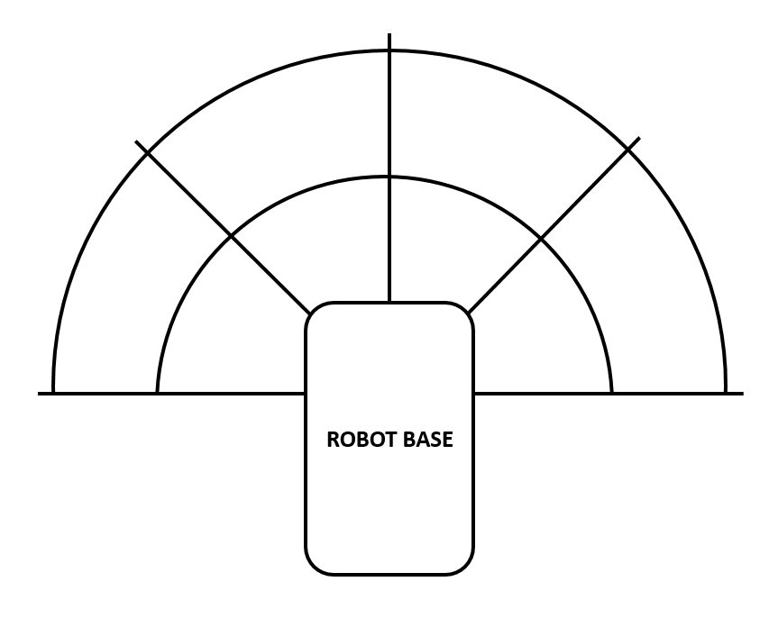

Group 2 member names:
______________________________________ ______________________________________
______________________________________ ______________________________________

Group 2 instructions: Write out the sequence of commands that moves the robot arm from the start to the end position in the above diagrams. (Hint: Use the commands from your magnetic code pieces.)

