Unplugged robotics assessment key

Debugging
The following program has been written to move a block from start position 1-A to end position 5-B. The diagram below shows the correct start and end positions. But there are bugs (mistakes) in the code! Debug the following sequence by adding in the missing actions so that the robot arm places the block in the correct position:

Step | Action
1 | Start
2 | Turn left
3 | Turn left
4 | Claw open
5 | Arm forward
6 | Turn right
7 | Turn right
8 | Turn right
9 | Arm backward
10 | Open claw

Answer:
Missing actions
- Arm down (after arm forward, step 5)
- Claw close (after arm down)
- Turn right (after turn right, step 8)
- Arm down (after arm backward, step 9)

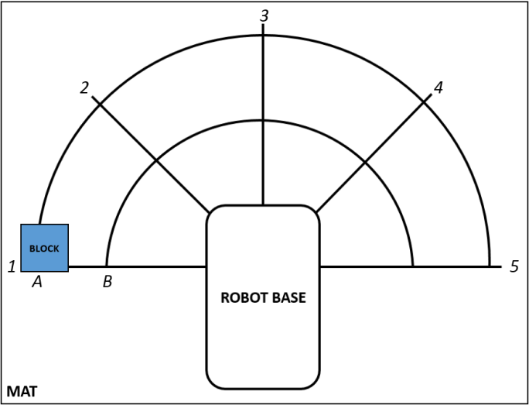 | 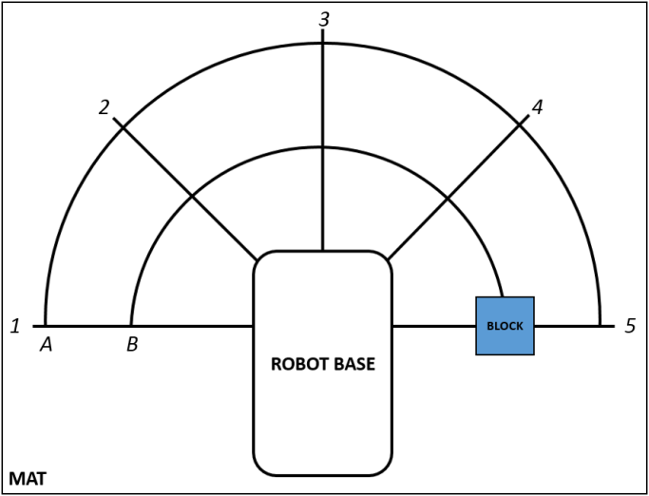
Start position. The block is at position 1-A. | End position. The block is at position 5-B.

Domain knowledge
- Name one rule that sequences follow. Describe why this rule is important for sequences.

Answer:
Order matters: The steps in a sequence must be arranged in a particular order to accomplish the specific end goal/task that the robot is programmed to achieve. This rule is important because without the specific order, the task is unlikely to be accomplished.

Flexibility: Sometimes it is possible to do one step before another without the end goal/task being affected. This is important to the programmer because it allows the programmer to choose the step that provides the greater ease of code implementation or action execution.

- Consider the rule you listed in question 1. Provide a real-world example of a sequence that would fail without the use of that rule. Explain where in your sequence you are applying the rule you listed and how it is an accurate application of the rule. (Hint: Write down the steps to show where the failure would take place if the rule isn’t followed.)

Answer:
Students may use the teeth brushing example or the lemon and lime sorting video example. Ideally, students will use an example from their own lives that was not mentioned during the lesson. They should then accurately explain where the failure in the code would take place.

- Looking at the sequence below, are steps 3 and 4 flexible? That is, will swapping these steps in the sequence change the robot’s end goal? Justify your answer.

Answer:
Yes, steps 3 and 4 are flexible because the two steps in either order move the robot arm closer to grabbing the block, but they do so along different paths. The end goal is to grab the block and place it in a different position; therefore, the order of the steps to grab the block doesn’t matter, as long as the end goal is still achieved.

- Looking at the sequence below, are steps 2, 3, and 4 flexible? That is, can step 2 be step 3 or 4, can step 3 be step 2 or 4, and can step 4 be step 2 or 3? Justify your answer.

Answer:
Yes, steps 2, 3, and 4 are flexible because the three steps in any of the different orders moves the robot arm closer to grabbing the block, but they do so along different paths. The flexibility in the three steps is more complex, but the end goal of grabbing the block is still achieved.

- Looking at the sequence below, are steps 5 and 6 flexible? Justify your answer.

Answer:
No, steps 5 and 6 are not flexible. The end goal, to grab the block, is not achieved because closing the claw (step 6) before moving the arm down (step 5) means the robot’s end goal will be obstructed. When the robot closes its claw, the block needs to within the small range the robot has to grab the block. Therefore, closing the claw is dependent upon the arm being down.

Step | Action
1 | Start
2 | Claw open
3 | Turn left
4 | Arm forward
5 | Arm down
6 | Claw close
7 | Arm up
8 | Turn right
9 | Arm down
10 | Claw open

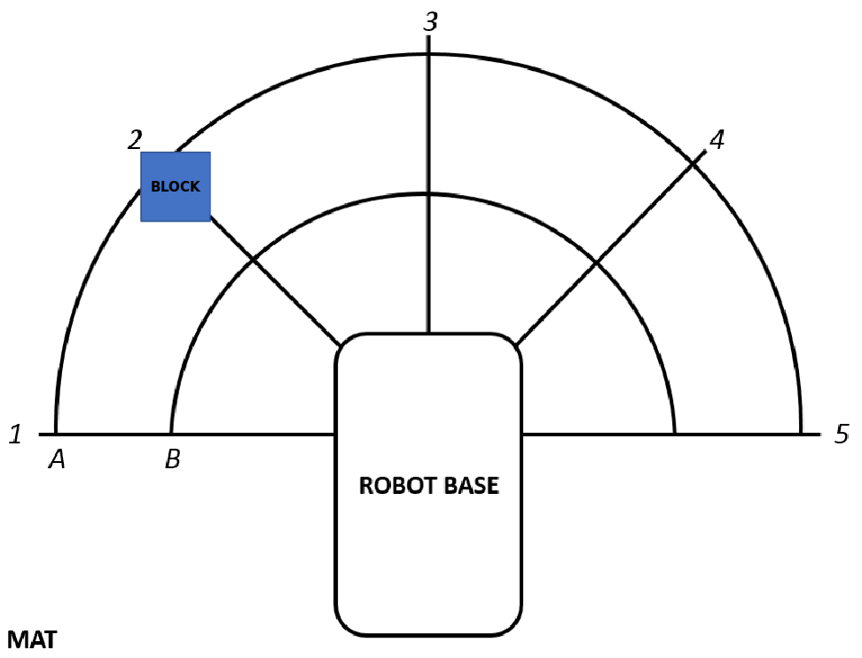 | 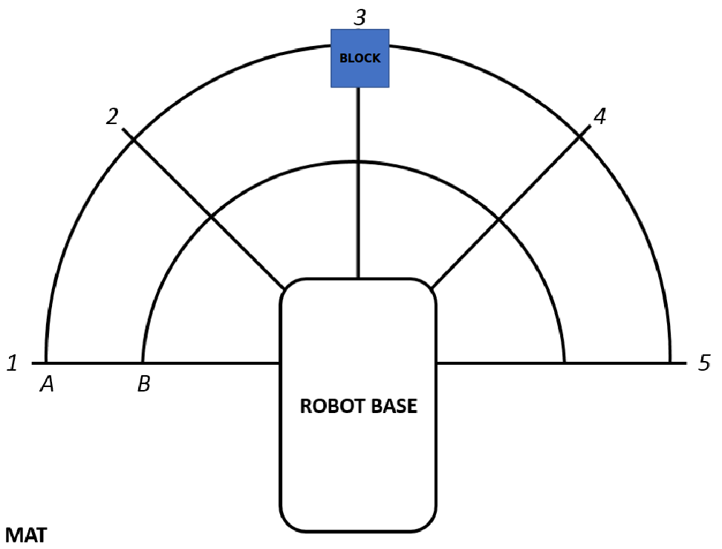
Start position. The block is at position 2-A. | End position. The block is at position 3-A.

Sequence implementation
Write a program to move a block from start position 3-B to end position 5-A. (Hint: Draw a mat and use your arm to test your final answer. If the code is wrong debug it.)

Answer:
Step | Action
1 | Start
2 | Claw open
3 | Arm forward
4 | Arm down
5 | Claw close
6 | Arm up
7 | Turn right
8 | Turn right
9 | Arm backward
10 | Arm down
11 | Claw open

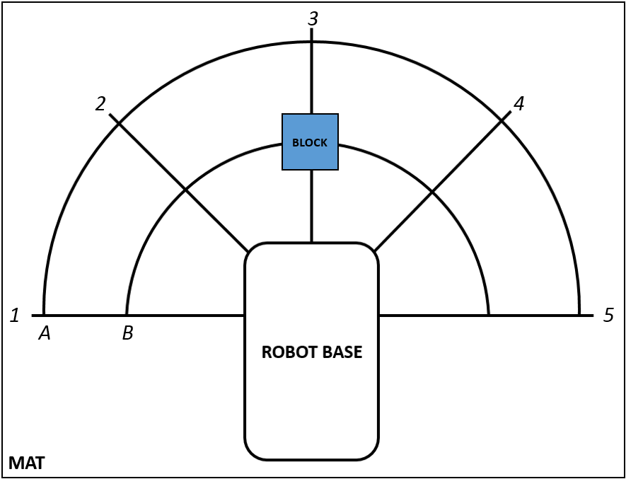 | 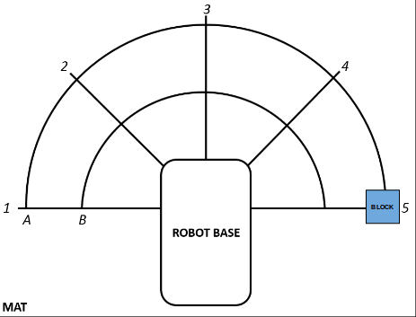
Start position. The block is at position 3-B. | End position. The block is at position 5-A.

