Water Bottle Challenge | 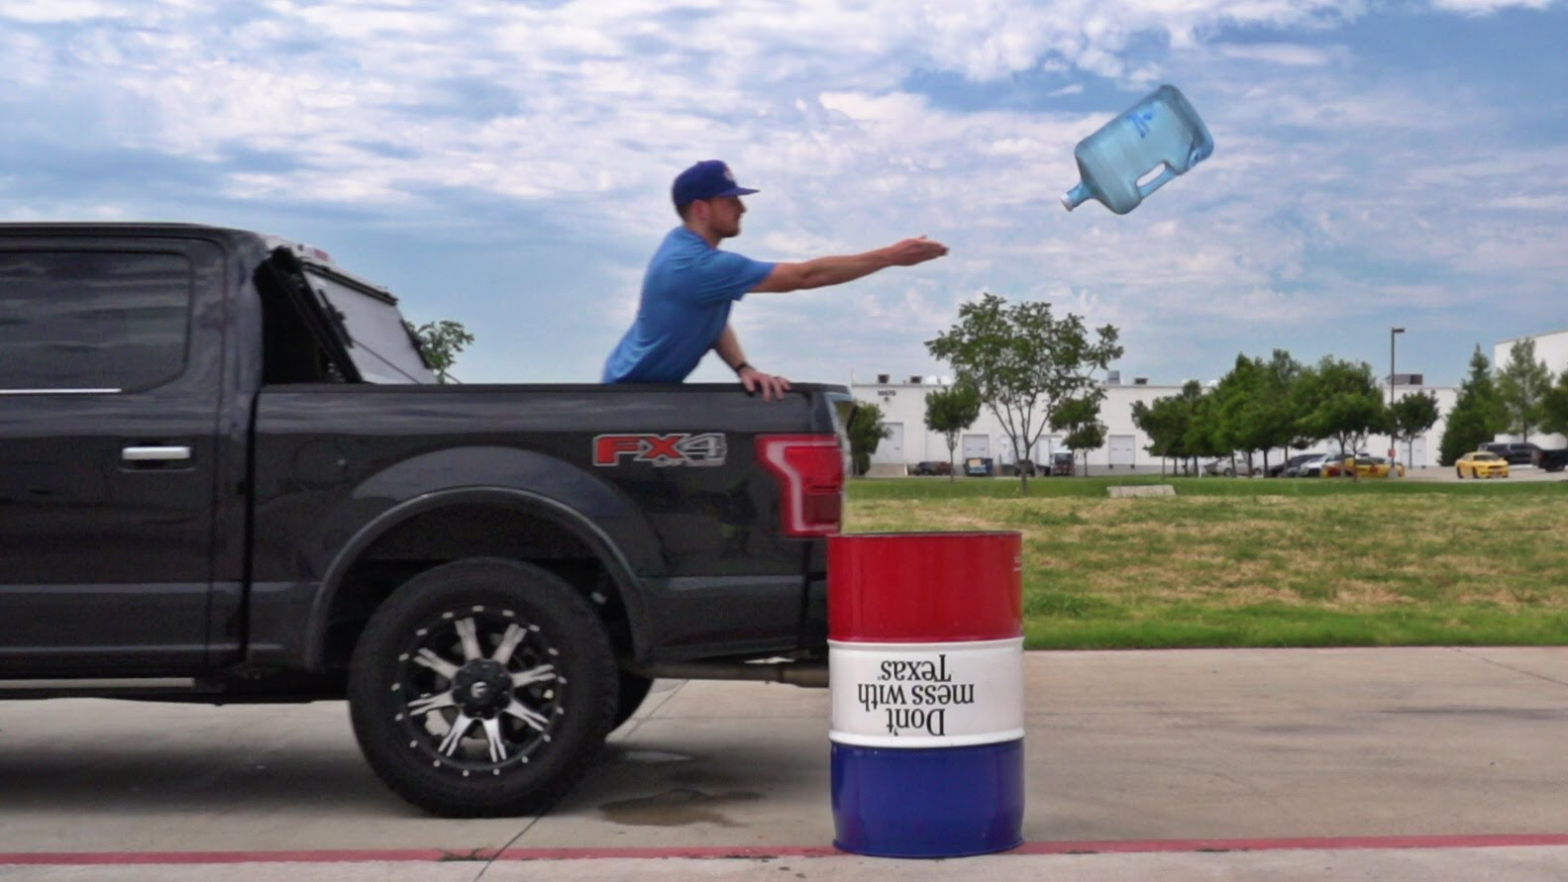
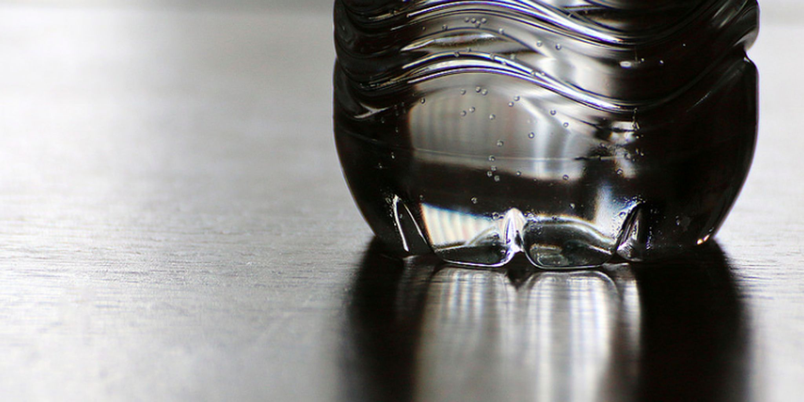 | 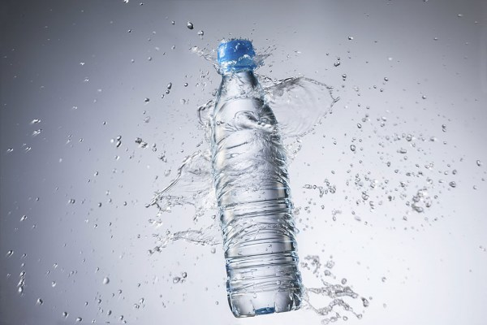

  - What makes a good flip?
Your task is to design a series of investigations to help you determine the best conditions when flipping and landing a tossed plastic bottle. The variables you can test are endless!
Sample tests could include:
- How does the amount of liquid in the bottle impact landing rates?
- Does the type of liquid (viscosity) alter the chance of success?
- Would using sand or sugar instead of water help your chances?
- To what degree does the bottle size/shape help boost your odds?
- Does the landing surface alter your chances of sticking the landing?

Guidelines
When designing your investigations, keep the following guidelines in mind:
- A successful land occurs when the bottle lands vertically after at least one spin in the air.
- Your group may test as many variables as you want given that you are able to complete the accompanying inquiry report before the due date of ______________________.
  - You will use your Microsoft 365 accounts to collaboratively construct a final lab report to outline your findings and share your results.
    - Make sure to “share” your paper with Mr. Shafer as an editor
      - Aaron.shafer@beavercreek.k12.oh.us
- Your paper needs to defend the question of “what conditions make for the perfect flip?” and include the sections and headings described below.
  - Introduction: The beginning of your paper should introduce your investigation
  - Hypotheses: For all of your tested variables, your group should provide a hypothesis
  - Procedure: A detailed description of the tested variables and methods your group used should be presented.
    - An explanation of how your group was able to control your experiments to the best of your ability should be included as well.
  - Data: Data tables, graphs, and statistical analysis (mean, median, and mode) should be abundant throughout your paper.
    - This section should simply be your findings and data—no conclusions yet!
  - Conclusion: After the data has been presented, your paper should also include a conclusion where your group addresses the following:
    - Were your hypotheses supported or rejected based on the data you collected? Explain using your data tables and graphs.
    - Provide a detailed and thorough discussion of your collected data to show what conditions provide the best outcomes for bottle flippers.
      - This section needs to use the collected data (refer to tables and graphs) as evidence
  - Reflection: Finally, your paper should include a detailed reflection where your group responds to the following:
    - How reliable is the data you collected? Explain.
      - What are possible sources of error?
    - What did your group do well? If you had the chance to redo this investigation, what would your group do differently?
    - What did you learn from this lab? What will you take away?
- At the conclusion of the lab, a final showdown will occur. This “battle of the bottles” will be the ultimate test where your group has a chance to rise to the top of the bottle flipping world.
  - Each group will get 25 flips with their ideal bottle conditions.
    - The group that is able to land the highest number of flips will be crowned champion!

