Unit: Earth’s Changing Weather
Table of Contents
Investigation 1: What explains changes in the weather? (Engage Activity) 3
Investigation 2: What was the weather like before and after the weather changed in Marissa, IL? (Explore Activity) 7
Investigation 3: What is an air mass and how does it move? (Explain Activity) 11
Investigation 4: What features divide air masses and how they move? (Explain Activity) 13
Investigation 5: Can we predict changing weather? (Elaborate Activity) 17
Investigation 6: What is the explanation for why the weather changed in Marissa, IL? (Evaluate Activity) 19
Investigation 7: What changed CT’s weather? (Extension Activity) 22
Appendix A: Unit Summary Table 25
Appendix B: Word Sort Activity for Investigation 4 26
Appendix C: Adapted Weather Discussion from the National Weather Service for Investigation 7 27

Interactive Science Notebook
The Interactive Science Notebook (ISN) is a place for students to use writing as a tool for learning. The notebook provides a physical location for doing the work of a scientist before, during, and after investigations (hypothesizing, modeling, observing, explaining, etc.). The notebook is not just a place to ‘put stuff’ in, but rather a location for students’ active processing of science learning. As a science writer, the notebook is a great place to brainstorm, set goals, and begin drafts of explanations and arguments.

Investigation 1: What explains changes in the weather? (Engage Activity)
For the first investigation, we will develop a preliminary explanation of a weather phenomenon in order to explain how weather changes.
Making of a Superstorm (engage)
- To start the unit, we will watch the short three-minute video from NOAA* titled “Making of a Superstorm.” Please follow the steps below to complete Table 1.1.
  - Watch the video once and record your reactions to it. Please share out.
  - Next, watch the video a second time, but now record as many kinds of weather conditions that you can observe from it in the “I Think” column. With a small group, then share your list with others. In the “We Think” column, record your final list of weather conditions that occurred in the video.
  - Share your “We think” column with the entire class.
Table 1.1: Making of a Superstorm
link: https://oceantoday.noaa.gov/makingofasuperstorm
Reactions to the Video
I Think  (observations of weather) | We Think  (observations of weather)
*NOAA is the National Oceanographic and Atmospheric Association, a division of the U.S. Dept. of Commerce.
- Based on what you learned thus far, what weather phenomenon would you hypothesize might have caused Hurricane Sandy to become a post-tropical storm called Superstorm Sandy and why?

The Anchoring Phenomenon: What can explain the change in weather from Marissa, IL? (explore)
Next, we are going to watch a video by Dan Robinson, a storm chaser from the Midwest. Although what is depicted in this video is a common weather phenomenon, the intensity of it is more dramatic, which is one of the reasons why Superstorm Sandy became so intense. Thus, our goal is to analyze this weather phenomenon and develop a preliminary explanation for it. Below is the research question we will respond to by the end of this investigation.
Investigation Research Question
What can explain the change in weather from Marissa, IL?
- To provide a context for this weather phenomenon, this video was taken in the late afternoon of October 25, 2012. It was videotaped to the northeast (see county road Rte. 10 on Google Maps) of the Prairie State Generating Company in Marissa, IL, which is about 35 miles southeast of St. Louis, MO. Please review this location and ask questions if you do not understand something.
- Qualitative Data: As we watch the video and respond to the investigation research question, use the T-chart below to answer the following questions.
Observed Changes | Wonder (questions)
- Watch the weather phenomenon storm chasing video by Dan Robinson at https://youtu.be/H_KJ3zRRqSs, which occurred on October 25, 2012. Individually record all observational changes in the weather conditions as well as what questions you may wonder about to explain what changed the weather in Marissa, IL. Hint: Watch the “smoke” coming from the Power Plant as one indicator to help you identify what is happening with the weather.
- Share your ideas with your lab group. What observations and questions do you have that are similar? What observations and questions are different? Be sure to record all group observations and questions in your T-chart.
- Share your group’s ideas of what was observed and the questions you have with the entire class. Continue to add any new observations and questions to your T-chart. Discuss as a class.

- Quantitative Data: Next, since we cannot “see” all of the weather conditions from this video, we are going to use weather data collected from Marissa, IL from October 25, 2012. In your lab group, use Weather Underground at https://www.wunderground.com/ to collect this weather data. Below are general methods to collect this data.
- Along the top menu of the webpage, click on “More” and then “Historical Weather.”
- Type in “Marissa, IL” in the search location box and then use the drop-down menu to select the date of the phenomena which is “October 25th, 2012.” Then hit the “submit” button.
  - Analyze the hour-by-hour weather data (after the graphs). Respond to the guiding questions listed below to help figure out what is happening in order to better explain this phenomenon.
    - Were there any abrupt or sudden changes in the weather (consider ALL weather “conditions”) at any point during the day? If so, what were the changes? When did they occur?
    - What numerical data correlates with the observational data of this natural weather phenomena from Marissa, IL?
    - What patterns do you notice in the “hour-by-hour” weather data related to this change? NOTE: It might be easier to examine each weather variable separately as you analyze them—this will make it less overwhelming. Also, you may examine the graphs, the table data, or both.
Developing a Model to Explain the Weather Changes in Marissa, IL (explain)
- Based on the weather data you collected (both qualitative and quantitative) regarding the weather changes from Marissa, IL, develop a model to try to explain why these changes in weather occurred. Please review Table 1.1: Gotta-have-it Checklist which highlights what needs to be included in your model.
Table 1.1: Gotta-have-it Checklist
This weather model should include:
- _____ The weather conditions, both observable (e.g. wind speed) and unobservable (e.g. temperature).
- _____ The location of the phenomenon (use Google Maps again, if needed) and the power plant.
- _____ Time passing—before, during, and after the weather phenomenon (estimate timing if needed).
- _____ Include labels (e.g. words & phrases) to identify parts of the model and relationships among the parts.
NOTE: This is a preliminary model. We will make changes to it as we go through the unit.
  - Next, individually, brainstorm what you would like to include in your model based on the “Gotta-have-it Checklist.” Record both observable and unobservable weather conditions similar Table 1.2. IMPORTANT: Do this BEFORE you start drawing your model.
Table 1.2: Brainstorm List of what to include in the Model
Individual:
Group:
  - Now, share your brainstorm list with the group. Add and modify the list in Table 1.2 with your group as necessary.
  - Using poster paper, create a model to explain what you think what was happening to the weather in Marissa, IL. Please check off each element of the “Gotta-have-it Checklist” as you complete it.
Constructing a Preliminary Explanation/Hypothesis: (elaborate):
- Based on the model you created, explain what you think is happening. In Table 1.3, use the sentence starters to help, if needed.
Table 1.3: Explanations/hypotheses
From the video and weather data of this weather phenomenon, we learned that…(state what happened in Marissa, IL)…
-We think a possible reason for why this weather phenomenon is happening is because…

-Another possible reason for why we think this phenomenon is happening is because…
NOTE: If you can think of other reasons, please include them too.

Personal Assessment of Quality of Model and Explanation: (Evaluate)
- On a scale of 1-5, record your level of confidence in the accuracy and completeness of your weather phenomenon model. Justify your response.
Table 1.4: Weather Model and Explanation Evaluation
Level of Confidence (1-5) | Justification

Investigation 2: What was the weather like before and after the weather changed in Marissa, IL? (Explore Activity)
During Investigation 1, we figured out that there was an abrupt change in the temperature, air pressure, moisture (e.g. dew point, precipitation), and wind speed and direction from Marissa, IL on October 25th, 2012. However, to better understand this phenomenon, we will collect additional data before and after the abrupt change in weather. Thus, we will conduct our own scientific investigation, using similar data collection methods from Investigation 1 that will help us respond to the research question below.
Investigation Research Question:
What was the weather like before and after the abrupt change in the weather conditions in Marissa, IL on October 25, 2012?

Planning and carrying out and investigation
Before we begin our investigation, record the following headings in your science notebook.
- Problem
- Methods
- Data
- Findings
- Discussion

- The Problem: Record the research question in your notebook. Explain why this question may be relevant to ask for us to better understand this natural weather phenomenon that occurred in Marissa IL?
- The Methods: Record the data collection methods that is needed in order to respond to the research question in your notebook. Use the guidelines below to help you with this task.
  - In your Lab Group, assign who will collect the weather data listed in the table below and record it in your notebook. In addition, record the measurement units too. If you have questions about this, please go to Weather Underground (www.wunderground.com) to identify the units that are used for each weather variable. If you still need help, please ask your teacher.
Lab Group Member | Weather Variable | How it is Measured
 | Temperature
 | Air Pressure
 | Humidity/Precipitation
 | Wind Speed and Direction
  - As a class, decide how much data to collect (i.e. number of days), and the number of measurements (i.e. data points per day)? Discuss why it is important to collect this data in order to respond reliably to the research question. Record these methods and the rationale in your methods section.
    - Why might it be important for the class to have similar methods? Explain in your notebook.
- Data Collection: Next, you will be paired into “expert” teams based on the weather variable (e.g. temperature) you decided to specialize in from your lab group.
  - As the “expert team,” each pair will record and organize their data either into hand-written data tables/graphs or an electronic spreadsheet.
NOTE: graph your data using the guidelines described below.
Graphing Guidelines
- Choose a type of graph. In general, any continuous data (e.g. time, distance, temperature) requires a line graph, scatterplot, or histogram while descriptive/discrete data (e.g. based on categories) is best depicted using a bar or pie graph. Use the table below to choose the best type of graph to display the data.
Continuous Data (e.g. 1, 2, 3…)—Line, Scatterplot, Histogram Graphs | Discrete Data (categories)—Bar, Pie Graph
Line —track changes over time; multiple data sets (lines) can be graphed together, however a key must be used.  Histogram (type of bar)—ordered columns based on time, temperature, distance, etc. Bars touch one another.  Scatterplot—determines relationships between groups; use a trend line (does not connect dots, but rather line of best fit) to show positive, negative, or no correlation. | Bar—compares data between/among different groups—bars are separated—can be rearranged, if desired (e.g. numerically, alphabetically).  Pie—compares parts of a whole, usually in percent; must have labels and include the total number.
- Write a title on the graph—all of the variables should be listed in the title.
- Decide the range (e.g. 1-10) of the data for each axis and use regular intervals (e.g. 2, 4, 6…).
- Write a title as well as the units for each axis
- Create a key, if appropriate (e.g. comparing lines from two or more data sets).
- Findings: Complete the two-step analysis process below.
Expert Team
  - In your “expert team,” discuss and record your analysis of the data using your table and graph. Interpret all of the data—focus on any patterns/trends, including “breaks” in the patterns/trends. Record this analysis directly on your table and/or graph.
Lab Group Team
  - Next, return to your original lab group so that all weather variables are represented. Display all graphs so that all lab group members can view them. Each person, one at a time, will then share their findings with the entire group.
  - Finally, in your lab group, record a group analysis of your data in your notebook. Below are guiding questions that can help you with the analysis.
    - Describe the general patterns for each data set you collected.
    - How do the weather conditions before October 25, 2012 compare with the weather conditions afterwards?
    - What relationships exist between or among the data sets? Consider before and after October 25, 2012 too.
- Conclusions: Based on the data you collected and analyzed, what two or three conclusions can your lab group draw from the data to answer our original research question (see below).
Investigation Research Question:
What was the weather like before and after the abrupt change in the weather conditions in Marissa, IL on October 25, 2012?
- Discussion (Possible Explanations): Use the sentence starters below to give possible reasons for this change.
From this investigation, we learned that the weather conditions before and after the abrupt change in weather was like….
- Now that we know what happened before, during, and after the change in the weather conditions in Marissa IL, we think a possible reason to explain this phenomenon is…
- We also think a possible reason for why this phenomenon is happening is because…
NOTE: Please include as many reasons as possible.

Ideas to Revise our Model
Review your initial model. Then, complete the row for this investigation in your Summary Table. You will complete the summary table column using the data and conclusions that you drew from this lab investigation. NOTE: Focus on the ideas that will inform the revision of your model.
Rubric for Writing your Lab Report: Following the completion of the investigation, type a group lab report as a single Google doc. See the rubric below for how you will be graded. Please review it carefully. IMPORTANT: Copy and paste the rubric to the end of your Google Doc.
Criteria | Excellent | Adequate | Needs Improvement
PURPOSE: Specifies the purpose of the investigation and includes a research question. | The purpose of the lab and/or the research question to be answered for this investigation is clearly stated, including why it is relevant to the investigation. (8pts) | The purpose/problem and/or research question is unclear or the rationale for the investigation is not defended adequately. (6pts) | The purpose/problem and/or research question is erroneous or irrelevant. (2pts)
METHODS: Includes the tools/materials and the methods in which the data is collected and aligns with the purpose. | The selection of the sources of data used are clearly and accurately described. A clear rationale to why the sources of data are valid and reliable are provided. (3pts)  The selection of what and how much data to be collected is identified and justified completely and accurately as it relates to the purpose of the investigation. (3pts)  The methods (e.g. procedures) are clearly written, sequentially outlined, and concretely detailed. Replicable. (3pts) | The selection of the sources of data used are described. The rationale for why the data is valid and reliable is unclear and/or not adequately justified. (2pts)  The selection of what and how much data to be collected is identified but justification is unclear and/or inadequate as it relates to the purpose of the investigation. (2pts)  The methods (e.g. procedures) are unclear, not adequately outlined, and/or too abstract. Replicable. (2pts) | The selection of the sources of data used are incomplete. The rationale for why the data is valid and reliable is incomplete and/or misaligned with the purpose of the lab. (1pt)  The selection of what and how much data to be collected is incomplete and/or the justification is incomplete or misaligned with the purpose of the investigation. (1pt)  The methods (e.g. procedures) are unclear and/or lack enough details to be justified or replicated. (1pt)
DATA PRESENTATION: Displays data in tables and/graphs. | Professional looking and accurate representation of the data in tables and/or graphs. No more than two minor inaccuracies that do not compromise the integrity of the data displays. (8 pts) | Accurate representation of the data in tables and/or graphs. No more than three inaccuracies and/or may compromise the integrity of the data displays. (6pts) | Data is presented, but may be incomplete and/or the data displays are confusing and inaccurate. (2pts)
FINDINGS: Summarizes the data in written form. | The relationship between the variables is discussed and trends/patterns logically analyzed. Predictions are made about what might happen if part of the lab were changed or how the experimental design could be changed. (12 pts) | The relationship between the variables is discussed and trends/patterns logically analyzed. (9pts) | The relationship between the variables is discussed but no patterns, trends or predictions are made based on the data. (4pts)
DISCUSSION: Provides an explanation for what was learned, which is supported by evidence and reasoning. | Provides a clear explanation of what was learned related to the purpose of the lab that includes how the evidence supports the explanation as well as any possible sources of error. (8pts)  Describes the skills learned, the information learned, how the new information accurately connects to what was previously learned and/or what is known (e.g. textbooks). (8pts) | Provides a vague explanation of what was learned related to the purpose of the lab. The evidence to support the explanation is unclear and/or misaligned, and/or inaccurate. (6pts)  Describes, inadequately, the skills learned, the information learned, how the new information connects to what was previously learned and/or what is known (e.g. textbooks). (6pts) | Little explanation provided and/or it is misaligned as it relates to the purpose of the lab. (2pts)  Little or misaligned connections between what was learned and what is known. (2pts)
OVERALL WRITING QUALITY  The manner in which the written composition functions as a whole.  Appropriate scientific tone: precision of communication; objective and authoritative; third person point of view. | Uses clear, concise language with accurate scientific terms and all relevant vocabulary; appropriate scientific tone. (8pts) | Writing uses clear and understandable language with some use of accurate scientific terms and vocabulary (between one and four) or may not use appropriate scientific tone. (6pts) | Writing is somewhat unclear; does not include specific scientific terminology or vocabulary and/or uses tone inappropriate to science. (2pts)
PARAGRAPH and SENTENCE STRUCTURE  The way the writing is structured in sentences and paragraphs.  Appropriate paragraphs: several paragraphs are used; organized by key ideas with supportive details; sentences sequenced within paragraphs.  Well-constructed sentences: sentences convey compete ideas and follow correct conventions (capitalization, punctuation). | Structures writing with appropriate paragraphs and well-constructed sentences. (8pts) | Paragraphs not purposefully constructed or contain poorly constructed sentences. (6pts) | Writing is not developed in appropriate paragraphs or sentences. (2pts)
WRITING MECHANICS  The final written product contains correct grammar, punctuation, and spelling. | Uses appropriate grammar, punctuation, and spelling, with no more than four errors. (8pts) | Several errors (5-7) in grammar, punctuation, and spelling. (6pts) | Numerous (more than 7) grammar, punctuation, and spelling errors that interfere with communication. (2pts)

Investigation 3: What is an air mass and how does it move? (Explain Activity)
In the first investigation, you created a model and an explanation to describe what happened before and after the abrupt weather change in Marissa, IL on October 25, 2012. In your model and explanation, you may have illustrated what is known to be an ‘air mass.’ This is because the characteristics of the air before and after the abrupt weather change depicted in the initial phenomenon video and the data collected from Weather Underground indicate two distinct air masses. One is warm and moist and one cold and dry. Thus, to better understand this weather phenomenon, your goal is to determine to what extent your initial model reflects what the weather science community knows about air masses.

- First, let’s review what an air mass is together by reviewing the University of Illinois’ WW2010 weather website using the link below. Please record this weather concept in the glossary section of your science notebook.
Air Mass: http://ww2010.atmos.uiuc.edu/(Gh)/guides/mtr/af/arms/home.rxml
Reading Literature about Air Masses
- Next, read about air masses from WW2010 Weather (see links below). You will receive hard copies of the readings; as you read record the “text codes” shown in Table 3.1 directly on reading.
Link 1: http://ww2010.atmos.uiuc.edu/(Gh)/guides/mtr/af/arms/artc.rxml
Link 2: http://ww2010.atmos.uiuc.edu/(Gh)/guides/mtr/af/arms/trp.rxml
Table 3.1: Reading Text Codes
√ = This idea matches my idea about air masses.
! = This idea is similar to my idea about air masses and needs to be clarified.
+ = This idea needs to be added to my model and/or explanation about air masses.
- Based on what you’ve learned in the initial reading, add the following vocabulary to the glossary section of your science notebook.
Air Masses
Maritime Tropical or mT
Maritime Polar or mP
Continental Tropical or cT
Continental Polar or cP

Videos and PowerPoint Lectures about Air Masses
- In your notebook, record Table 3.2. Use the same text code strategy as you did with the reading, but this time record your science ideas about air masses that align with the text codes as you watch a video about and a listen to an instructor-led PowerPoint presentation. The link to the video is below and the PowerPoint will be presented to you by your instructor.

Link to Air Masses Video: at https://www.youtube.com/watch?v=Kmhizd4De2E .
Table 3.2: Interactive Text Codes
 | (√) These ideas matches my idea about air masses. | (!) These ideas about air masses needs to be clarified. | (+) These ideas needs to be added to my model and/or explanation about air masses.
Video
PowerPoint

Ideas to Revise our Model
- Review your initial model. Then, complete the row for this investigation of your Summary Table based on what you read, what you watched, and what you listened to about air masses. NOTE: Focus on the ideas that will inform the revision of your model.

Investigation 4: What features divide air masses and how they move? (Explain Activity)
Thus far, we learned about air masses and how they change our weather. We also learned that in many cases, the change is abrupt. Thus, our goal for this investigation is to better understand the unique characteristics of each type of air masses.

Engage:
- Examine the current weather map of the U.S. from the Weather Channel at https://weather.com/maps/currentusweather. As you examine this map, create a T-chart in your notebook, as shown below, and complete it.
NOTE: Please add a printed copy of the weather map to your notebook.

What I know | What I wonder about

Explore:
- Word Sort Activity: Complete the “word sort” activity in your groups. Choose one word as your “Big Idea.” Then divide the remaining words into two groups. Leave this in the center of your table and try not to move it.

NOTE: Please take a picture of your work and post it to Google Classroom (confidentially).
- Hypothesizing: Obtain a weather map from the National Weather Service’s (NWS) Weather Prediction Center (WPC) for OCT 25, 2012 (see link below).
WPC link: http://www.wpc.ncep.noaa.gov/dwm/dwm.shtml.
  - Identify where Marissa, IL is on the map. Then, hypothesize what feature(s) (e.g. symbols) on the map you think “divide air masses and how they move.” Justify your response.
  - Next, with your instructor, have him or her identify fronts and high and low pressure systems on the map. How does it compare to what you noted previously? Explain.

- Testing your Hypothesis: Use the Weather Prediction Center (WPC) website to collect more evidence (see WPC link above). Collect these weather maps for two days before (OCT 23 & 24) the change in weather (OCT 25), and two days after (OCT 26 & 27). Record your analysis of these maps in Table 4.1

IMPORTANT: Focus your attention to the central part of the U.S., where Marissa, IL is located. If you look at the map holistically, it might be too much data for you to process.

Table 4.1: Testing Your Hypotheses
Guiding Question | Findings
Examine the synoptic map (the top map). How do the fronts and the L’s and H’s change over time?
Examine the temperature maps. Where is the abrupt change in temperature for each day? Where are the warm air masses? Where are the cold air masses?
How does the data from this investigation compare to the numerical data collected in Investigations 2 ( OCT 25) and 3 (OCT 23 & 24, and OCT 26 & 27)?
Explain:
- Conclusions and Discussion: Recall, our goal is to develop an understanding of “what divides air masses and how they move?” Individually, respond to the following questions in your science notebook…
      - What claim can I make about what divides air masses and how they move?
      - What evidence do I have to support this claim(s)?
      - How does this evidence support this claim(s)?
  - Next, share your ideas with your lab group members, then respond to the following…
      - What claims are similar among the group members? What claims are different?
      - Record similarities. Reconcile differences and then record your final ideas in your science notebook.
Elaborate:
- Obtaining, Evaluating, and Communicating Science Information: Using the link below from WW2012 Weather Guides to learn about fronts, which is what divides air masses. For each type of front, summarize, in your own words, the “gist” of each front reading in 2-5 sentences. Record this information in your notebook in a format similar to Table 4.2 below.
WW2010 link: http://ww2010.atmos.uiuc.edu/(Gh)/guides/mtr/af/frnts/home.rxml

Table 4.2: Fronts
Term | Gist Statement—2-5 sentences
Cold front
Warm front
Stationary front
Occluded front

- Next, you will watch and listen to a PowerPoint about fronts, led by your instructor. In your notebook, record notes from the PowerPoint presentation. Please use the Frayer Model (see below) for each type of front as you take notes. In addition, you add only the terms to the glossary section of your notebook.
Figure 4.1: Frayer Model

Evaluate:
- In your notebook, describe how your ideas have changed from the beginning of this investigation (see “brainstorming ideas”) in light of the new evidence (data, readings, PowerPoint) from this investigation. Explain fully. Record and use the graphic organizer below to complete this task in your notebook.

I used to think | But now I know

- Redo your “word sort” activity as a complete concept map. Then, your instructor will provide you with his or her concept map. How do they compare? How does the final part of the “word sort” activity compare to what you did initially?

Ideas to Revise our Model
- Review your initial model. Then, complete the row for this investigation of your Summary Table based on what you read and what you listened to about fronts. NOTE: Focus on the ideas that will inform the revision of your model.

Investigation 5: Can we predict changing weather? (Elaborate Activity)
We have learned that when we see significant differences in weather conditions, it is typically a result of changing air masses. Low pressure systems (or storm systems), typically have multiple air masses around them (high pressure systems), which are separated by fronts. For instance, we have investigated through multiple investigations that a warm moist air mass (mT) was affecting the weather in Marissa, IL on OCT 25, 2012; then around 6pm, the cold front passed through and colder and drier air (cP) then affected this area. By understanding how air masses move, you can now predict how a moving air mass (cause) can be used to predict what the weather will be like in the future (the effect).

The Task:
You will receive today’s weather map that will depict the location of all pressure systems and fronts. Based on what you learned thus far about how the weather changes in this unit, your goal for this investigation is to predict (probabilistically) what the weather will be like tomorrow as well as the day after tomorrow.
IMPORTANT: Although the goal of this activity is to make a forecast, you will not be assessed on whether or not it becomes reality. You only need to make a forecast based on the best available data given.

Research Question: How can we develop a weather forecast?
- Obtain a current weather map of the United States. Briefly become familiar with it.

- View the electronic version displayed and three areas labeled “A,” “B,” and “C.”

  - Select one major city, in your lab groups, that is located in each of the three areas. Record your three cities in the “Investigation 5 Data Sheet.”
Lab Investigation:
- Making Predictions: Analyze the current weather map in detail with your lab group. Use the Investigation 5 Data Sheet* to make predictions about 1) the current conditions, 2) tomorrow’s weather forecast, and 3) the day after tomorrow’s weather forecast.

*NOTE: Use the “Investigation 5 Data Sheet” to complete this task. It also lists the options for predictions. In the boxes, only keep the prediction that your group believes is the best one and delete the other predictions listed.

  - Provide a rationale for all predictions—cite all evidence. You should include formal academic science vocabulary such as air masses (e.g. mT), fronts (e.g. cold), and pressure systems (e.g. lows).

- Collecting and Analyzing Weather Data: As the weather conditions occur, record the actual weather conditions in the Investigation 5 Data Sheet. It is suggested that since you are already familiar with Weather Underground, please use this source. In addition, please obtain the most current weather map for tomorrow and the day after tomorrow and include it as part of your submission.

- Conclusions: Provide your assessment of the similarities and differences between the prediction and the actual weather that occurred for all three days. Include evidence and formal academic vocabulary in your assessment.

Ideas to Revise our Model
Review your initial model. Then, complete the row for this investigation of your Summary Table based on the conclusions you developed from this lab investigation. NOTE: Focus on the ideas that will inform the revision of your model.

Investigation 6: What is the explanation for why the weather changed in Marissa, IL? (Evaluate Activity)

The unit research question is “What explains the changes in weather in Marissa, IL?” To start answering this question, we watched a video depicting the passage of a cold front in Marissa, IL, which later combined with Hurricane Sandy. Since our first investigation exploring this phenomenon, our ideas have changed in light of new evidence. As such, we should recognize that our initial model had many “gaps” and we did not initially understand this complex weather phenomenon.
Since the first activity of the unit, we conducted many different types of investigations such as labs and research to better understand this phenomenon. To this end, our final goal is to compile all of evidence we collected during this unit and construct a new science model and explanation to answer our unit research question, “What explains the changes in weather in Marissa, IL?”

To meet this goal, we will complete the following steps:

- Review our initial model,
- Review our unit summary table,
- Create a new, revised model,
- Share our model, and
- Write a gapless science explanation of our model.

Step 1: Review the Initial Model (engage)
Review your initial model and what you learned since you first created it. What were the strengths of the model? What were the limitations of it? Record your ideas in your notebook as shown in Table 6.1 below.
Table 6.1
Strengths | Limitations

Step 2: Review the Summary Table (explore)
Next, review/complete your summary table. Review all of your investigations again and highlight all of the parts of this table that you will use for your new, revised model.
NOTE: Only highlight key words, not whole sentences, otherwise you might highlight most of your summary table, which we want to avoid.

Step 3: Create your new, revised model (explain)
The directions for creating this new model are the same as your initial model. The revised model, however, should look much different than your initial model now that you know more about changing air masses.

In your group, construct a concept model on poster paper with the evidence collected. This model must have the parts of the weather phenomenon as well as the links that depict the relationships among the parts. Table 6.2 is the Gotta-have-it Checklist for this model.

Table 6.2 Weather Model Gotta-have-it Checklist
Idea Generation Procedures
Based on what you have learned thus far, create a list of as many concepts based on the data and evidence that you can think of. To start, record these on Post-it Notes. NOTE: One post-it per concept please.

- Location of where the phenomenon is occurring (use Google Maps again, if needed)
- Both vertical (altitude) and horizontal (along the ground) components of the atmosphere
- All five weather ingredients (both observable and unobservable)

Organization of Concepts Procedures
Your next goal is to organize these ideas that will be developed in your model. From the list of concepts you listed previously, organize and group related concepts together on your poster paper.

- Related concepts connected using lines with arrows to show a direct relationship
- Time passing—before, during, and after the weather phenomenon
- Words and phrases to identify parts of the model as well as any relationships among the parts

IMPORTANT: Label each line with words or short phrases that describes the relationship between two or more concepts (e.g. how one concept affects another concept).

Evaluation Procedures
- Examine the “lines” and “arrows” that link the concepts to make sure they are valid.
- Rearrange and remove concepts to simplify the concept map.
- When you are satisfied with your concept map, make sure it is neat and clear.
Written Explanation:
- Write an explanation, using complete sentences, underneath the model.

Evaluating your Model:
First, share your poster. Then, visit other group’s posters and provide feedback to each of them. You are limited to three types of feedback which include:
  - Adding an idea—use ____Green__ __sticky notes. An example of this might be providing a NEW idea you believe will improve the model.
  - Revising an idea—use _____Blue______ sticky notes. An example of this might be suggesting a CURRENT idea on the model might not be complete.
  - Posing a question—use ___Orange___ sticky notes. An example of this might be asking a question to clarify an idea about the model or ask a question that will help them think about possible revisions for the group who created the model.
Second, review the comments on your poster and complete Table 6.3 in your notebook.

Table 6.3: Final evaluation our model
Which ideas will you add to your model based on your feedback, if any | Which ideas will you use to revise your model based on your feedback, if any | What questions that others posed would you address as part of your model revision?

Third, Make any final changes to your model based on the feedback you received and post your model electronically (e.g. Google Classroom) so that everyone in the group can review it.

Step 5: Write a science explanation of the model (evaluate)

Finally, write a gapless scientific explanation* of “What explains the changes in weather?” You may do this on a separate sheet of paper or on the back of your poster.

*What is a gapless explanation? This is an explanation requires you to link all of science ideas (e.g. concepts, principles) we learned over the course of this unit and how related evidence supports the rich account of claims to explain a phenomenon, in this case, the passage of a front and air masses in Marissa, IL. Please refer to the “Gotta-have-it” checklist.

NOTE to Instructor: The paper can be graded as a group or done individually. A similar rubric to the one at the end of Investigation 7.1 can be used.

Investigation 7: What changed CT’s weather? (Extension Activity)
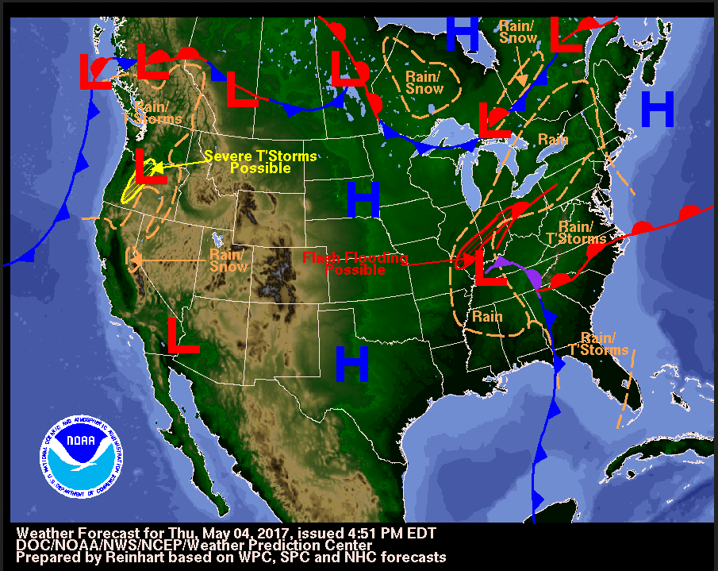For this final assignment, you will write a technical discussion of a weather event that recently occurred in Connecticut several weeks ago. Technical discussions of the weather are written daily by the National Weather Service (NWS) for other meteorologists. The NWS in Boston is in charge of writing these technical discussions for the Hartford area. You can view one of these discussions by going to http://www.weather.gov/box/ and clicking on “Forecast Discussion.” You will also receive a generated “forecast discussion” that was written by a “beginning meteorologist.” Review both of these documents.
Now that you are familiar with this kind of writing, your task is to write your own technical discussion for a weather event that occurred in CT from Saturday June 11, 2016 through Sunday June 12, 2016.
Resources: To help you, you may use the following resources:
- A discussion of what happened during this weekend from WFSB, a local CBS affiliate.
LINK: http://www.wfsb.com/story/32186701/gorgeous-today-weekend-storms
- Data from Weather Underground—use the historical data for Saturday June 11, 2016 through Sunday June 12, 2016. Use data from Bradley International Airport (BDL).
LINK: https://www.wunderground.com/ then type in BDL and search for historical data.
- Weather Maps from the NWS—Weather Prediction Center
LINK: http://www.wpc.ncep.noaa.gov/dwm/dwm.shtml
NOTE: Use this data as the “evidence” described in the “Gotta Have It” Checklist.

RAFT Assignment
To complete this task, you will individually write a technical discussion about a recent weather event, which depicts a passing low pressure systems with its associated fronts and air masses. Please read your role, audience, format and topic for this writing assignment below. In addition, read the “Gotta-have-it” checklist before you start writing. Also, please refer to it as you are writing.

Role: You are a meteorologist working for the National Weather Service (NWS) in Boston.
Audience: Your technical discussion will be written for meteorologists in the Hartford area.
Format: You will write a minimum of three paragraphs (approximately a half of a page single spaced) in the style of technical reports (see resources above).
Topic: A weather event occurring in Connecticut on Saturday, June 11 to Sunday, June 12, 2016.
“Gotta Have It” Checklist
Your technical discussion should include (content):
- The kind of storm system approaching CT over this weekend.
- The type of air mass(es) that is affecting CT on Saturday, June 11, 2016
  - Include timings and evidence from the resources above.
- The front that passes through CT on Saturday, June 11, 2016
  - Include timings and evidence from the resources above.
- The type of air mass(es) that is affecting CT on Sunday, June 12, 2016
  - Include timings and evidence from the resources above.
- The front that passes through CT on Sunday, June 12, 2016
  - Include timings and evidence from the resources above.
The technical discussion should include the following stylistic elements (writing):
- Develops technical discussion with concrete language and uses unit-specific vocabulary (e.g. cold front, maritime polar.
- Explains the weather event over time.
- Describes the cause and effect relationships of the weather event.
- Uses good writing mechanics such as grammar and punctuation.

Assessment: Please review the rubric for this writing assignment; this is how you will be graded.

Writing Rubric
Criteria | Excellent | Adequate | Needs Improvement
ELEMENTS OF A TECHNICAL DISCUSSION  The writing addresses all required components:  -Uses content terminology accurately (type of storm, air masses, and fronts)  -Describes the weather event over the specified time  -Explains the cause and effect relationship of the weather event | Includes all required content elements and uses them accurately.  (8pts) | Includes two of the three required elements of the technical discussion and uses them accurately.  (6pts) | Includes only one or part of one of the required elements accurately.  (2pts)
OVERALL WRITING QUALITY  The manner in which the written composition functions as a whole.  Appropriate scientific tone: precision of communication, objective and authoritative; third person point of view. | Uses clear, concise language with accurate scientific terms and vocabulary; appropriate scientific tone. (8pts) | Writing uses clear and understandable language with some use of accurate  scientific terms and vocabulary (between one and four) or may not use appropriate scientific tone. (6pts) | Writing is somewhat unclear; does not include specific scientific terminology or vocabulary and/or uses tone inappropriate to science. (2pts)
PARAGRAPH and SENTENCE STRUCTURE  The way the writing is structured in sentences and paragraphs.  Appropriate paragraphs: several paragraphs are used; organized by key ideas with supportive details; sentences sequenced within paragraphs.  Well-constructed sentences: sentences convey compete ideas and follow correct conventions (capitalization, punctuation). | Structures writing with appropriate paragraphs and well-constructed sentences. (8pts) | Paragraphs not purposefully constructed or contains poorly constructed sentences. (6pts) | Writing is not developed in appropriate paragraphs or sentences. (2pts)
WRITING MECHANICS  The final written product contains correct grammar, punctuation, and spelling. | Uses appropriate grammar, punctuation, and spelling, with no more than four errors. (8pts) | Several errors (5-7) in grammar, punctuation, and spelling. (6pts) | Numerous (more than 7) grammar, punctuation, and spelling errors that interfere with communication. (2pts)
Total Points: 32 points Earned Points: Comments:

Unit Appendices:

Appendix A: Unit Summary Table

Unit Summary Table: What is the explanation for the change in the weather from Marissa, IL?
Unit Activity  These are the activities that we did | Data Patterns & Observations  record what happened | Why?  What might cause these patterns & observations | Clues?  How does this help us figure out the unit phenomenon?
Investigation 2: What was the weather like before and after the weather changed?
Investigation 3: What is an air mass and how does it move?
Investigation 4: What features divide air masses and how do the features move?
Investigation 5: Can we predict changing weather?

Appendix B: Word Sort Activity for Investigation 4

Cold Fronts | Air Masses | Low pressure system
Pressure system | Stationary front | Warm front
Stormy weather | Occluded Front | Sunny weather
High pressure system |  | Fronts

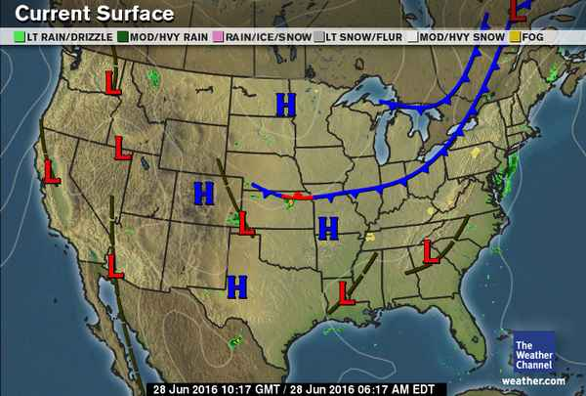Appendix C: Adapted Weather Discussion from the National Weather Service for Investigation 7
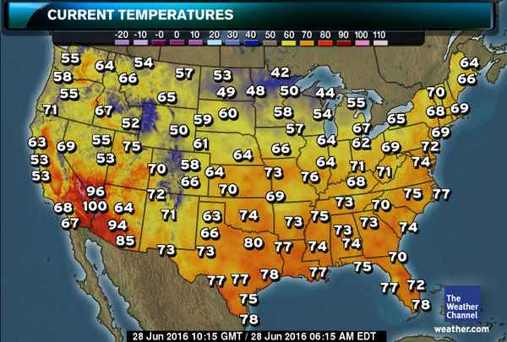Connecticut will be warm and muggy today. The low temperature this morning is currently in the upper 60’s, which is about five degrees above where it should be this time of year. Also, the dew point temperature is in the upper 60’s, which means it is very humid. The reason why it is so warm and humid this morning is because we are currently located in a maritime tropical (mT) air mass which typically forms over the warm Gulf Stream off the southeast coast of the United States. To our west, there is a cold front that is moving east, toward Connecticut. Winds in front of a cold front are typically from the south, which is why this air mass traveled from the south to the north from the southeastern part of the US to the northeastern part (where we live).

Connecticut will experience a greater chance of showers and possibly a thunderstorm later this afternoon. As indicated by the arrows on the blue line, as the cold front moves toward Connecticut, it typically brings precipitation with it as the warm moist air gets pushed up forming clouds and precipitation. Currently, there are a few showers in western New York, which is just ahead of the cold front. This explains why these showers will move toward CT later today.

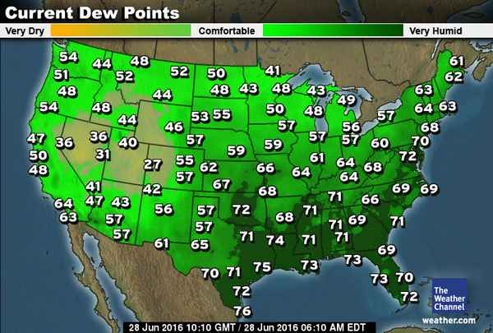The cold front will pass through CT tomorrow and the low pressure system (storm system) associated with it will move to our east. When this occurs, a cooler, drier air mass will settle into CT, bringing us a very nice summer day. Presently, the air behind the cold front is in the 50’s, which about 10 degrees colder than the current temperature. Also, the dew points behind the cold are in the 40’s, which is significantly lower than what CT is currently experiencing. Winds behind the cold front are typically from the north. This is the reason why the continental polar air mass from Canada will move toward CT and bring us cooler and drier weather for tomorrow.

