Ice Cream Challenge: Design Journal
Name: ___________________________________________ Date: ______________ Hour: ______________
Now that we have identified the chemical processes that are endothermic we will be using one to make ice cream! Your task is to create a device which can decrease the temperature of the ice cream as much as possible in five minutes.

Knowledge Probe
What did you learn in the Endothermic v. Exothermic Investigation?
An endothermic reaction takes in heat energy and results in a decrease in temperature. We discovered that the most endothermic reaction is citric acid and baking soda. However, because ice water and salt started much cooler it may be a better reaction for freezing ice cream. An exothermic reaction gives off heat energy would not help to freeze the ice cream.

What is the basic method for making homemade ice cream? (Include list of ingredients and amounts of each.)
Add milk, vanilla and sugar to a quart-sized bag. Add ice and salt to a gallon sized bag. Put the quart size bag in the gallon size bag. Shake for one minute then let it sit for four more minutes.

What is the endothermic process that will freeze your ice cream?
The ice melting is the endothermic process that will freeze the ice cream.
What are the possible surroundings that the ice can take heat from in order for this endothermic process to occur? (Include a diagram)
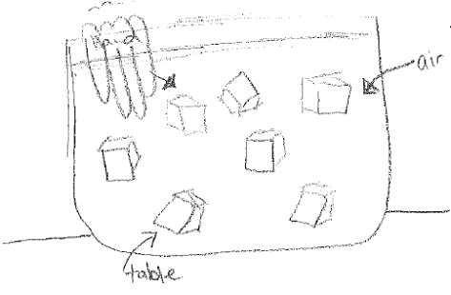
Examples: Table, hand, air, milk mixture

What is the goal? Where do we want the heat to transfer from? (Include a diagram)
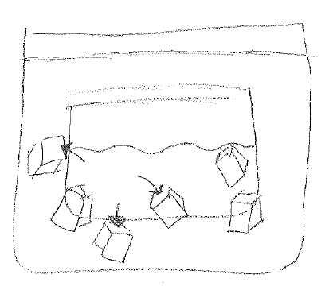
We want to freeze the milk mixture. We want the heat to come from the milk mixture.

How can you make sure that the heat comes from the surrounding of your choosing rather than another?
Insulate the mixture from the other sources of heat (energy).

