Knowledge Probe: Exothermic v. Endothermic
Name: ____________________________________
Write notes as you work together to gather scientific information for your experiment.
Article: What did you read?
Article: Endothemic vs. Exothermic Reactions - Khan Academy
- What are chemical bonds?

- Describe the exchange of energy (heat) that occurs when bonds are formed and when they are broken.

- Fill in this concept map.
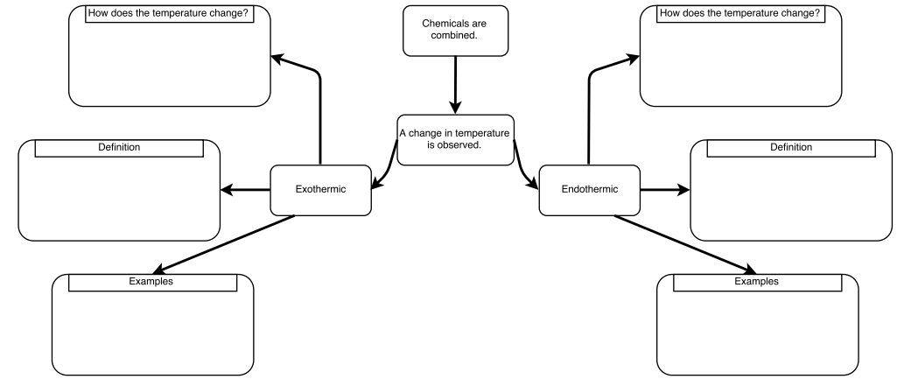

Video: What did you see?
Video: What are Endothermic and Exothermic Reactions?
- What are examples of exothermic reactions?

- What are examples of endothermic reactions?

- How can you determine if the reaction is exothermic or endothermic?

Examples:
Reaction 1: https://www.youtube.com/watch?v=GQkJI-Nq3Os
- Describe what happened.

- Is this an endothermic or exothermic reaction? Why?

Reaction 2: https://www.youtube.com/watch?v=NTFBXJ3Zd_4
- Describe what happened.

- Is this an endothermic or exothermic reaction? Why?

