Expert roles and engineering steps

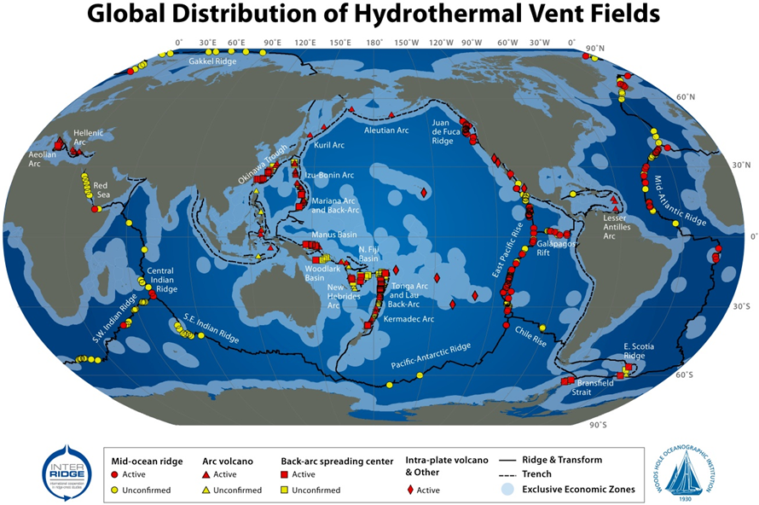
www.pmel.noaa.gov/eoi/PlumeStudies/global-vents/images/global-vents-map.png
Interactive map: http://vents-data.interridge.org/ventfields-geofield-map

Challenge
Design, build, and test a sampling chamber using the engineering design process. The chamber will hold hot water and be designed to keep the water sample hot when placed in icy water. The chamber must sit on the bottom of the tank (not float) and be no larger than a soda can. The temperature of the hot water will be taken before the chamber is submerged and again after 10 minutes. The device must be able to be opened to test the water temperature and it must be reusable. The chamber with the smallest change in temperature is the “winner.”

Constraints on chamber
- Size: No larger than a soda can
- Maintain water heat of 60°C (140°F)
- Made of material that is least reactive to microbes
- Hold no more than 70 mL of hot water at 60°C (140°F) and 70°C (158°F)
- Be reusable and allow for temperature measuring after the test

Step 1: Background research
Divide the research among your group members. Each one of you should become an expert on what you research and teach the others in your group.

Define your roles
Heat expert:
Buoyancy expert:
Microbe expert:

Science concepts you need to know
Heat
Heat is a form of energy. Heat is transferred in three ways. Read and watch the following to learn more about heat:

- What is heat? How is it measured? What are the units?—http://bit.ly/2EnVPKu
- Are heat and temperature the same? Why is this important?—www.youtube.com/watch?v=vH3wyV4Zrrg; www.youtube.com/watch?v=yxBTEMnrZZk
- How is temperature measured at the hydrothermal vents?—www.divediscover.whoi.edu/hottopics/temp.html
- How is thermal energy transferred? What will be the dominant method of heat transfer from the sampling chamber to the surrounding water?—http://bit.ly/2nLIyRG; www.youtube.com/watch?v=1fbG4zt9xn4; http://bit.ly/2E5wGFr; http://bit.ly/2s98ood;
http://bit.ly/2ByexTM; http://bit.ly/2E58vXB
- How can heat transfer be slowed down?—http://bit.ly/2nFTAJf
- Materials possess a property called specific heat. What is specific heat and how does it relate to the engineering challenge?—http://bit.ly/2shjkAr

Pressure in the ocean
What is the pressure like at the bottom of the ocean? Why does the water leaving the deep-sea hydrothermal vent at high temperature (up to 400ºC [752°F]) not boil?—http://bit.ly/2E5rfSP; http://bit.ly/2E6R092; www.divediscover.whoi.edu/hottopics/deepsea.html

Will it sink or float?
What do you need to know to make your chamber sink to the bottom? What is buoyancy and how is it measured? What does density have to do with an object floating?—http://bit.ly/2nLmirn; http://bit.ly/2EivLRb; www.ck12.org/physical-science/Density-in-Physical-Science

Microbes and bacteria
What is important to know about bacteria when designing a sampling chamber? What materials might best keep the bacteria and microbes functioning like they do at hydrothermal vents?—www.divediscover.whoi.edu/hottopics/bacteria.html; www.divediscover.whoi.edu/hottopics/microbes.html;
http://bit.ly/2E59x1C; www.ck12.org/biology/Chemosynthesis/lesson/Chemosynthesis-BIO; www.sciencedaily.com/releases/2012/08/120813074017.htm; http://bit.ly/2E36ydZ

Step 2: Collaboration
Discuss with your group how you will work together and make decisions. Remember to share your roles with others in your group. How will you decide how to take turns? The most productive groups are those that establish emotional safety.

Record your decisions about collaboration:

Decide on the tasks and decide who will do them:

Step 3: Engineering
Define the problem:

Who are the clients?

What are the constraints for the design challenge?

Summary of background information
 | Conclusions | Questions we still have
Heat transfer
Buoyancy
Reactivity to microbes
Reusability of design

Brainstorm materials that can be used to solve the problem.

Tinker with materials, but take notes.

Conduct an experiment using Heat Lost Lab that answers the following question: “What is the best combination of materials to slow heat transfer?” Record your results below.

Table 1: Heat lost
Container | Heat lost  (mass*[T1–T2]*joules)
Plastic test tube
Glass test tube
Metal tube/pipe
PVC tube/pipe

How can the chamber be designed so that it sinks to the bottom?

What materials are least reactive to microbes?

Step 4: Design
Decide on the tasks and who will do them:

Based on your experiments and the data you collected, what is the best combination of materials to solve the problem?

Describe in words and pictures (sketch) how the chamber will be built.

Get approval from your teacher before building.

Step 5: Build a prototype and test it
Decide on the tasks and decide who will do them:

Document any changes you make to your design as you build.

Engineering Challenge Week schedule
Class 1: Design and build
Classes 2 and 3: Finish building, test designs, consult client (Dr. Sievert)
Class 4: Redesign and test
Class 5: Final testing if needed; work on presentation
Class 6: Presentations
Class 7: Reflection

Class 1
- The microbe group will make final observations about the bacteria culture. Take pictures and record your observations in a document. Share your results with the engineering team.
- The heat and buoyancy experts within each group will discuss the pros and cons of each design.
- Each group will decide on a final design. The following tasks need to be completed. Each group will decide on one or two people to complete a task. A person can have more than one role.
  - Sketcher of the final design that reflects a consensus of each group member’s ideas
  - Constraint checker
  - Materials guru and cost calculator
  - Builders
  - Note-takers
  - Photographer
  - Heat-lost hero
  - Buoyancy barista
  - Stay on-task police
  - Clean-up artist

- Use the Engineering Challenge document that your group already created to record your progress. Every choice your team makes needs to be written down in the document. For each choice, give a reason for why it was chosen.

Testing summary
Trial | Mass of water | Starting temperature | Ending temperature | Change in temperature | Heat lost | Mass of device | Volume of device | Density of device | Buoyancy | Reusable?
1
2
3
4

Design log
Design | Date | Changes made
1
2
3
4

Step 6: Solution
Describe in words and pictures your solution.

Summary of final test
Group | Mass of water | Starting temperature | Ending temperature | Change in temperature | Heat lost | Mass of device | Volume of device | Density of device | Buoyancy | Reusable?
1
2
3
4

Step 7: Communicate
Create a presentation using the Presentation Checklist and the Engineering Design Rubric.

