Name ____________________________________________ Date _____________________
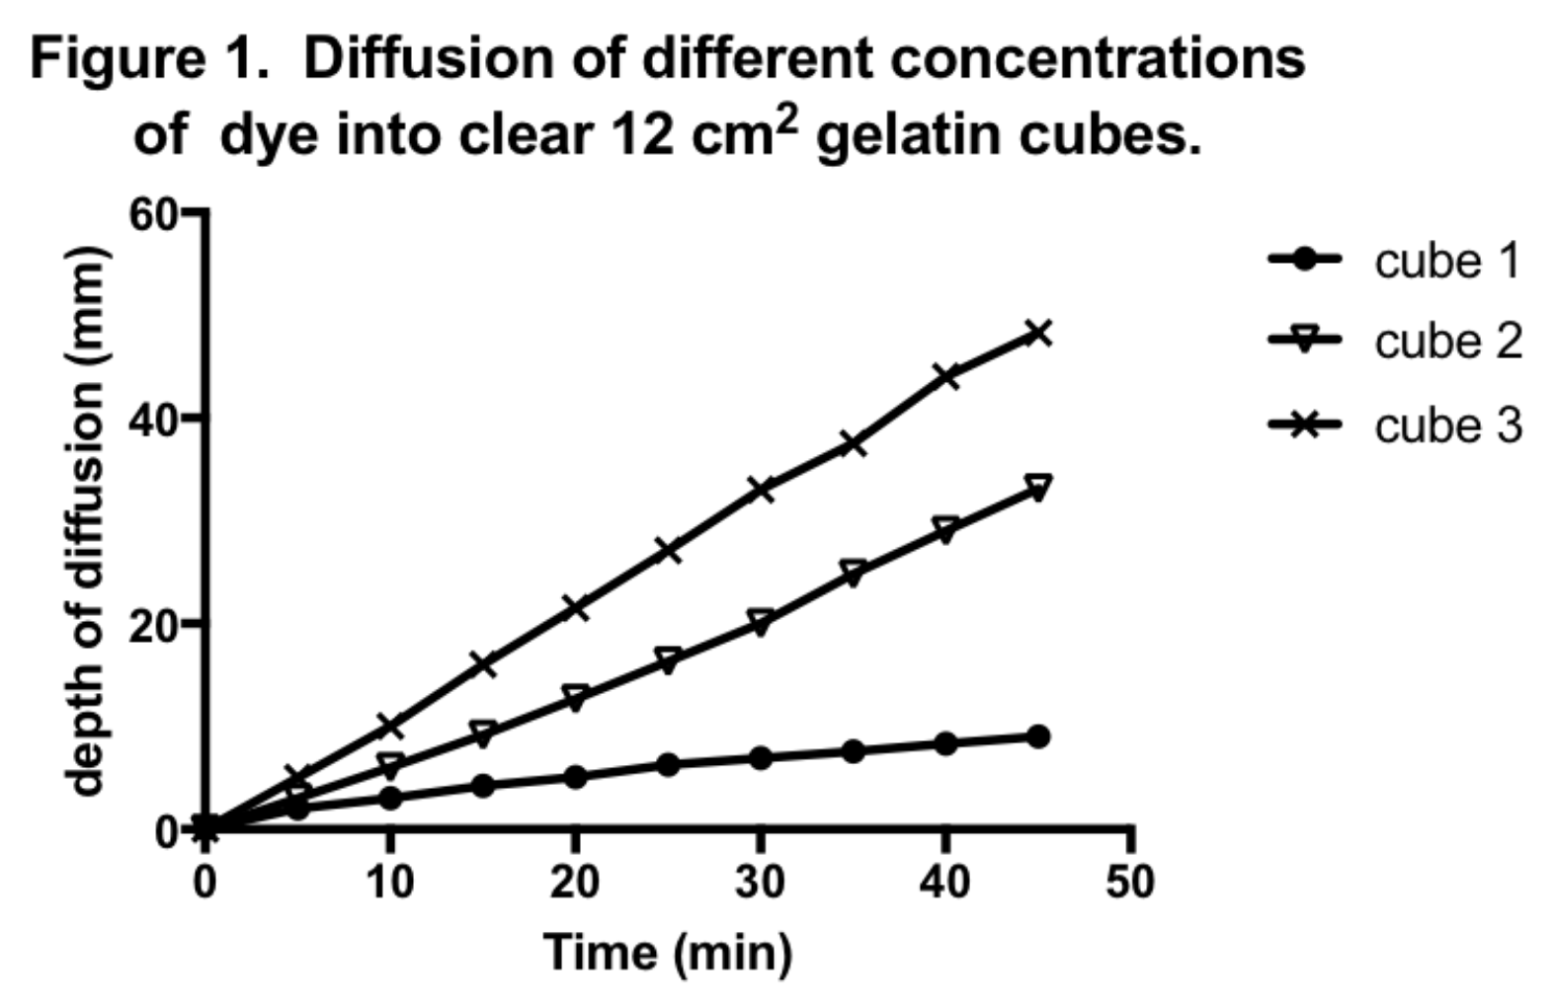
1. In this graph, 12 cm² cubes of gelatin are placed in dye solutions. Which cube shows

a. the fastest rate of diffusion ________________

b. the slowest rate of diffusion
________________

2. In the same graph (figure 1), what is the depth of diffusion after 30 minutes for
Cube 1 ___________ Figure 2. Marine Fish lose water due to
osmosis at different rates.
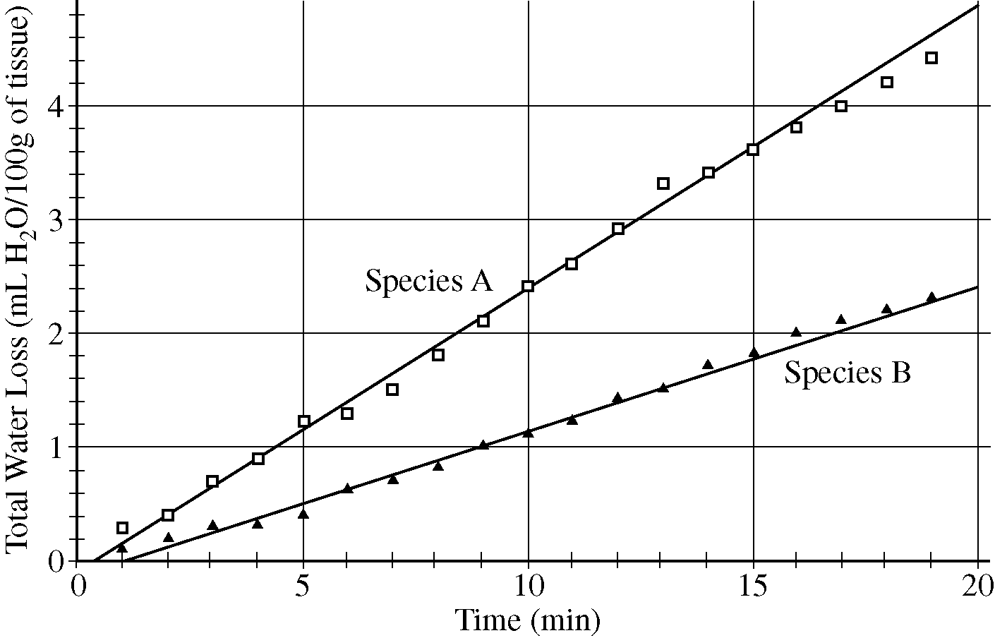
Cube 2 __________

Cube 3 ___________

3. How long did it take for the dye to reach a depth of 40 mm
in Cube 3 ?
____________

4. In Figure 2, two marine fish species are losing water by osmosis. Which of the two species has the fastest rate of water loss?
___________

5. Which fish species shows a total water loss of
1 ml in ten minutes? _______ How about a total loss of 3.5 ml in 15 minutes?________

6. How long did it take Species B to lose 2.0 ml of water? _____________________

7. You have a 4 cm³ cube of BTB agar, and an 8 cm³ cube of BTB agar. Which one would you expect to turn yellow first, when both are dropped into the same cup of vinegar at the same time?
______________________________

8. It takes you 30 minutes to walk one mile – but your friend can walk the same distance in 15 minutes. Which of the following must be true?
a. You are walking at a faster rate c. You both are walking at the same rate
b. Your friend is walking at a faster rate d. Your friend is walking at a slower rate

9. In 5 minutes you can run half a mile. In the same 5 minutes, your friend can run ¾ mile. Which of the following must be true?
a. You are running at a faster rate c. You both are running at the same rate
b. Your friend is running at a faster rate d. Your friend is running at a slower rate
10. It takes you 30 minutes to walk one mile. You friend can walk two miles in 60 minutes. Which of the following must be true?
a. You are walking at a faster rate c. You both are walking at the same rate
b. Your friend is walking at a faster rate d. Your friend is walking at a slower rate

11. Two cubes of BTB agar are dropped into the same cup of vinegar at the same time. After ten minutes they are removed and cut open to determine the depth of diffusion of vinegar into the agar.

a. If cube X had 10 mm left to go before the entire cube was yellow, and
cube Z only had 3 mm to go before the entire cube was yellow, can you tell me which cube was larger?
____________________________

b. Would you say that one cube has a faster rate of diffusion? ____________________

If so, which one? _____________________________
If the rates were the same, why did one cube turn yellow faster? ______

_________________________________________________________

12. You have a 2 x 2 x 2 cm cube and a 2 x 1 x 4 cm rectangular cuboid of BTB agar.
Cube Cuboid

What is the volume of each? ___________ ___________

What is the surface area of each? ___________ ___________

What is the surface area : volume ratio of each? ___________ ___________

Which do you expect to turn yellow first, when dropped into vinegar? ________________

13. Circle the cube that has the faster rate of diffusion – circle both if the rates are the same:

a big cube or a small cube - both dropped into the same temp / concentration of vinegar.

a big cube or a small cube - big cube dropped into Hot vinegar, small cube dropped into Cold vinegar.

a big cube or a small cube - big cube dropped into 20% vinegar, small cube dropped into 30% vinegar.

a big cube or a small cube - big cube dropped into 200 ml of 5% vinegar, small cube dropped into 50 ml of 5% vinegar (all vinegar at room temperature).

14. Some of the cells in your body are designed to allow rapid diffusion of nutrients and
gases. What are they and what characteristics do these cells have?

15. When a cell is very thin, flat or narrow, it can obtain nutrients quickly. What possible
disadvantages might there be to such a cell shape?
Name ____________________________________________ Date _____________________

- Two plants are growing in the same garden. One is a carrot, with a large taproot. One is wheat, with many smaller fibrous roots (see picture below). This summer there is a drought and plants are competing intensely for water – Explain, using scientific argument and evidence, which plant has the advantage.

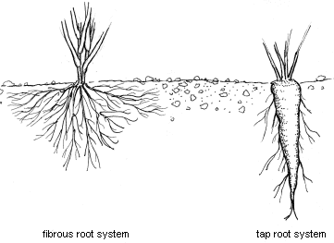

- Many mammals, like jackrabbits, live all across America. The Black-Tailed Jackrabbit lives in hot desert areas in the Western U.S. and Mexico. The White-Tailed Jackrabbit lives in higher altitudes, plains, prairies, and alpine meadows – all cooler areas. Explain, using scientific reasoning, which species you expect to have larger ears.

- Using this resource ( http://anthro.palomar.edu/adapt/adapt_3.htm ) describe three ways that human bodies adapt when living at high altitudes for long periods of time by increasing the surface area of a body part.

- In the March 15, 2011 issue of the Journal of Epidemiology & Community Health, researchers from the University of Colorado School of Medicine and the Harvard School of Global Health reported that people generally live longer at high altitudes and have a lower risk of dying from coronary artery disease. The researchers speculated that mild hypoxia improves the way the heart functions and produces new blood vessels that increase blood flow for the heart. An alternative explanation presented by the authors is that increased exposure to ultraviolet radiation from the sun at higher altitudes increases the body's ability to produce vitamin D, which has beneficial effects on the heart. How would you scientifically test the hypothesis that people who live at high altitudes produce more vitamin D?

- In ecology, there is a rule called “Bergmann’s rule” which states that within a taxonomic clade (related species, like white tailed deer, mule deer, reindeer, and moose) populations and species of larger size are found in colder environments and species of smaller size are found in warmer regions. Why would this pattern exist?

- Leaves most likely evolved in order to increase evaporative cooling. What else can happen with a greater leaf surface area? Which are good and which are harmful?

- Graph the following data – and write an evidence – based conclusion from it.

Surface Area : Volume ratio | Length of side of a cube (cm)
6 | 1
3 | 2
2 | 3
1.5 | 4
1.1 | 5
1 | 6
0.9 | 7
0.7 | 8
0.65 | 9

