Name ________ANSWER KEY _______________________ Date _____________________
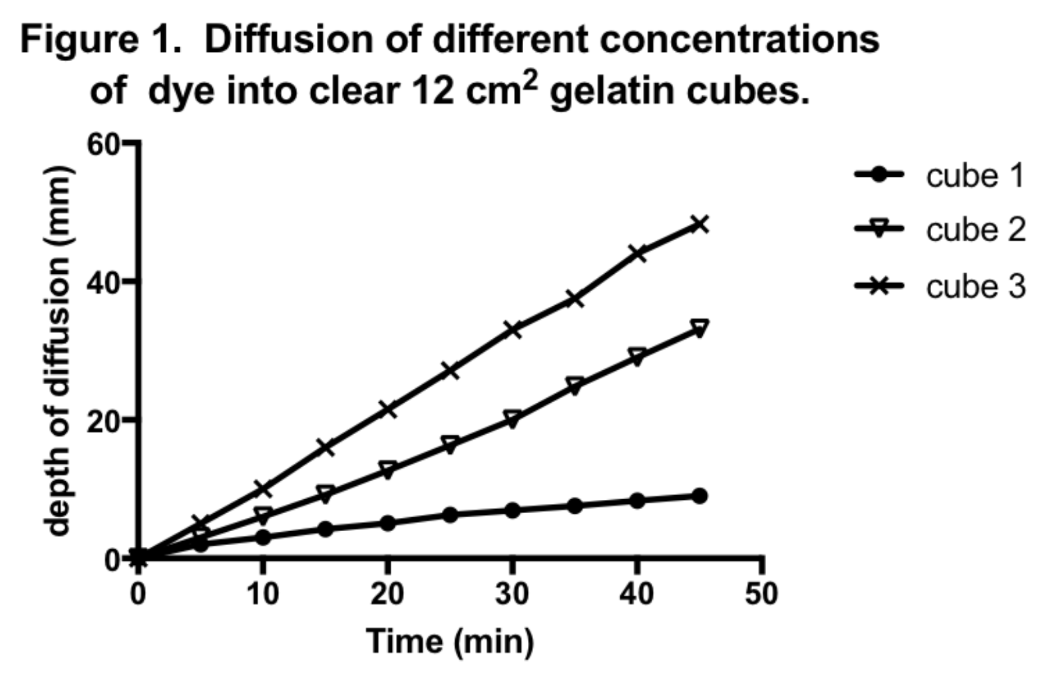
1. In this graph, 12 cm² cubes of gelatin are placed in dye solutions. Which cube shows

a. the fastest rate of diffusion _____CUBE 3___

b. the slowest rate of diffusion
______CUBE 1___

2. In the same graph (figure 1), what is the depth of diffusion after 30 minutes for
Cube 1 __7-10 MM___ Figure 2. Marine Fish lose water due to
osmosis at different rates.
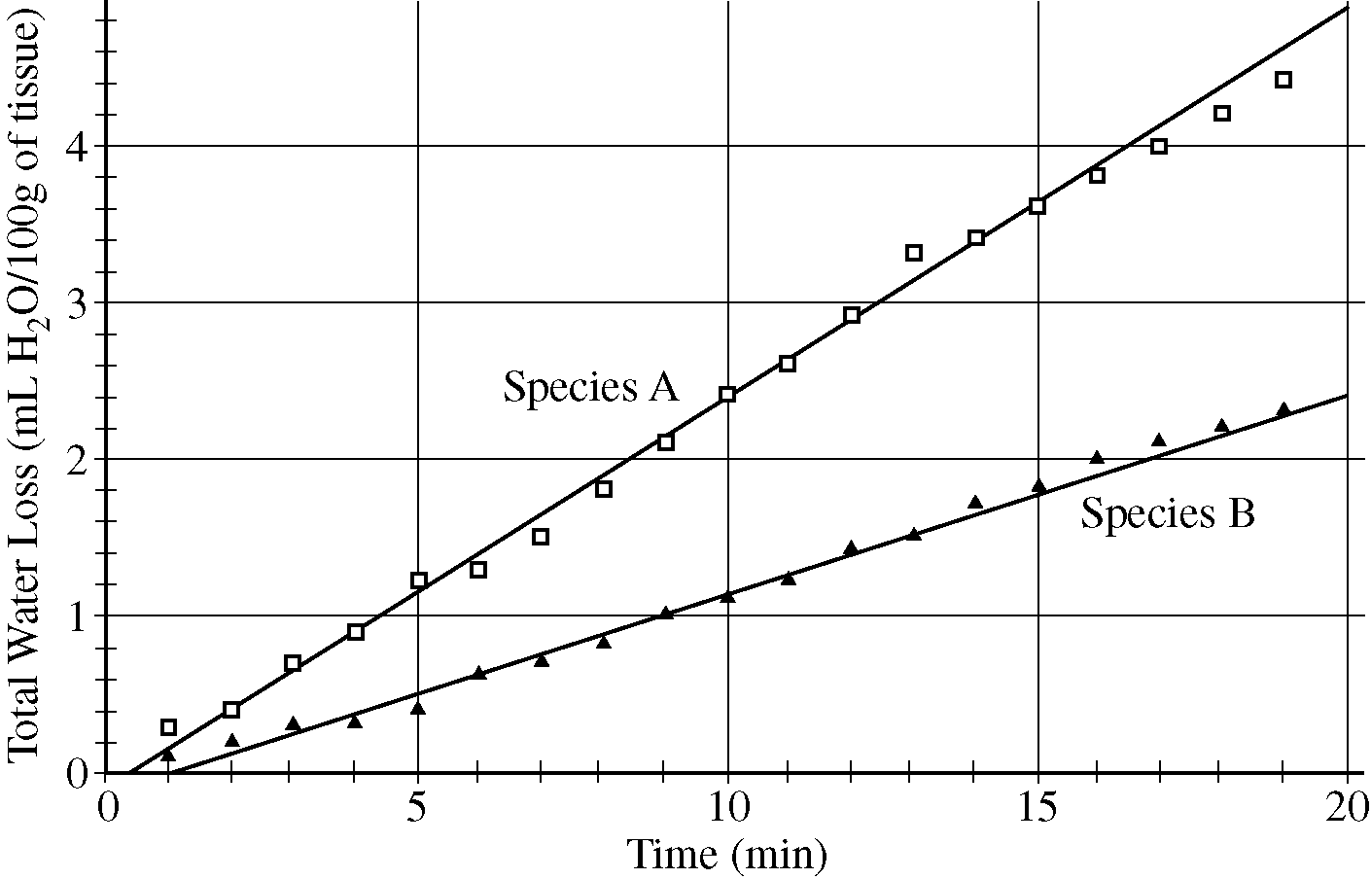
Cube 2 ___20 MM___

Cube 3 ___30-35 MM_

3. How long did it take for the dye to reach a depth of 40 mm
in Cube 3 ?
____38-40 MINUTES

4. In Figure 2, two marine fish species are losing water by osmosis. Which of the two species has the fastest rate of water loss?
____A_____

5. Which fish species shows a total water loss of
1 ml in ten minutes? ___B___ How about a total loss of 3.5 ml in 15 minutes?___A___

6. How long did it take Species B to lose 2.0 ml of water? ____17 MIN____________

7. You have a 4 cm³ cube of BTB agar, and an 8 cm³ cube of BTB agar. Which one would you expect to turn yellow first, when both are dropped into the same cup of vinegar at the same time?
__4 CM³ BECAUSE IT IS SAMLLER – HAS LARGER SA:V________

8. It takes you 30 minutes to walk one mile – but your friend can walk the same distance in 15 minutes. Which of the following must be true?
a. You are walking at a faster rate c. You both are walking at the same rate
b. Your friend is walking at a faster rate d. Your friend is walking at a slower rate

9. In 5 minutes you can run half a mile. In the same 5 minutes, your friend can run ¾ mile. Which of the following must be true?
a. You are running at a faster rate c. You both are running at the same rate
b. Your friend is running at a faster rate d. Your friend is running at a slower rate
10. It takes you 30 minutes to walk one mile. You friend can walk two miles in 60 minutes. Which of the following must be true?
a. You are walking at a faster rate c. You both are walking at the same rate
b. Your friend is walking at a faster rate d. Your friend is walking at a slower rate

11. Two cubes of BTB agar are dropped into the same cup of vinegar at the same time. After ten minutes they are removed and cut open to determine the depth of diffusion of vinegar into the agar.

a. If cube X had 10 mm left to go before the entire cube was yellow, and
cube Z only had 3 mm to go before the entire cube was yellow, can you tell me which cube was larger?
______CUBE X________________

b. Would you say that one cube has a faster rate of diffusion? NO, RATE WAS SAME

If so, which one? __________no_________________
If the rates were the same, why did one cube turn yellow faster? ______
THE SMALLER CUBE HAD LARGER SA:V RATIO SO TURNED YELLOW FIRST

12. You have a 2 x 2 x 2 cm cube and a 2 x 1 x 4 cm rectangular cuboid of BTB agar.
Cube Cuboid

What is the volume of each? ____8 cm³__ ___8 cm³__

What is the surface area of each? ___24 cm²__ _36 cm²__

What is the surface area : volume ratio of each? __3:1______ ___4.5:1__

Which do you expect to turn yellow first, when dropped into vinegar? ___cubiod______
2

2

2
4

2

1

VOL = LxWxH = 2x2x2 = 8 cm³ VOL = LxWxH = 4x2x1 = 8 cm³

SA = 6(S²) = 6x2² = 24 cm² SA = 4 (LxW) + 2 (LxW) = 4 (4x2) + 2 (2x1) = 36 cm²

13. Circle the cube that has the faster rate of diffusion – circle both if the rates are the same:

a big cube or a small cube - both dropped into the same temp / concentration of vinegar.

a big cube or a small cube - big cube dropped into Hot vinegar, small cube dropped into Cold vinegar.

a big cube or a small cube - big cube dropped into 20% vinegar, small cube dropped into 30% vinegar.

a big cube or a small cube - big cube dropped into 200 ml of 5% vinegar, small cube dropped into 50 ml of 5% vinegar (all vinegar at room temperature).

14. Some of the cells in your body are designed to allow rapid diffusion of nutrients and
gases. What are they and what characteristics do these cells have?

Red blood cells have a flattened concave shape which increases SA:V and allows efficient diffusion

15. When a cell is very thin, flat or narrow, it can obtain nutrients quickly. What possible
disadvantages might there be to such a cell shape?

It could potentially be easier to eat (larger predator)
Toxins would also diffuse in more quickly

Name ____________________________________________ Date _____________________

- Two plants are growing in the same garden. One is a carrot, with a large taproot. One is wheat, with many smaller fibrous roots (see picture below). This summer there is a drought and plants are competing intensely for water – Explain, using scientific argument and evidence, which plant has the advantage.

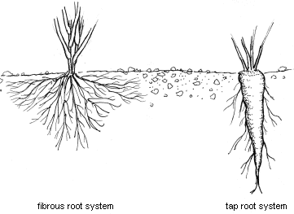
Wheat, with many smaller fibrous roots
will have a larger SA:V ratio – so more water
will diffuse into these roots and the wheat
plant will be better off in a drought.
Branching is a way to increase SA.

- Many mammals, like jackrabbits, live all across America. The Black-Tailed Jackrabbit lives in hot desert areas in the Western U.S. and Mexico. The White-Tailed Jackrabbit lives in higher altitudes, plains, prairies, and alpine meadows – all cooler areas. Explain, using scientific reasoning, which species you expect to have larger ears. The black tailed jackrabbit lives in the hot desert – having larger ears is a way for it to diffuse more heat into the atmosphere. Rabbits are warm blooded, and make extra heat which diffuses into the air (just like humans). Having bigger ears gives them a larger surface area for that heat to diffuse out into the air, away from their body.

- Using this resource ( http://anthro.palomar.edu/adapt/adapt_3.htm ) describe three ways that human bodies adapt when living at high altitudes for long periods of time by increasing the surface area of a body part.
1. Breathing rate increases, and 2. heart rate increases, and the 3. body forms more capillaries and 4. more red blood cells and 5. more hemoglobin per red blood cell to increase the amount of oxygen they can bind and transport - as well as 6. increasing lung size so there is more surface area for diffusion.
On returning to sea level after successful acclimatization to high altitude, the body usually has more red blood cells and greater lung expansion capability than needed. Since this provides athletes in endurance sports with a competitive advantage, the U.S. maintains an Olympic training center in the mountains of Colorado. Several other nations also train their athletes at high altitude for this reason. However, the physiological changes that result in increased fitness are short term at low altitude. In a matter of weeks, the body returns to a normal fitness level.

- In the March 15, 2011 issue of the Journal of Epidemiology & Community Health, researchers from the University of Colorado School of Medicine and the Harvard School of Global Health reported that people generally live longer at high altitudes and have a lower risk of dying from coronary artery disease. The researchers speculated that mild hypoxia improves the way the heart functions and produces new blood vessels that increase blood flow for the heart. An alternative explanation presented by the authors is that increased exposure to ultraviolet radiation from the sun at higher altitudes increases the body's ability to produce vitamin D, which has beneficial effects on the heart. How would you scientifically test the hypothesis that people who live at high altitudes produce more vitamin D?

You could measure vitamin D levels in people that live at altitude and people that live at sea level, and compare. You could measure your vitamin D level (as well as levels in many friends – for replication) at low altitudes then go spend a month in a high altitude environment and after a month has passed, measure your levels again to see if there is an increase.

- In ecology, there is a rule called “Bergmann’s rule” which states that within a taxonomic clade (related species, like white tailed deer, mule deer, reindeer, and moose) populations and species of larger size are found in colder environments and species of smaller size are found in warmer regions. Why would this pattern exist?

Because a larger animal has a smaller SA:V ratio and so will NOT lose their body heat as quickly as a smaller animal with a high SA:V ratio. Retaining heat is adaptive in cold environments and helps survival.

- Leaves most likely evolved in order to increase evaporative cooling. What else can happen with a greater leaf surface area? Which are good and which are harmful?

A larger surface area also allows the leaf to absorb more sunlight (for photosynthesis) and it will also have more stomata so more CO₂ can be taken in (for photosynthesis). BUT, more stomata can also mean more water loss (transpiration) which can make the plant wilt.

- Graph the following data – and write an evidence – based conclusion from it.

Surface Area : Volume ratio | Length of side of a cube (cm)
6 | 1
3 | 2
2 | 3
1.5 | 4
1.1 | 5
1 | 6
0.9 | 7
0.7 | 8
0.65 | 9

SA:V ratio
0 1 2 3 4 5 6 7 8 9 10
6

5

4

3

2

1

0

Length of side of cube (cm)

As a cube gets larger, the surface area:volume ratio gets smaller - this will affect diffusion. The larger the surface area as compared to volume, the shorter the amount of time before materials diffuse all the way through the cell

