African Penguin  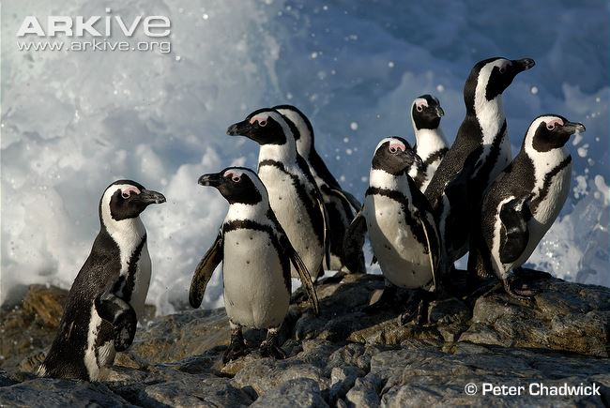  https://www.aza.org/SAFE-african-penguin | Asian Elephant  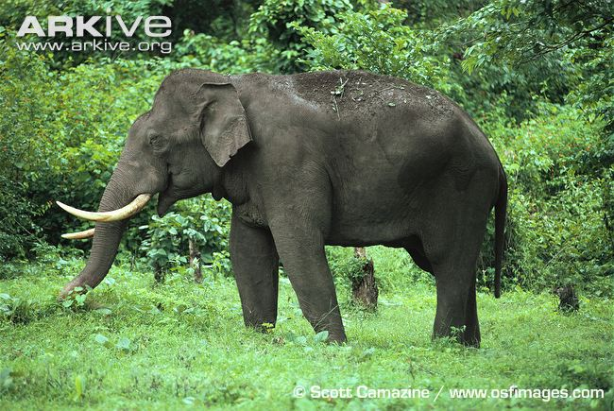  https://www.aza.org/SAFE-asian-elephant
Black Rhinoceros  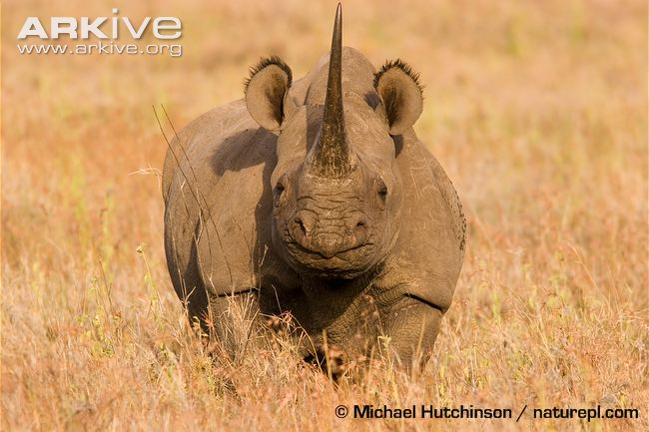  https://www.aza.org/SAFE-black-rhino | Cheetah  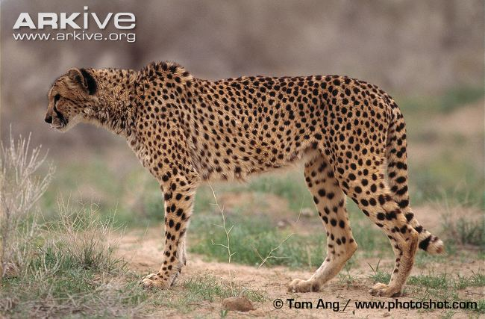  https://www.aza.org/SAFE-cheetah
Gorilla  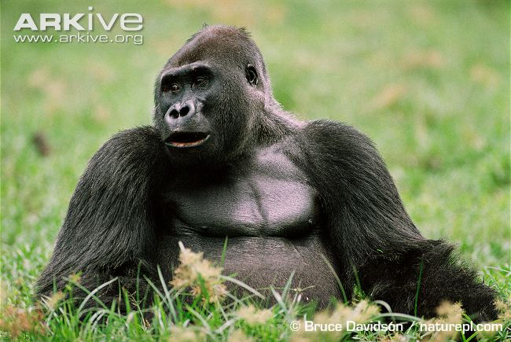  https://www.aza.org/SAFE-gorilla | Sea Turtles  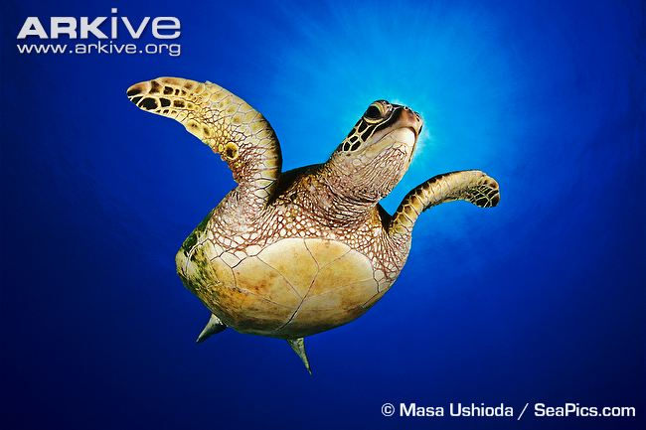  https://www.aza.org/SAFE-sea-turtle
Sharks and Rays  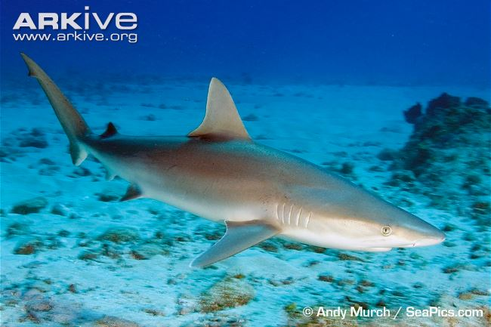  https://www.aza.org/SAFE-shark-and-ray | Vaquita  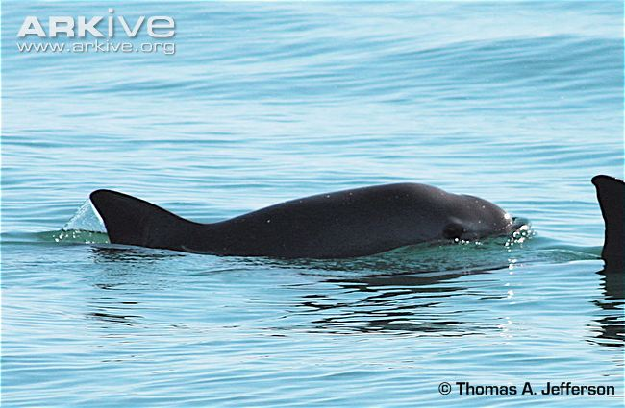  https://www.aza.org/SAFE-vaquita
Western Pond Turtle  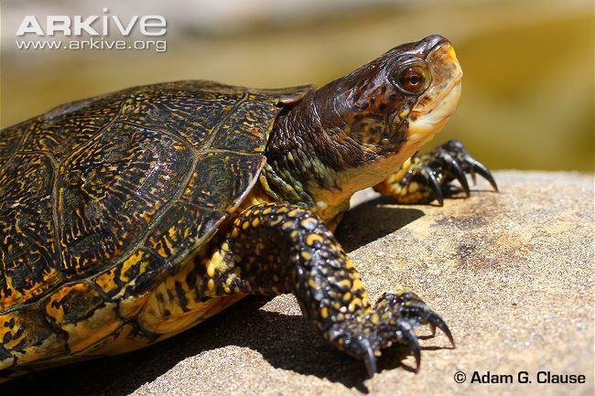  https://www.aza.org/SAFE-western-pond-turtle | Whooping Crane  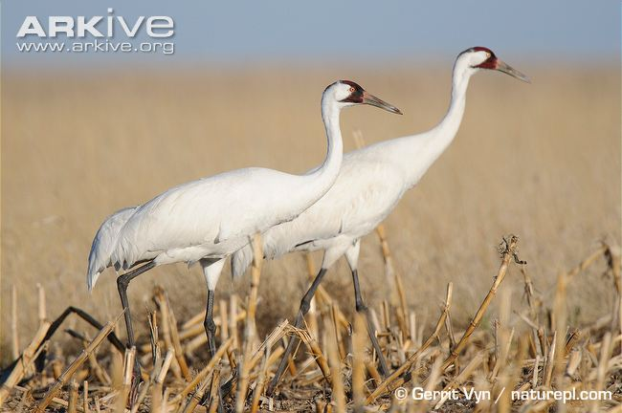  https://www.aza.org/SAFE-whooping-crane

