SAMPLE DATA COLLECTION SHEET
Name:
Period 3
10/1/17

- Insert a picture of the cups after step 4 of the discrepant event:
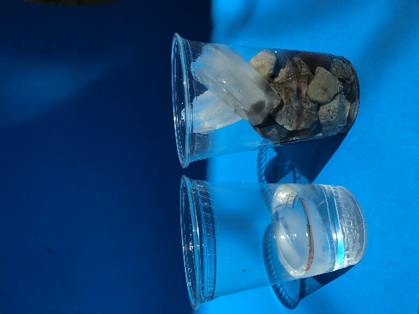
- Insert a picture of the cups after the ice melts:
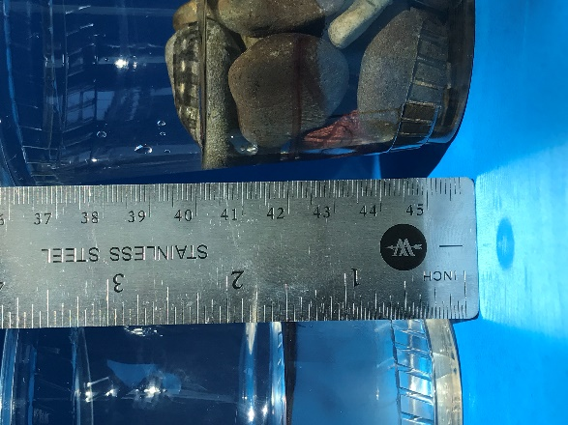

- Describe and explain the results, and compare this to the melting polar ice caps:
The cup that has only ice and water represents most of the ice found in the Arctic. Under the massive ice cap in the Arctic Ocean. The ice in this region is a floating mass. Most of the polar ice cap is submerged in the Arctic Ocean. The second cup with the rocks represents Antarctica, where much of the polar ice cap is an ice sheet created by snow falling on land, not melting before the following snowy season, and covered each year with fresh snow that compacts into a thick shelf of ice. Much of this polar ice cap is not submerged in water. Since the Arctic ice is already mostly submerged, the melting of this ice does not have a significant impact on sea level rise. Since most Antarctic ice is on land, it has a significantly higher impact on sea level rise as new water is added to the ocean. With the melted water level in the second cup above 2 inches, the discrepant events shows a model of the difference melting ice in the Polar Regions could have on Earth’s coasts.

