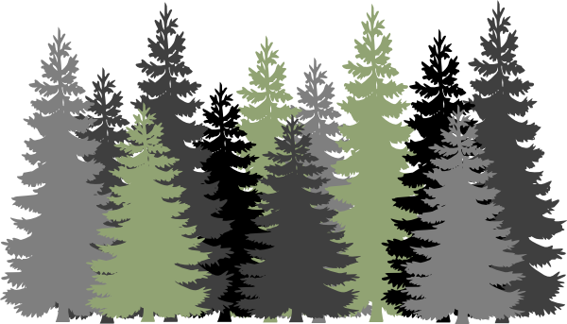
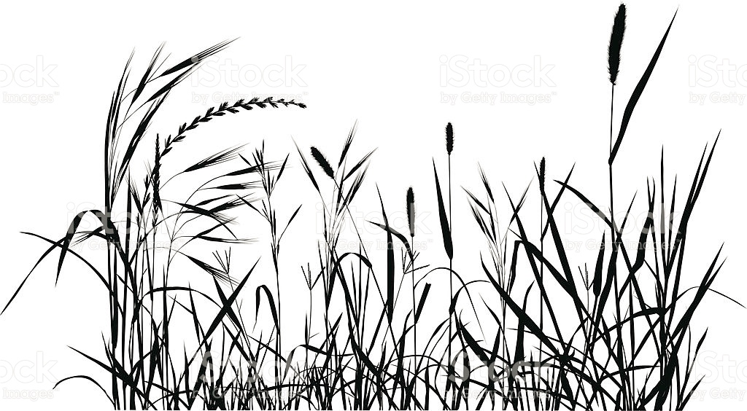 Habitat Happenings

eMammal deployment name: _________________________________________________________________________

Describe what your habitat looks like: ___________________________________________________________________
____________________________________________________________________________________________________________________________________________________________________________________________________
WATER: Is there water? NO YES Can animals easily access the water? NO YES
Water source type: Stream Puddle Lake River Pond Swamp Other: _________________

FOOD: Do you see any food sources? NO YES Can animals easily access the food sources? NO YES
What kinds of food? Berries Leaves Nuts Insects Other animals Other:____________________

Do you see any tracks or scat (animal poop)?  NO YES | Do you see any potential animal homes?  NO YES
Draw what you observe. | Draw what you observe.

Look straight up. What percentage of the sky above you is covered by trees? 0% 25% 50% 75% 100%
How could trees help an animal? _______________________________________________________________________
How could tree cover be problematic for an animal? _______________________________________________________
__________________________________________________________________________________________________

Do you see any features that might be harmful to animals? Why? ____________________________________________
__________________________________________________________________________________________________

Based on your observations, what animals do you believe would live in this habitat? _____________________________
____________________________________________________________________________________________________________________________________________________________________________________________________

What makes this habitat suitable for their survival? _______________________________________________________
____________________________________________________________________________________________________________________________________________________________________________________________________

