Figure 5: Design requirements of a new car body

Vehicle body constraints |  | Value | Rationale
Volume | Minimum | 9.5 cm³ (3.75 in.³) | Enough space in the vehicle for the driver
 | Maximum | None
Length | Minimum | 12.7 cm (5 in.) | Long enough to fit the driver’s legs and fit on the wheel base
 | Maximum | 25.4 cm (10 in.) | Short enough to be 3-D printed (might need to be adjusted based on capabilities of available 3-D printer or adjusted for ramp radius)
Height | Minimum | 2.5 cm (1 in.) | Tall enough for conceptual driver and components
 | Maximum | 12.7 cm (5 in.) | Short enough to be 3-D printed (may need to be adjusted based on available 3-D printer)
Width | Minimum at base attachment location (see below) | 2.5 cm (1 in.) | Ensure model size is sufficient to attach to the base
 | Maximum | 3.8 cm (1.5 in.) | Thin enough to fit on wheel base
Base attachment | Make two holes on the bottom of the car shape to connect to the base. Each hole is .63 cm (0.25 in.) in diameter and 1 cm (0.4 in.) deep. The holes are 6.3 cm (2.5 in.) apart. The holes are designed to connect the post protrusions of the car base. The car shape can rest on the base or be secured with tape.  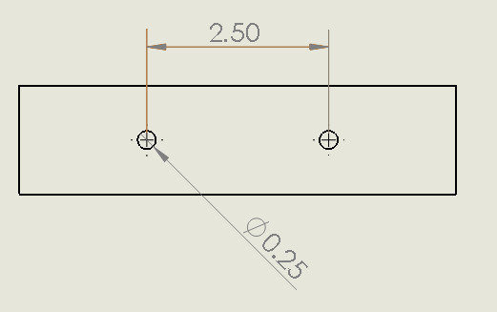

Appendix F- Car files for 3D printers
Part files will be supplied in a universal 3D printing file type (.STL). Illustrations of shapes are shown below for review.

- Car Base.STL

- Tall Block.STL

- Short Block.STL

- Short Wedge.STL

- Tall Wedge.STL

- Short Trapezoid.STL

- Tall Trapezoid.STL

- Semi-circle.STL

- Assembly instructions
  - Print Car Base.STL
  - Insert wheel axle into wheels

  - Insert wheel assembly into Car Base

  - Print basic shapes (e.g., Tall wedge, Tall Block)
  - Ensure weights of basic shapes by adding washers to bottom of basic shapes as necessary. Secure with tape.
  - Connect basic shape to base by inserting the pins on base to the holes in the top shapes.

