Worksheet I: Observations and testing on track

Using different shapes installed to the base of the car, record your observations on the motion of the car on the track.

Shape |  | Predictions | Time recorded
Tall block | 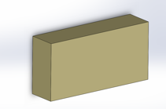
Short block | 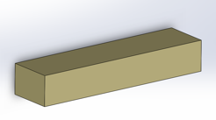
Short wedge | 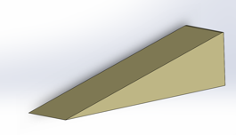
Tall wedge | 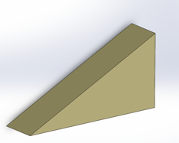
Short trapezoid | 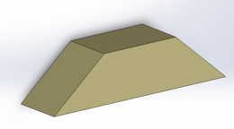
Tall  trapezoid | 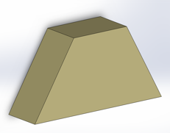
Semi circle | 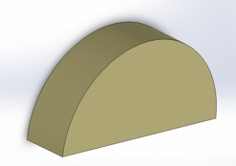

Worksheet II: Brainstorm solution with CAD

You will use your “engineering toolkit” with aerodynamics and CAD to design a shell of the soap box derby to solve the problem.

- What are the requirements and constraints?

- Based on previous testing (track), which shapes are more efficient?

- Sketch a possible design solution here:

- Use the 123D Design software to sketch your design on the computer. Save your file with your name.

Save your file often!

- Export file as 3D .STL file with the following options checked: Fine, Export as ASCII

