Answer keys:

Figure 3:
a. (the decreasing answer is given)
b. As the amount of water increases (meaning the glass is fuller), the frequency or pitch of the sound decreases.
c. A number between 1010 and 972.
d. The graph shows the decreases. When compared to the pitch rank, the pitch rank also became lower.
e.

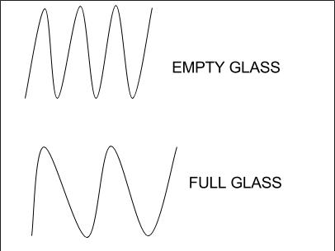

f. The wavelength changes as the frequency changes. Lower frequencies mean a longer wavelength.

Figure 4:
a. y=x^2
b. Energy = amplitude^2
c. 16,000 microns
d.
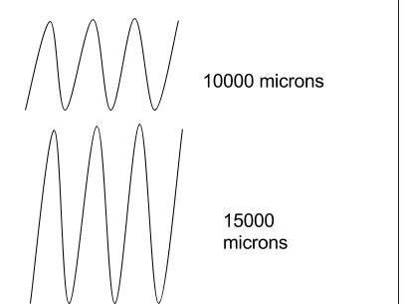
e. 16 Joules

