A Student Guide for the Biology of Terrestrial Isopods
By Ron Wagler
Terrestrial isopods are arthropods. All arthropods are united by the common characteristics of having an exoskeleton on the outside of their bodies made of chitin, a segmented body, and jointed appendages. Approximately 75% of Earth’s known animal species are arthropods. They live on all continents and in almost every body of water on Earth. Five of the most well-known arthropod groups are the arachnids (e.g., spiders and scorpions), insects, millipedes, centipedes, and crustaceans. Terrestrial isopods are crustaceans, but unlike most crustaceans they live on land and not in water. In fact, if they fall into water and cannot get out, they will drown. Terrestrial isopods live in the moist leaf litter and top layer of soil in most urban and natural environments. Some terrestrial isopods such as pill bugs can roll up into a tight ball for defense against predators (Figure 1). In many cases, the terrestrial isopods that cannot roll up into a tight ball (i.e., sow bugs) can run much faster than pill bugs, and they use their speed as a way to escape predators.

Figure 1: A terrestrial isopod (Armadillidium genus) rolled up in a defensive posture

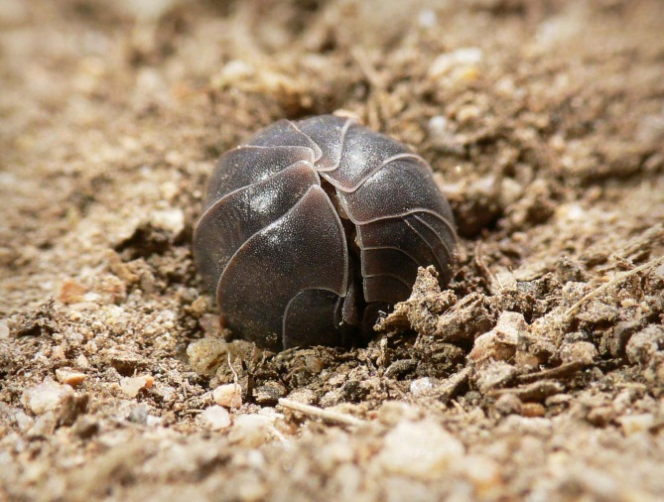 Note: This file is licensed under the Creative Commons Attribution-Share Alike 3.0 Unported license.
Source: http://upload.wikimedia.org/wikipedia/commons/2/2b/Slater_rolled_up_for_wiki.jpg

Full-grown terrestrial isopods are less than 2 cm in length, and most species are smaller. Terrestrial isopods hard, segmented exoskeleton is composed of three body parts. The first body part is the head (i.e., cephalothorax), which has two compound eyes, two sets of antennae (very small and large), and mouth parts for manipulating and chewing food. The next body part is the thorax (i.e., pereon) and has seven attached sets of jointed walking legs of equal size. The last body part is the abdomen (i.e., pleon); in some species of terrestrial isopods, two small appendages called uropods stick out the end of the terrestrial isopod.
Terrestrial isopods can get water from drinking it, from the food they eat, absorbing it (i.e., water vapor) from the atmosphere, and absorbing it through their anus (Wright and Machin 1990). Yes, terrestrial isopods can drink from both ends of their body. This is just one of the ways evolution has allowed terrestrial isopods to live on land. Terrestrial isopods get oxygen through white gill-like organs (i.e., pseudotrachea) on the back underside of their body. If you flip your terrestrial isopods over and look at the abdomen you will see two white dots. These are the gill-like organs. These organs must stay moist or the terrestrial isopod will die. This is why terrestrial isopods live in moist, humid environments such as under dead logs and rocks. Terrestrial isopods are detritivores, which means they primarily eat dead plants and dead animals.
Terrestrial isopods reproduce sexually. Identifying a terrestrial isopod as a male or a female can be difficult even with a hand lens, but you can identify some of your terrestrial isopods as males or females by watching them mate. If you see one of your terrestrial isopods begin to touch another terrestrial isopod with its large antennae and then get on top of the other terrestrial isopod, the pair is most likely mating. The male is the one that approached the female and started touching her with his large antennae. He will then attempt to fertilize the female’s eggs.
Another way to identify your terrestrial isopods as females is when they become gravid (i.e., pregnant). When the male terrestrial isopod successfully fertilizes the female terrestrial isopods eggs, she may become gravid. The female terrestrial isopod will have a swollen white brood pouch (i.e., marsupium) under her body where the baby terrestrial isopods will live and grow until they are released in about 40 to 50 days. The number of babies can vary from 10 to 70, and a female can have from one to three groups of babies a year. The babies are very small (≈ 1 mm) and usually molt (i.e., shed) their exoskeleton with 24 hours. They then molt again in the next two weeks and then a third time in the third week. They molt less frequently as they get older. Terrestrial isopods live on average two years, but some have been known to live longer.
References
Wright, J.C., and J. Machin. 1990. Water vapour absorption in terrestrial isopods. The Journal of Experimental Biology 154: 13–30.

_____________________________________________________________________________
Ron Wagler (rrwagler2@utep.edu), Ph.D., is an associate professor of science education at the University of Texas at El Paso and the founder and director of the Living Arthropod and Environmental Education Laboratory at the University of Texas at El Paso.

