1. Make a copy of the spreadsheet you created so that students can analyze data using this duplicated spreadsheet. Students can generate a pivot tables to observe, summarize, and explore data based on various criteria. Students can also generate charts to present the results of data analysis.
2. To create a pivot table, highlight all data in the sheet (you can use the Ctrl + A shortcut), click “Data” on the menu, and choose “Pivot Table.”
3. We want to observe data in two groups: male and female. Click “Add field” next to “Rows,” and choose “Gender.”
4. Now, we want to specify the data to present in each group. Click “Add field” next to “Values,” and choose “Before exercises …” Change “Summarized by: SUM” to “AVERAGE” to display the average of the before-exercise heart rates.
5. Repeat 3 and 4 to add a field for showing the average of the “After exercises” data set. Your table should look like this:

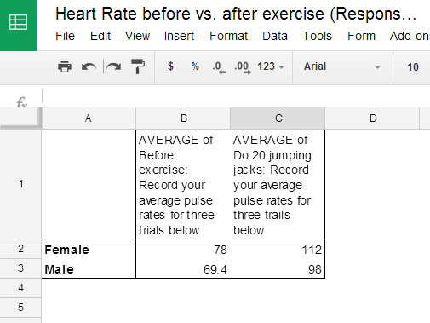
Pivot table result.

6. You can also have students create a chart to display the data. Highlight all data in the table (you case use the Ctrl + A shortcut), click “Insert,” and choose “Chart.” Guide students to choose the best chart to present the data analysis result (see below). There are several charts appropriate for comparing one or more value sets, such as column, bar, or line chart. Students can preview different type of charts and choose the best one to present their findings.

