- Go to http://drive.google.com, click “New,” on the left menu, and choose “Google Form.” Type the title of the form (“Heart rate before versus after exercise”).
- Create one multiple-choice question to collect gender data (male vs. female; see image below).
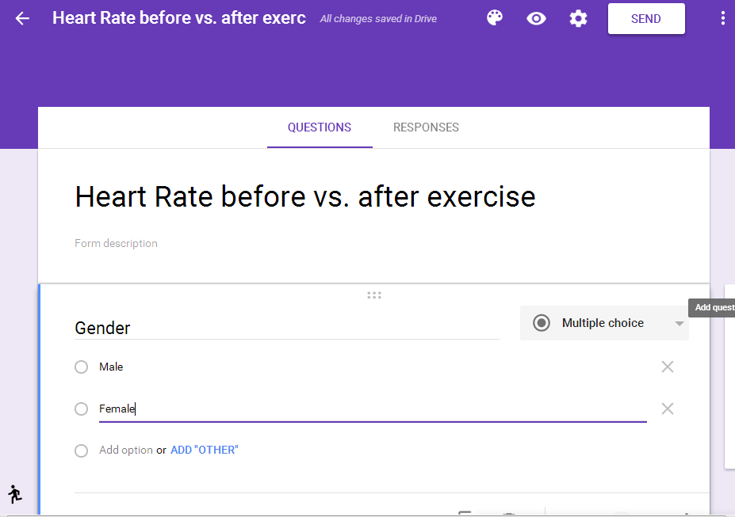

- Click “Add Question” and two short-answer questions: “Before exercise: Record your average pulse rates for three trials below,” and “Do 20 jumping jacks, then record your average pulse rates for three trials below.” Make sure to activate the “Require” option so students will be required to provide the data for all three trials. You can find a sample Google Form here: http://goo.gl/forms/1pm6uIvkcc.
- Click “Responses,” and then “Create Spreadsheet” to create a blank spreadsheet for archiving data (see below). The data collected through the Google Form will be collected in this spreadsheet.
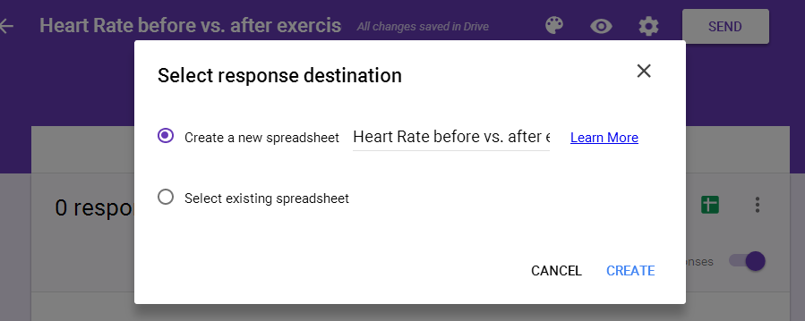

- Click “Send,” and choose “Link” to create a URL for this form. You can distribute the URL on the classroom’s interactive whiteboard, via e-mail, or through e-classroom platforms (such as Edmodo or Google Classroom).
- Have each student connect to the form and input the data of his or her gender and heart rates before and after exercise. Have students input the average heart rate data for all three trials to make sure that the data is accurate.
- After all students input all three sets of data, check the data in the spreadsheet (see below). We suggest teachers sort the data by gender for students to evaluate.

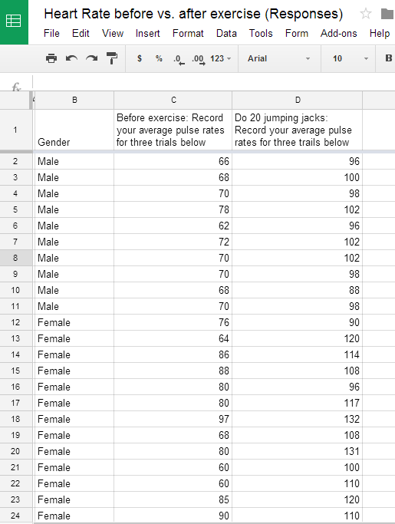

- Change the sharing settings of the spreadsheet to “Anyone with the link can view.” All students should be able to access this link to analyze the data. Teachers can find this sample spreadsheet here: https://goo.gl/Jf4bf8.
- Choose “File” and select “Make a Copy” to duplicate this spreadsheet and save to your own Google Drive. Now this becomes your own spreadsheet for further data analysis.

