Name: _____________________________________

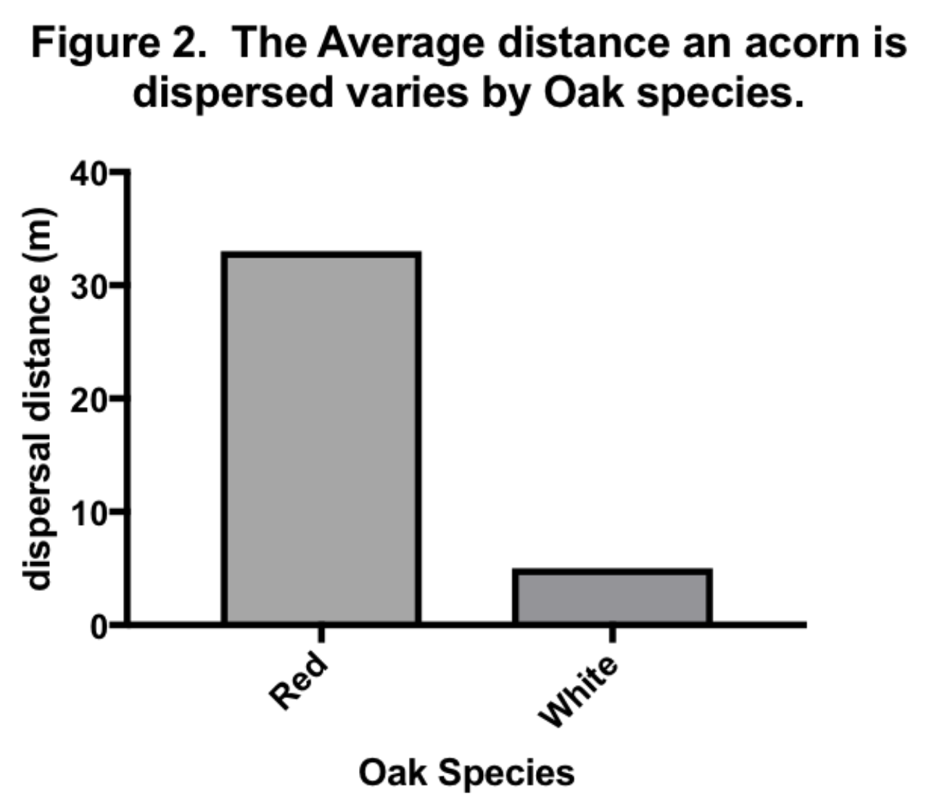
The graphs below show data on acorn collection by squirrels. Are squirrels dispersers and planters of oak forests, or pesky seed consumers? Squirrels eat acorns but also bury many to eat later. If they forget where they have buried their cache, then those acorns effectively become planted seeds, which grow into oak seedlings. In fact, in fall and winter, the majority of the squirrel diet is composed of nuts. For squirrels to be an effective method of seed dispersal, they must forget where they left some acorns. Using the graphs, answer questions 1–3:
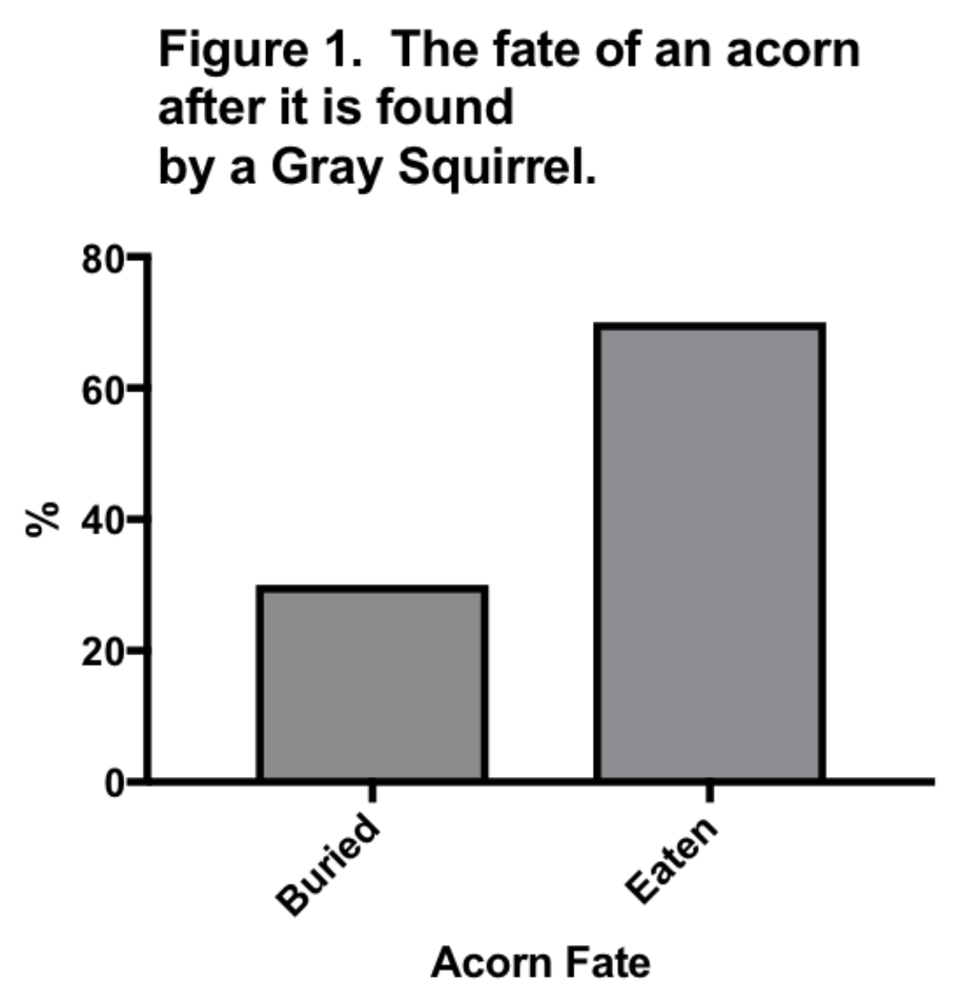

1. What percent of acorns are buried, rather than eaten right away? _________________

2. Which species of oak gets more widely dispersed? __________________________________

3. If you wanted to study which species of oak likely produces more successful seedlings (those that grow into adulthood):

- What is your hypothesis?

- What do the data tell you?

c. What is your conclusion? Support your answer (claim) with evidence.

4. Researchers have also seen that gray squirrels do not always eat the whole acorn. The acorn contains the embryo, but the embryo is only in the bottom half (farthest from the acorn cap). The bottom half of the acorn also contains much higher levels of bitter-tasting tannins. Many acorns are only partially eaten, and usually the portion that is eaten is the top.

What is your hypothesis for why this is so?

Graph the following data (making sure to include a title, units of measurement, and axis labels). Based on the data and graph, what is your conclusion?

Part of acorn eaten | % germination
Bottom half | 12
Top half | 73
Whole acorn | 0

5. Squirrels eat a variety of seeds and nuts. Acorns are more easily opened than many other nuts and are more often eaten than stored for later use.

What percent of acorns are eaten immediately versus buried for later use?

Which nut is most likely to be buried for later use?

Graph the following data (making sure to include a title, units of measurement, and axis labels). Based on the data and graph, what is your conclusion?

Type of nut or seed | % buried
Acorn | 18
Walnut | 73
Hickory | 48

Answer key

The graphs below show data on acorn collection by squirrels. Are squirrels dispersers and planters of oak forests, or pesky seed consumers? Squirrels eat acorns but also bury many to eat later. If they forget where they have buried their cache, then those acorns effectively become planted seeds, which grow into oak seedlings. In fact, in fall and winter, the majority of the squirrel diet is composed of nuts. For squirrels to be an effective method of seed dispersal, they must forget where they left some acorns. Using the graphs, answer questions 1–3:
1. What percent of acorns are buried, rather than eaten right away? 30%

2. Which species of oak gets more widely dispersed? Red oaks

3. If you wanted to study which species of oak likely produces more successful seedlings (those that grow into adulthood):
- What is your hypothesis? Oaks species that have acorns dispersed far from the parent a better chance at survival and reproduction. (If an oak has widely dispersed acorns, then the acorns have a greater chance of growing to adulthood.)

- What do the data tell you? Red oaks have wider dispersal.

c. What is your conclusion? Support your answer (claim) with evidence.
Red oaks have a 32-meter dispersal radius from the parent tree, much greater than white oaks at 5%. The wider dispersal radius gets the acorns far from the parent tree, so the acorn can germinate in an area where competition with the parent tree will be reduced, leading to a greater chance of survival for the acorn seedling.

4. Researchers have also seen that gray squirrels do not always eat the whole acorn. The acorn contains the embryo, but the embryo is only in the bottom half (farthest from the acorn cap). The bottom half of the acorn also contains much higher levels of bitter-tasting tannins. Many acorns are only partially eaten, and usually the portion that is eaten is the top.

What is your hypothesis for why this is so? If the bottom part of the acorn tastes bad, then squirrels will leave it alone and the acorn will germinate. Acorns have adapted to squirrel predation—natural selection causes acorns with bitter tannins in the embryo portion of the acorn to survive better (i.e., if the squirrels do not like the taste, they will not eat the embryo). These embryos are able to germinate, grow, and reproduce, passing the gene for bitter tannins to the next generation in greater numbers, and so more of the next generation makes these tannins.

Graph the following data (making sure to include a title, units of measurement, and axis labels). Conclusion: When the embryo portion of the acorn is eaten, germination is reduced, because the embryo does not survive. The ones with more tannins are less likely to be eaten, so they survive, grow, reproduce, and pass on gene for tannins to the next generation.
Part of acorn eaten | % germination
Bottom half | 12
Top half | 73
Whole acorn | 0

5. Squirrels eat a variety of seeds and nuts. Acorns are more easily opened than many other nuts and are more often eaten than stored for later use.
What percent of acorns are eaten immediately versus buried for later use? 82%
Which nut is most likely to be buried for later use? Walnut
Graph the following data (making sure to include a title, units of measurement, and axis labels). Conclusion: The nuts that are harder to open usually get stored, and the ones that are easy to open, such as acrons, get eaten right away.

Type of nut or seed | % buried
Acorn | 18
Walnut | 73
Hickory | 48

