- What causes the number of hours of daylight a place receives to change over the course of a year?
- Changes in the moon’s path around the earth cause the moon to block sunlight from reaching a place for different amounts of time over the course of a year.
- Changes in how fast the earth turns on its axis cause a place to spend different amounts of time in sunlight over the course of a year.
- Changes in the earth’s distance from the sun cause the amount of time that sunlight can reach a place to change over the course of a year.
- Changes in the angle between earth’s axis and the sun cause the amount of time that sunlight can reach a place to change over the course of a year.
- The diagram below shows the earth with its axis of rotation pointed toward the sun
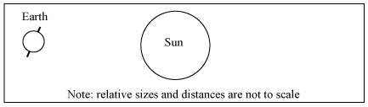
Which of the following diagrams show the earth and sun six months later?
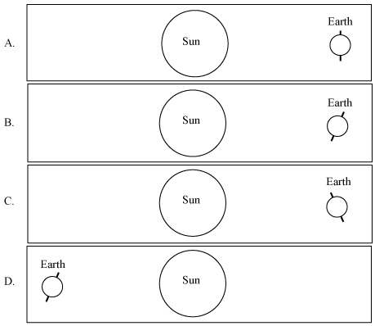

- The average daily temperature at a town begins to decrease in August. Could a change in the amount of energy transferred from the sun to the town explain the decrease in air temperature?
- Yes, the amount of energy transferred to the town from the sun begins to decrease in August, which makes the air temperature at the town decrease.
- Yes, but only if the amount of energy transferred to the town from the sun becomes smaller than the amount of energy being transferred away from the town.
- No, the amount of energy stored in the ground at the town must be starting to decrease, and this causes the temperature of the air above it to decrease.
- No, a change in the amount of energy transferred to the town has no effect on the air temperature at the town.
- The map below shows two places in the United States, Place 1 and Place 2.
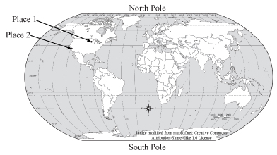
Which of the following statements explains why one place has more hours of daylight in July than the other?
- Place 1, because it is farther inland than Place 2
- Place 1, because it is farther north of the equator than Place 2
- Place 2, because it is closer to the ocean than Place 1
- Place 2, because it is closer to the equator than Place 1

- One day in the winter, a girl who lives in the continental United States noticed that as the sun moved across the sky, the maximum height it reached was the top of a building next door to her house.
What will the girl see if she watches the sun move across the sky during a day in the summer?
- The maximum height of the sun will be above the top of the building.
- The maximum height of the sun will be below the top of the building.
- The maximum height of the sun will be the same as it was in the winter.
- The maximum height of the sun depends on where she is in the United States. In some places the sun will be higher in the summer than in the winter, and in some places it would be lower.
- Place 1 is shown in the diagram below. Which of the following statements is TRUE about the maximum height of the sun when viewed from Place 1 during the month of January?
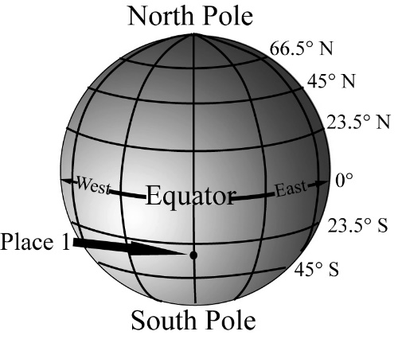
- The maximum height of the sun gradually gets a little higher each day in January.
- The maximum height of the sun gradually gets a little lower each day in January.
- The maximum height of the sun changes some days in January, but it does not change every day in January.
- The maximum height of the sun does not change at all in January.

- There are no clouds above Place 1 and Place 2 at the moment shown below.
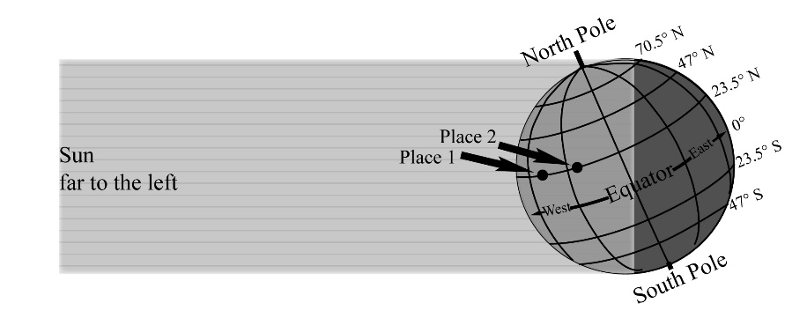
At which place is the sunlight more intense, at Place 1 or at Place 2?
- Place 1
- Place 2
- The intensity would be the same at both places.
- There is not enough information to know at which place the intensity would be greater.
- Which of the places shown in the diagram below has the greatest intensity of sunlight over the course of a day in the middle of July?
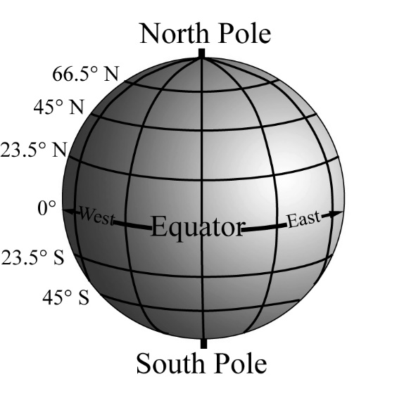
- 0° (equator)
- 20° N
- 30° N
- All places in the northern hemisphere have equal intensity of sunlight over the course of a day in the middle of July.

- Seasons are caused by Earth’s
- orbit and tilted axis
- tilted axis and size
- orbit and distance from the sun
- orbit and distance from the moon
- What must be TRUE about the number of hours of daylight at Place 1 compared to Place 2?
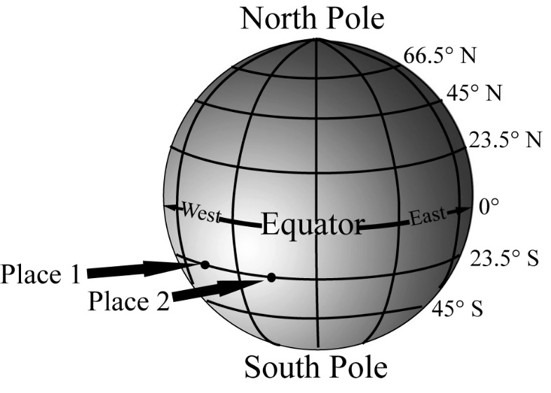
- There are more hours of daylight at Place 1 than at Place 2 every day of the year.
- There are fewer hours of daylight at Place 1 than at Place 2 every day of the year.
- Both Place 1 and Place 2 have the same number of hours of daylight every day of the year.
- Whether or not there are more daylight hours at Place 1 or Place 2 depends on the time of year.

- A student who lives at Place 1 measured the number of hours of sunlight on a day in January and on a day in July. Another student, who lives at Place 2 made the same measurement on the same two days. Both places are in the northern hemisphere.
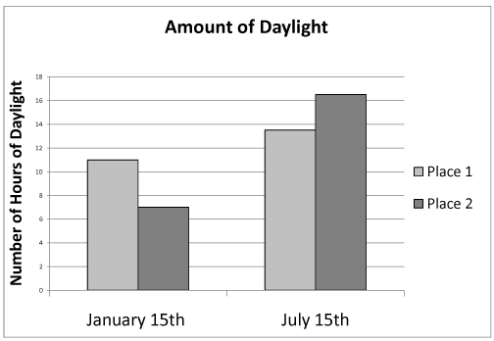
Based on their measurements, as shown in the graph above, what must be TRUE about Place 2?
- Place 2 is closer to the Equator than Place 1.
- Place 2 is farther from the Equator than Place 1.
- Place 2 is farther to the east than Place 1.
- Place 2 could be north, south, or east of Place 1, because the number of hours of sunlight cannot be used to compare the location of one place to another.
- Fill in the table:

Date | Season (Spring/Summer/Fall/Winter) | Hours of Daylight (long /short/equal)
March 21 | 1. North_____  2. South_____ | 1. North- long /short/equal  2. South- long /short/equal
June 21 | 1. North_____  2. South_____ | 1. North- long /short/equal  2. South- long /short/equal
September 21 | 1. North_____  2. South_____ | 1. North- long /short/equal  2. South- long /short/equal
December 21 | 1. North_____  2. South_____ | 1. North- long /short/equal  2. South- long /short/equal

