Water Quality
Water is an important resource for living things. In America, we depend on access to clean water every time we turn on the faucet in our homes. Unfortunately, there are times this is not the case. In Flint, Michigan, residents have been drinking bottled water for a year due to poor water quality. The national headlines covering the case in Flint has the public asking questions about the purity of the water they consume.
Between June 2012 and April 2013, Flint officials investigated other sources of treated water. Their goal was to save money. In April 2013, the city officials decided to change water suppliers. They switched from the Detroit Water and Sewage Department, which used Lake Huron as a water source, to the Karegnondi Water Authority (KWA). KWA was building a pipeline from Lake Huron. This put Flint in a short term need of water treatment. Detroit Water and Sewage offered a temporary contract, but the city government decided against it. Instead, they decided to use the Flint River and the city water treatment plant as their interim or temporary solution (Brewer 2016). On April 25, 2014, the change began.
Issues with water quality started soon after the switch. There were complaints of foul- smelling water coming out of the faucet. During August and September of 2014, issued alerts for E.coli and Total Coliform bacteria stated for residents to boil their water before using it. As a response, treatment of the Flint River water included increased added chlorine. Soon after, a General Motors plant announced they stopped using treated water from the Flint River because of corrosion found on steel parts. In December, the Michigan Department of Environmental Quality alerted Flint that its drinking water was in violation of standards (Roy 2015).
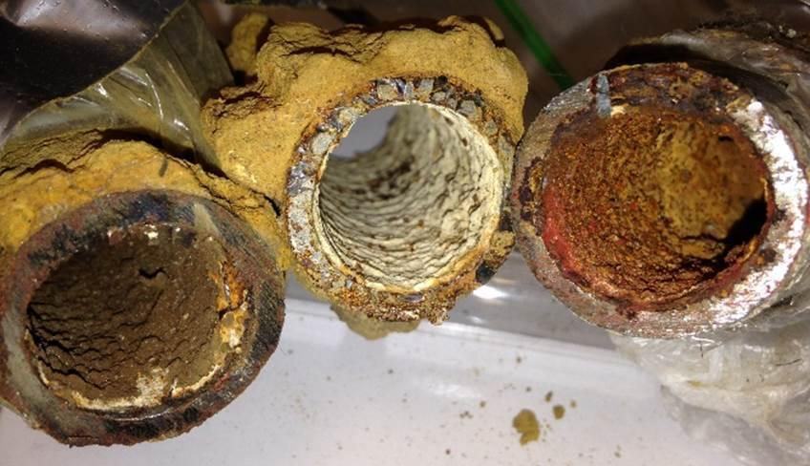
Corroded Flint drinking water pipes.
(Photo courtesy of FlintWaterStudy.org)
Specifically, the water tested positive for high concentrations of trihalomethanes, a by-product of chlorines used for disinfecting water in treatment plants. A trihalomethane forms when chlorine reacts with organic molecules in the water. Starting in January of 2015, the problems with Flint water quality made national headlines. During the summer of the same year, researchers from Virginia Tech University tested the water in a home located in Flint, Michigan. One of the water samples tested over 13,000 parts per billion (ppb) lead. Even after 20 minutes of running the water, the lowest water test registered over 300 ppb (Torrice 2016). The acceptable concentration of lead in water is 15 ppb. By September of 2015, Dr. Marc Edwards, lead researcher of the team from Virginia Tech University, sampled 252 homes. Their findings showed many homes with readings of 25 ppb lead or higher. A doctor from Hurley’s Children’s Hospital in Flint released evidence of increased concentration of lead in the water. The data in the report stated before the change in water supply, the levels of lead in the blood of children under the age of 5 was 2.4%. After the switch, that number rose to 4.9%. In areas where the lead concentration was worse, the percentage of children with elevated lead levels was as high as 10% (Torrice 2016). In the face of the increasing evidence, the city of Flint switched back to the Detroit Water and Sewage for its water source.
While the problem is not over, things are improving in Flint, Michigan. What happened in Flint is not a unique situation and brings up several important questions. Questions such as where do we get our water? How the water we drink is treated? And if lead is an issue, why did we choose to use it for pipes?
Where do we get our water?
The simple answer is from precipitation. Precipitation occurs when water vapor condenses or changes to liquid form and falls back to the Earth as rain, sleet, or snow. Even though precipitation falls globally, most of the water on earth is undrinkable. In fact, only 2.5% of the total water is freshwater while the rest is saline. Saline means salt water or ocean-based. Out of that 2.5% fresh water, only 1% is accessible or easy to get to and use. That said, we get our drinking water from lakes, rivers, and groundwater. Groundwater is underground water that supplies wells. For most Americans, this water is pumped to a treatment plant, treated, and then sent to houses through a pipe distribution network.
How do we treat our water?
The purpose of water treatment is to provide safe, reliable water for the population to use. Waterborne diseases occur regardless of location. This is why water treatment facilities use disinfectants to kill possible pathogens and bacteria. The details of water treatment can differ depending on your location in America and water source. For example, Americans living in the Midwest experience higher nitrate concentrations in their drinking water. Farming activities create a situation where nitrates from fertilizers, materials that make plants grow better and improve the soil quality, are in the runoff to rivers, lakes, and groundwater. If the amount of nitrates in the water is high, it can lead to "Blue-Baby Syndrome.” Infants that have ingested a large amount of nitrates become sick and experience shortness of breath. One way to reduce nitrate levels is to use an ion-exchange treatment similar to Des Moines, Iowa. Lowered nitrate levels in the water lowers the risk of “Blue-Baby Syndrome.” Another example is the western states. Many western states use seawater and brackish, or partly salty groundwater, as their water source. Reverse osmosis is one procedure for removing salt from the water. The saline or brackish water passes through semipermeable membranes under high pressure, which separates it from the salt. Another common method to remove salt is to use heat. The heated salt water creates water vapor that condenses and collects as freshwater. But no matter where you live or source of water, there are certain steps that all water must go through to be safe to drink.
Even though water purification methods differ slightly, there are some common steps to each system. The first step in any water treatment is coagulation and flocculation. To create coagulation, treatment plants add chemicals with a positive charge to the water. The positive- charged ions neutralize the negative charged dirt and debris in the water. Once neutralized, the particles of dirt and debris bind with the coagulation chemicals to form larger particles referred to floc. The second step is sedimentation. After coagulation, water moves into large pools, and settles. Settling allows the large particles of floc move to the bottom of the pool (CDC 2015). The third step is filtration. During filtration, the clear water passes through filters of sand, gravel, and charcoal, plus different pore sized filters. The purpose of filtration is to remove or filter out any particles such as dust, parasites, bacteria, viruses, and chemicals. The last step is disinfection. A disinfectant, such as chlorine or chloramine, added to the water kills any remaining parasites, bacteria, and/or viruses. Plus the disinfectant works to protect the water from germs as it travels to homes and businesses in the community. Different communities choose different disinfectants. Chlorine is a common choice, but some companies use ozone and claim it is more effective. Other communities go a step further.
Some communities add fluoride to their water. Fluoridation is one of the top 10 public health achievements of the 20th century. The purpose of fluoridation is strengthening the teeth of the drinker and reducing tooth decay. Most drinking water contains some fluoride ions, but there is not enough to provide adequate protection. Many people, including doctors and dentists, think adding fluoride is a must.
Why did we use lead pipes?
Lead is a useful metal that is easy to bend and shape. While lead was more expensive than iron, lead lasted about twice as long, plus it easily bent around existing structures. However, by the late 1800s, scientists identified lead pipes as a source of lead poisoning. Lead poisoning affects humans dependent on age. Children can suffer from issues with brain development and the nervous system. For adults, lead ingestion can increase their blood pressure and cause kidney damage. Lead exposure in pregnant women potentially causes many issues. Examples include miscarriage, stillbirth, premature birth, or low birth weight plus other minor formation issues with their baby. By the 1920s, health concerns connected with lead took precedence over its engineering advantages. Many cities revised their building codes prohibiting the use of lead pipes for water distribution. This did not prevent continued use of existing lead pipes nor completely prevent new installation of lead pipes. Not all communities used the same building codes. The passage of the Safe Drinking Water Act Amendments of 1985 finally prohibited the new installation of lead water pipes across America.
References

Brewer, J. 2016. Flint mayor announces city will continue pipeline deal at center of lead water crisis. World Socialist Web Site. www.wsws.org/en/articles/2016/06/23/flin-j23.html.

Centers for Disease Control and Prevention (CDC). 2015. Community water treatment. www.cdc.gov/healthywater/drinking/public/water_treatment.html.
Roy, S. 2015. The unintended consequences of migrating to Flint River water. Flint Water Study.
www.flintwaterstudy.org/2015/08/the-unintended-consequences-of-migrating-to-flint-river-water.
Torrice, M. 2016. How lead ended up in Flint’s tap water. Chemical and Engineering News 94 (7): 26–29. http://cen.acs.org/articles/94/i7/Lead-Ended-Flints-Tap-Water.html.

