Plumbing line template

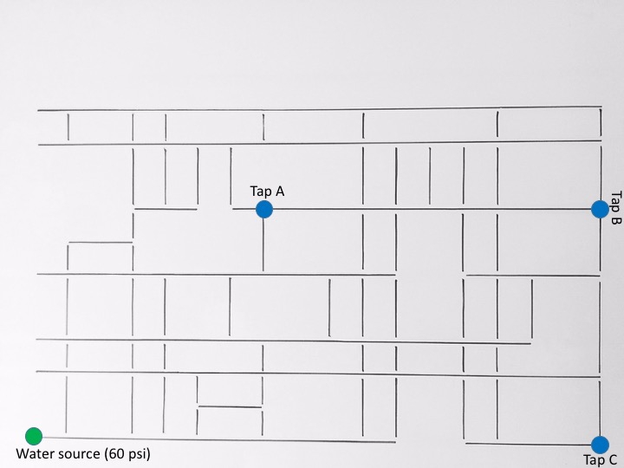

Prototype data tables, reflection questions, and rubric

Call the plumber design

Below are guiding and reflective questions for students when they are iteratively designing, prototyping, and testing the system. The data table and questions should be recorded in notebooks and should be duplicated and completed for each prototype.

Design criteria
What are the criteria for your company’s optimal plumbing system? What does the “best” plumbing system mean to your company? What will be your trade-offs? In the table, write answers to these questions and use them as a guide when you are creating your model. These can change as you make your prototypes.

Prototype 1: Budget
Item | Cost | Quantity | Total cost
1” pipe piece
¾” pipe piece
½” pipe piece
1” pipe bend
¾” pipe bend
½” pipe bend
1” pipe branch
¾” pipe branch
½” pipe branch
Final budget

Prototype 1: Pressure
Tap | Final pressure (psi)
Tap 1
Tap 2
Tap 3

Prototype 1: Photo (paste it in the space below)

Prototype 1: Evaluation
1. P1: Could you have a higher pressure at any of the taps? How?
2. P1: Could your model cost less? How?
3. P1: How is your design better than the very first one that was given to you?
4. P1: Look back at your design criteria. Why did you build your prototype this way?
5. P1: What criteria will you change for your next prototype? Why?

Copy and paste above for more prototypes.

Final design

Final budget
Item | Cost | Quantity | Total cost
1” pipe piece
¾” pipe piece
½” pipe piece
1” pipe bend
¾” pipe bend
½” pipe bend
1” pipe branch
¾” pipe branch
½” pipe branch
Final budget

Final pressure
Tap | Final pressure (psi)
Tap 1
Tap 2
Tap 3

Final photo (paste it in the space below)

Final analysis
1. Final: What worked well in your design?
2. Final: What failed in your design?
3. Final: How did your strategy for creating an optimal design change over the prototypes?
4. Final: Make a sales pitch! Sell your final budget and pressures. Why should your science teacher buy your design?
5. Final: If you were to design your plumbing system again, what changes would you make or what other materials would you use? Why?

Call the plumber design rubric

Below is a simplified sample rubric for assessing the work students have done in their company teams while iteratively designing, prototyping, testing, and presenting their system. This rubric is a guide and should be customized based on student abilities and needs.

Criteria | Below expectations | Met expectations | Exceeded expectations
Plumbing design criteria | The company has defined some of their criteria and trade-offs. It is unclear what they mean by “best” plumbing system. | The company has clearly defined their design criteria and trade-offs. It is clear what their “best” plumbing system is. | The company has clearly defined their design criteria and trade-offs and provided justifications for these based on real-world variables. It is clear what their “best” plumbing system is.
Prototype evaluation | The company has successfully calculated the pressure at taps and the budgets for most of the prototypes. The company sometimes referenced their design criteria when evaluating their prototypes. They sometimes adjusted their iterative designs or criteria. | The company has successfully calculated the pressure at each tap and the budget for each prototype. The company referenced their design criteria when evaluating their prototypes and adjusted their iterative designs or criteria accordingly. | The company has successfully calculated the pressure at each tap and the budget for each prototype. The company referenced their design criteria when evaluating their prototypes. They carefully considered and referenced their real-world variables for each prototype and adjusted their iterative designs or criteria accordingly.
Final design | There are mistakes in the calculations of the pressure at each tap and in the budget for the final design. The final design meets some of their design criteria. Answers to final analysis questions are limited or basic. | The company has successfully calculated the pressure at each tap and the budget for the final design. The final design meets their design criteria. Answers to final analysis questions are thoughtful and thorough. | The company has successfully calculated the pressure at each tap and the budget for the final design. The final design meets their design criteria. Answers to final analysis questions are in-depth and reference the real-world variables for their system.
Design pitch | Pitch references and justifies some of their design criteria. The final design with pressure and budget is showcased. Most members of the company spoke clearly and answered some questions asked. | Pitch references and justifies design criteria. The final design with pressure and budget is showcased. All members of the company spoke clearly and answered questions. | Pitch references and justifies design criteria in relation to the real-world variables for their system. The final design with pressure and budget is showcased. All members of the company are engaged, spoke clearly, and answered.

