Engagement probe

Name: _________________________

The Ball Drop
[Falling Objects]

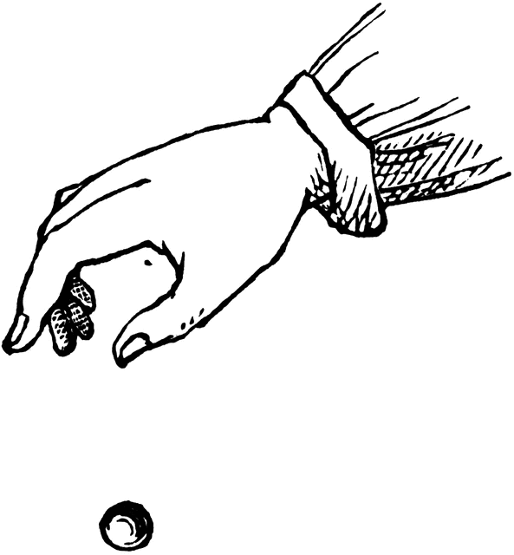

Imagine that a person in a tall building drops a ball. The ball is allowed to free-fall and does not hit any objects on the way down.

If the ball drops a total of 1 m during the first second, how far do you think the ball will drop during the second second? What about the third second? Describe your thinking.

____________________________________________________________________________________________________________________________________________________________________________________________________________________________________________________________________________________________________________________________________________________

Exploration data table
Time (unit does not have to be one second) | Total distance traveled by object |  |  | Distance object traveled during unit of time
 | Trial #1 | Trial #2 | Trial #3 | Trial #1 | Trial #2 | Trial #3
First unit of time
Second unit of time
Third unit of time
Fourth unit of time
Fifth unit of time

