While Utilitarianism has many variations, the most commonly used view is doing the most good for the largest number of people is the right thing to do. Due to this general philosophy, utilitarian- and economics-based land ethics are usually paired. However, there are times when they are at odds.

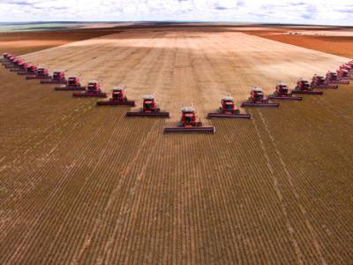

Fleet of combines on an industrial farm

A useful example of how Utilitarian-based land ethics can be both for and against economic-land ethics is industrial farming. Economics and utilitarianism would argue that producing larger yields of crops would make the most sense. However, an economics ethic would focus on the profit being as high as possible from the harvest. Utilitarianism would make sure that the most people would benefit from the use of the land. For instance, while more resources are being produced, easy access for more people would be favored over an individual making large profits. Further, if the individual was harvesting resources in a way that negatively impacted others, that harm outweighs any benefits.
Utilitarian-based land ethics are harder to see in action, but are often part of the decision-making process of some entities. One of the best examples of a resource where utilitarian-based land ethics come into play are caves. With any cave, there’s the constant struggle and debate of how much should be open, what should be closed, and whether more exploration should be done. The more of the cave that is opened up for anyone to enter, the more damage comes from use and human interactions. The more of the cave that is closed, the less accessible it is for anyone to see.

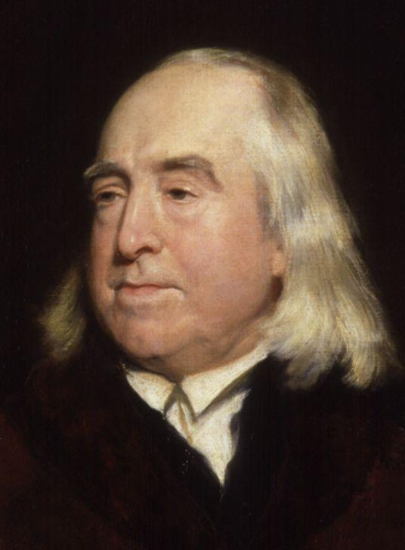

Portrait of Jeremy Bentham prior to his death in 1875

Origins of Utilitarianism
When Jeremy Bentham was active, much like Humboldt, Europe was in a time of social upheaval with many questioning the authority of the privileges of the ruling class. Gathering together works from philosophers before him, Bentham set out to create what he called the “Pannomion,” a complete code of all utilitarian laws. He believed that all human actions could be explained by two simple factors: pain and pleasure. However, his ideas were received with mixed reactions, due to the fact that many felt his pain/pleasure drivers took away both natural rights of humans, and endorsed activities like torture. One of his students, John Stuart Mill, would take the idea that society should strive to do the most for the greatest good for the largest number of people.

John Stuart Mill
John Stuart Mill’s father, James Mill, was also a utilitarian thinker, and so his thoughts were shaped from a young age. Another prominent influence was Bentham, however Mill saw some problems with his “greatest-happiness principle.”

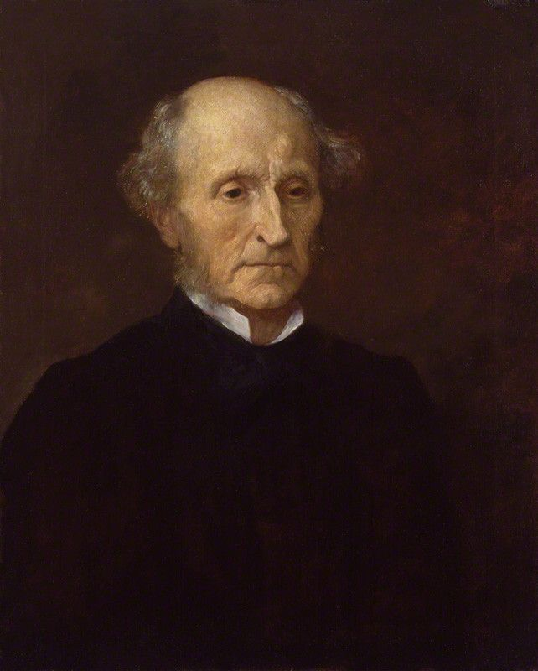

John Stuart Mill ca. 1873

While he agreed that humans should morally choose the action that increases the overall pleasure or happiness of the world, he wanted to expand on Bentham’s ideas. He thought that not only would people choose the decision that would generate the most pleasure or happiness, they would tend to choose the action that has given them the most pleasure in the past.

Benefits
The most obvious benefit from the utilitarian-based land ethic is the fact that the largest number of people can be positively affected. Ideally, following this ethic prevents one person from exploiting not only other people but also the land itself. Ideally, the decision-making process should be easier, because the best answer is always the one the benefits the greatest number of people. To make the point stronger, this ethic can also mean that the smallest number of individuals are negatively impacted. In fact, in an ideal situation, the action that would cause the greatest benefit would also be the one that causes as little pain or risks as possible.

Risks
A lot of the statements in the benefits sections included a key word, “ideal” or “ideally.” While in most scenarios, humans will not go out of their way to inconvenience their neighbors, they might unknowingly do something that damages or otherwise hurts their neighbor. An example is industrial farming, especially with “trademarked” plants. The initial intent for these genetically modified plants was to provide better quality crops that are more resistant to conditions not favorable to maximum harvests. However, with neighboring farms not being able to control how pollen spread, the benefit of larger harvests was outweighed by the cost of those smaller farms being shut down or taken over as the copyrighted plants spread.
A final risk draws heavily from Mill’s take on Utilitarianism: status quo. If the individuals responsible for making the decision always choose an action that has previously given the most pleasure, they might not be willing to take a new action because it will be assumed that the other action will give the most pleasure. These ruts can lead to even more dangerous and costly effects based on consumption of resources.

