Overview
The purpose of this document is to outline the scenario for use with the Land Ethic case studies. Land ethics are the philosophical guidelines that groups and individuals use to help them determine how land is used. This activity is designed for a high-school science classroom or groups of high-school age or older. The overall goal of this scenario is to help students think about why we use land the ways we do. Ideally, this will help students consider why some parcels of land have been set aside as National Parks or National Forests, while others have been opened to mineral extraction or logging or other private and recreational uses. The overall product from the scenario is a proposed use plan for Grand Staircase-Escalante National Monument (GSENM) in southern Utah.

Introductory Activity
To introduce the following scenario, start by thinking locally. Use the example of a local or state park as the initial focus. Using that example, tell the students the following scenarios:
- A bird is discovered in the park that is not found anywhere else. The park decides to close the park to reduce the impact on this species.
- A new deposit of copper is discovered under the park. A mining corporation buys the land where the deposit is found and starts to develop an open pit mine. They will keep areas not affected by mining open to the public during business hours.
- A local group wants to start a community garden in plots of the park that have been found to have very fertile soil. They require strict rules of those planning on using this shared space to ensure that no one individual negatively affects the rest of them.
- The park has been approached by a forestry team that wants to use the timber for construction projects around town. They plan to plant enough trees to replace the ones they are harvesting to ensure that they can utilize the resource into the future.
- The trails in the park have uneven surfaces or other hazards that make it difficult to impossible for individuals bound to a wheelchair or other aids that help with mobility. The department in charge of the park is looking at different ways to revamp or rebuild the trails in order to let everyone access and use the trails.

The students should be asked to think about how those changes would impact them and their use of the park. Then to introduce them to Grand Staircase-Escalante National Monument, using the following video from one of the former Bureau of Land Management Artists in Residence to visually show students the variety of features in this area: https://www.youtube.com/watch?v=RUyuzk172eQ

Group Assignment and Discussion
Divide the class into 5 groups. Every group will receive a copy of the Introduction Case Study as well as one of the five individual land ethic case studies: Economic, Utilitarian, Libertarian, Egalitarian, or Ecological. The groups will then be given time to read over the two case studies assigned to them, and discuss within their groups. As a group, the goal of the discussion is to shape a shared position for their Land Ethic. They can develop further pros and cons of their stance, brainstorm examples of where these ethics are seen in the world, how effective they have been in the past, or any other relevant information that they think will strengthen their stance.

Symposium
When bringing the groups together, give each group a chance to present an opening statement, introducing their assigned Land Ethic. Afterwards, allow the groups to discuss openly the merits and risks of using each one of the land ethics, including what sort of resource or land each would be best suited to. It is important to ensure that no one person dominates the symposium, so that all voices and opinions can be heard equally. Additionally, the point of the group discussion is not to prove that one Land Ethic is better than another. Rather, the point is to understand why these Land Ethics exist, why we use them to this day, and a proposed use plan for GSENM. It is important to note that the students are not bound to their assigned land ethics once they begin voting on the plan if another group or student was able to persuade them to another view. In the discussion guide, there are a few lines that are highlighted to show the areas where land ethics overlap to assist students trying to decide how they will vote.

The plan that the students will be voting on will consist of five major aspects of a protection plan, with each ethic having an aspect that is specifically crafted for them. This will allow them to have one choice that they will have to persuade others to vote for. Tying in the land ethics theirs overlap with can help them figure out what they can negotiate on in order to get the votes that they would need for their part of the protection plan to pass. They will then vote on all five, based on their land ethic, any agreements that were made for votes, and any parts that they felt persuaded on. Their votes can be placed using a set of 5 sticky notes per student. They will only put a sticky note if they agree.

After the symposium and voting for the proposed use plan, if time remains, ask the students put into writing why they were thinking the way they did, what new ideas the symposium sparked, and what parts of the symposium stood out to them in particular.

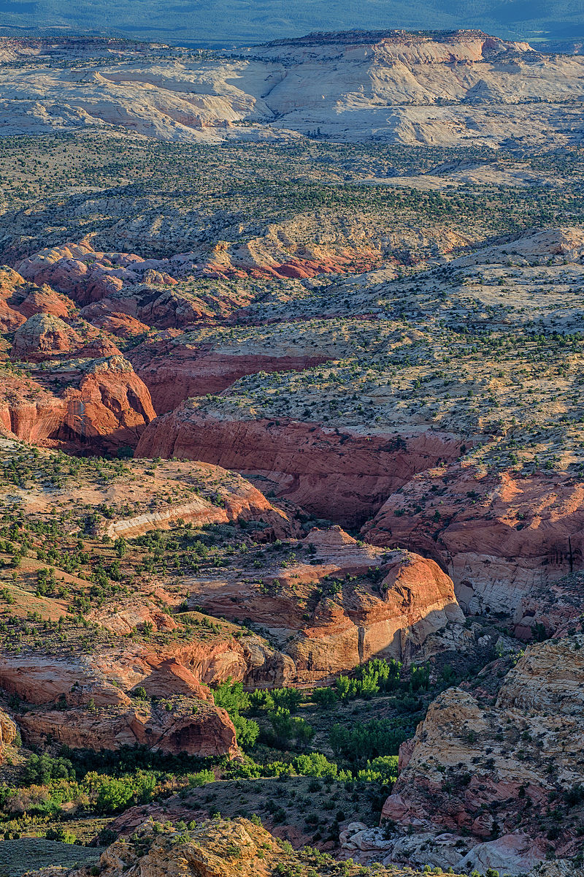

Grand Staircase-Escalante National Monument
Land Ethics Symposium
Grand Staircase-Escalante National Monument (GSENM) is a vast area in South-Central Utah that protects over 1 million acres. Initially designated in 1996 under the Antiquities Act, the monument contains large amounts of natural, cultural, and recreational resources. GSENM is one of 27 National Monuments that the Bureau of Land Management (BLM) is responsible for, allowing more recreational activities than would be possible under the National Park Service’s (NPS) mission.

The purpose of the symposium is to get the perspectives of multiple groups who have different perspectives as to the use of the land, and the ethics associated with them. Each group will be asked to work together with each of their members to discuss (1) how the role they represent uses the land, (2) the risks and benefits associated with the land ethic they primarily use, and (3) how their land ethic can work with others. From there, they will be expected to discuss those uses, risks, and benefits, in order to see how these different land ethics can work together for the benefit of all.

They will then be asked to vote on a five part protection plan, based on the results of the symposium. The five parts of the protection plan will be: (1) All collection of plant, animal, fossil, or artifacts will be done by permit only; (2) Cattle grazing is permitted throughout the GSENM area; (3) Areas rich in mineral deposits, such as copper or coal, will be opened for mining, assuming no human artifacts or fossils are found; (4) All for-profit groups operating in GSENM must have at least one person on staff to explain what they are doing to visitors from the general public; (5) Culturally and traditionally associated tribes will retain access to their ancestral lands.

The five land ethics are: Ecological-based, focusing more on the natural order being key; Economical-based, focusing more on human industry; Egalitarian-based, focusing on equal access to all portions of the land; Libertarian-based, focusing on individual freedoms with the land; and Utilitarian-based, focusing on the most efficient and sustainable ways to use the land.

Quick Resource Facts about Grand Staircase-Escalante National Monument
Area Protected: 1,003,863-1,880,461 acres

Land Management: Bureau of Land Management (BLM)

Natural Resources
- Numerous fossil locations
- Rocks ranging from oldest in Grand Canyon to youngest at Bryce Canyon
- Rivers, creeks, and water pockets
- Unique habitats

Cultural Resources
- Artifacts and structures from Ancestral Puebloan and Fremont Culture groups
- Artifacts and structures from European settlers
- Land sacred to Native tribes

Economic Resources
- Minerals: Coal, Copper, Gravel, Limestone, Gypsum
- Lumber: Pinyon-Juniper, Cottonwood, Aspen, Pine
- Cattle-grazing
- Tourism: Tour buses, hiking guides, river guides, canyoneering guides, Jeep/off-road guides
- Hunting: Elk, Mule Deer, Pronghorn, Black Bear, Desert Bighorn Sheep

Current Restrictions
- Fossil and artifact collection without permits is not allowed
- Overnight stays require permits
- Fire restrictions may affect the ability to have open fires
- Hunting and Fishing requires proper licenses and permits
- Mining and Lumber only in approved locations

Sample Roles
Below are some examples from each of the five land ethics of roles students can play in order to better centers themselves in the role. Keep in mind, while many, if not all roles have aspects of any of the five land ethics, they are grouped under the one they are most closely associated with.

Ecological
- National Park Service Representative
- Fish and Wildlife Service Representative
- Sierra Club Representative
- Utah Department of Natural Resources Representative
- Nature Conservancy Representative
- Worldwide Fund for Wildlife Representative
- Southern Utah Wilderness Alliance Representative
Economic
- Coal Mining Company Representative
- Logging Company Representative
- Travel Resort Company Representative
- Gas Drilling Company Representative
- Tour Bus Company Representative
- Hiking/Canyoneering Guide Company Representative
- Tourism Board Representative
- Politician
Egalitarian
- Photographer
- Artist
- Advocacy Group Representative
- School District Representative
- Girl/Boy Scout Troop Leader
Libertarian
- Neighboring Rancher
- Representative of Neighboring Community
- Representative of Local Business Affected by Access
- Tribal Council Representative
- Relatives/Descendants of Private Landowners In GSENM
Utilitarian
- US Forest Service Representative
- Bureau of Land Management Representative
- Utah Department of Transportation Representative
- Scientists
- Hunting Organization Representative

Discussion Guide
This guide contains five main points from each of the case studies to help shape the discussion if the groups are stuck on what to say. The color codes show similar points across land ethics.

Ecological
- Focus is on putting non-monetary value to natural resources
- Promotes natural systems working without human interference
- Little to no pristine wilderness left
- Humans still interfering by enforcing “natural” order
- Restricts other uses of the land

Economical
- Requires the least outside money because the purpose is profit
- Done properly, prevents long-term harm to resource to protect investment
- Overharvesting leads to the need to search for more sources of the resource
- Can negatively impact the profitability of other economic ventures
- Leads to monetary values being forced onto everything

Egalitarian
- Ideally supports everyone having the same access to resources
- Can justify the preservation of natural spaces and resources through access to those
- Justifies prevention of damage to natural spaces because it restricts everyone’s access
- People in positions of power can break the ideal, hindering access to certain groups
- Connections to unpopular philosophies

Libertarian
- Recognizes multiples ways to manage land, both individually and communally
- Concern for how use of land impacts those surrounding any individual
- Seeks to remove influence of individuals wanting to force or coerce others against their wishes
- By being unmanaged, individuals can exploit cooperators and resource
- Individuals can exploit resource on their own

Utilitarian
- Largest number of people positively affected
- Lowest number of people negatively affected
- Works ideally, but not always in practice
- While neighbors try to avoid negatively impacting each other, sometimes can harm unintentionally
- Supports the status quo, because it has provided a positive benefit in past, as compared to unknown which might not
Rubric for Discussion

 | Advanced | Proficient | Developing
Presents introduction with main talking points of risks and benefits | Covers at least one main talking point and includes several other examples | Covers at least one main talking point | Does not cover at least one main talking point, or does so after prompting
Discussion points aligned with assigned land ethic | Contribution align well with assigned land ethic | Contributions mostly align with assigned land ethic | Contributions do not align with assigned land ethic
Overall contribution to discussion | Contributes significantly without prompting, works well within and between groups | Contributes without or significantly with prompting, works with group and between groups | Does not contribute significantly with or without prompting, lacks working with group
Fielding questions | Successfully answers clarifying questions appropriately and is able to use them to ask clarifying questions of their own | Able to answer clarifying questions appropriately and finds connections | Has difficulties answering clarifying questions and answering appropriately

