Libertarian-based land ethics, like utilitarian and egalitarian, are more philosophical ways of looking at the use of land. The most generally accepted definition is that individuals are responsible for themselves and have certain natural rights, such as land ownership. Essentially, each person should be able to get as much liberty in their decision making as they want, as long as it does not negatively impact the ability of others to do the same.

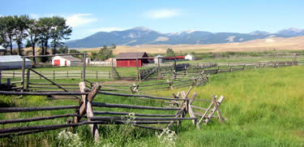

Grant-Kohrs Ranch National Historic Site
Libertarianism is not typically a factor for government entities, but is common for private individuals. How the resources are distributed, managed, and used depends on whether the person believes that those resources should be privately owned or have shared ownership. Most who follow the libertarian ethic in the United States fall into the category of supporting private ownership of land, resources, and infrastructure. In other countries, libertarianism supports communal or cooperative ownership by a group, typically shunning private ownership.

Tragedy of the Commons - Origins
William Forster Lloyd was a British economic theorist and author who was active during the mid-1800s. He is best known for his Two Lectures on the Checks of Population (1833). This lecture is where the concept of the “Tragedy of the Commons” originates. At the time in the British Isles, there was a shared grazing allotment in many smaller villages, known as a common. He came up with a hypothetical situation where one of the individuals allowed more than their allotted number of livestock to graze. In the scenario, he stated that no matter if the grazing land was shared or not, there would be a deduction in what was left to graze. The difference was whether the land was for use by the individual in question or shared. If the land was the individual’s that deduction would only be a cost to them. Otherwise, that cost would be shared by the others.

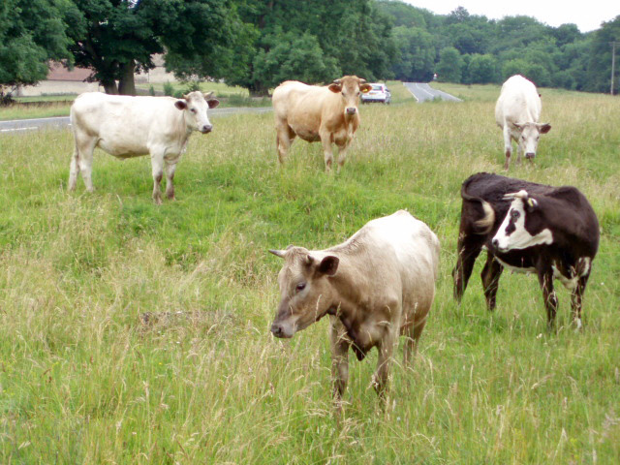

Cows grazing on a commons in Selsley, England, June 2007

Tragedy of the Unmanaged Commons
While William Forster Lloyd came up with the basis of the idea of the “Tragedy of the Commons,” Garret Hardin coined the term in 1968. He focused on population growth as his “tragedy.” His thought that was required to solve the issue of overpopulation was that the natural sciences should change what techniques are used rather than changes in values or morality. In his hypothetical situation, issues such as overpopulation should be self-solving, with death of children from starvation being the ultimate punishment. Further, he thought that in situations of shared resources, the resource would be used up. He believed this would happen because even when all individuals sharing the resource were acting in rational self-interest, there would be individuals who would abuse the conscience driven regulation. He stated that altruism would always be selected against in situations where conscience was the driving factor of decision making.
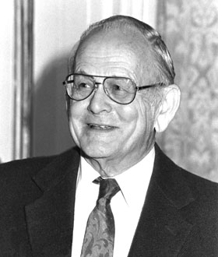

Garret Hardin, 1986 from The Garret Hardin Society

All of this made him conclude that the reason for the tragedy in the first place was the fact that the commons were shared and not necessarily managed. Thus, the commons needed to be managed in some manner, because the freedom to manage the land in question could be replaced with other freedoms.

Benefits
Libertarian-based land ethics recognizes that there are multiple ways to manage the land, both individually and communally. There is also the concern for how the use of the land affects those around the individual, even if the emphasis is on the individual. Egalitarianism is a key factor of libertarianism, meaning that all are held equal in the eyes of this ethic. Management can be decided by the individual as long as the decisions do not negatively impact those around the decision maker. Lastly, it seeks to remove the influence of individuals seeking to force or coerce others to behave in a way that is against their wishes.

Risks
One of the major risks is the “Tragedy of the Unmanaged Commons.” By being unmanaged, individuals could exploit not only their cooperators, but also the resource. Conversely, even individual management can lead to problems with the resource or land. The best historical example of this is the Dust Bowl in the southern plans of the United States.

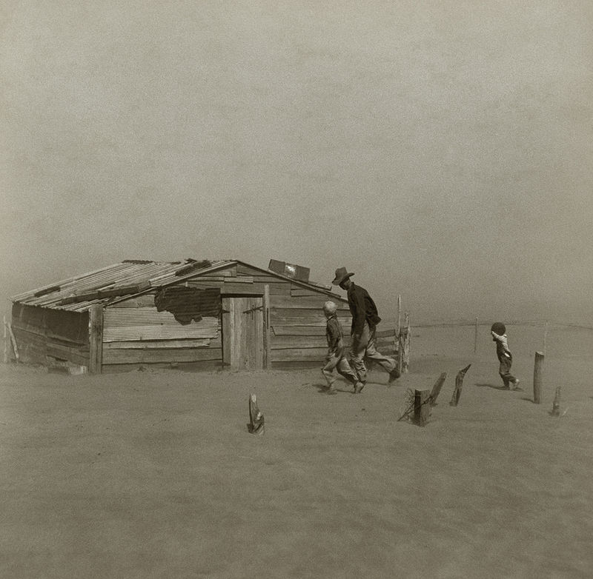

Farmer in Oklahoma during the Dust Bowl, ca. 1936

To keep up with demand, farmers needed to produce larger harvests by converting more prairie land to farms. With the onset of a drought in 1931, the barren fields were not able to hold the soil in place like the deep-rooted prairie grasses they had replaced resulting in massive dust storms and economic devastation.

