Land ethics is a concept that is relatively recent, coming about shortly after Aldo Leopold’s posthumous book A Sand County Almanac, put a name to it in 1949. However, his ideas were influenced by many others before him. One of the first to publicly think about and describe how humanity’s use of land affected the earth was the German explorer Alexander von Humboldt.

A New World
Alexander von Humboldt was always interested in travel and exploration. Prior to the start of the 19th century, most of his travel was confined to the parts of Europe friendly to Prussia and not embroiled in war. However, after his mother’s passing, he had money available and no longer “felt caged” by obligations, leaving for France.
Once in France, he searched for any expedition that would have him but had no luck due to the escalating conflicts spiraling from the French Revolution.
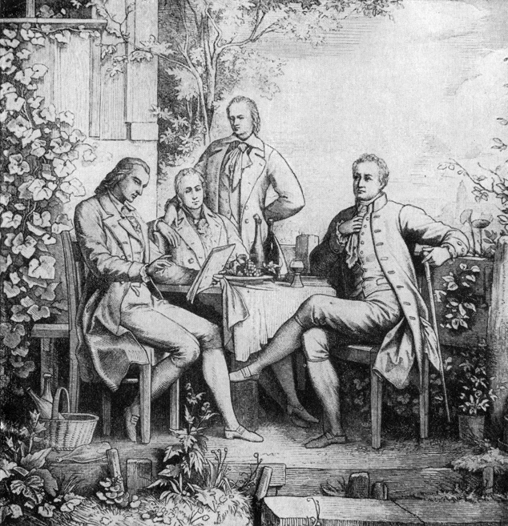

From left to right: Friederich Schiller, Wilhelm and Alexander von Humboldt, and Johann Wolfgang von Goethe in Jena, Thuringia ca. 1797
He and a colleague eventually found themselves in the court of the Spanish King Charles IV. Spain was interested in getting a better understanding of what its colonies in the New World had to offer the crown. Humboldt requested to join the expedition, offering to finance his own way. Once the King accepted, Humboldt would be able to set out on a journey that would change how we look at humanity’s place in the world.
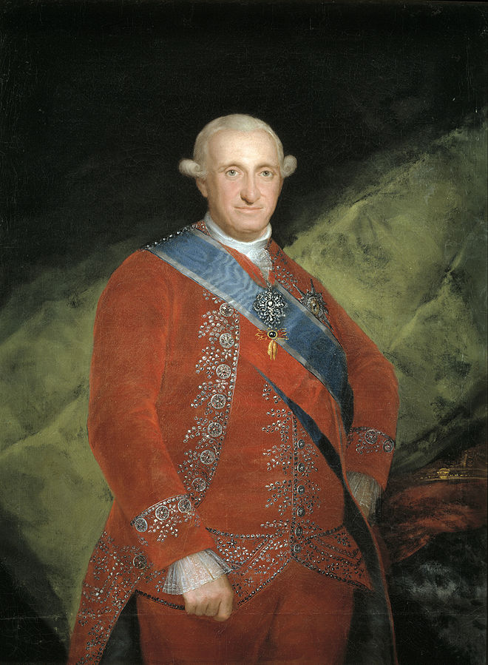

King Charles IV of Spain, ca. 1789
He departed on his trip later in 1799, leaving for the Spanish colonies. There, he made notes on the vast assortment of plants and animals he observed. However, one observation among the vast collection stood out for those who followed him and would help to influence what we know of today as the concept of land ethics.
After departing Spain, the expedition arrived in Caracas, the capital of modern day Venezuela. Along the route to Lake Valencia, Humboldt noticed how deforested the land was in populated areas. Once they arrived at Lake Valencia, the locals informed them of their concern about the dropping levels of the lake, exposing more land, but with less water available for crops. They thought the water loss was due to an underground river that was draining the lake.
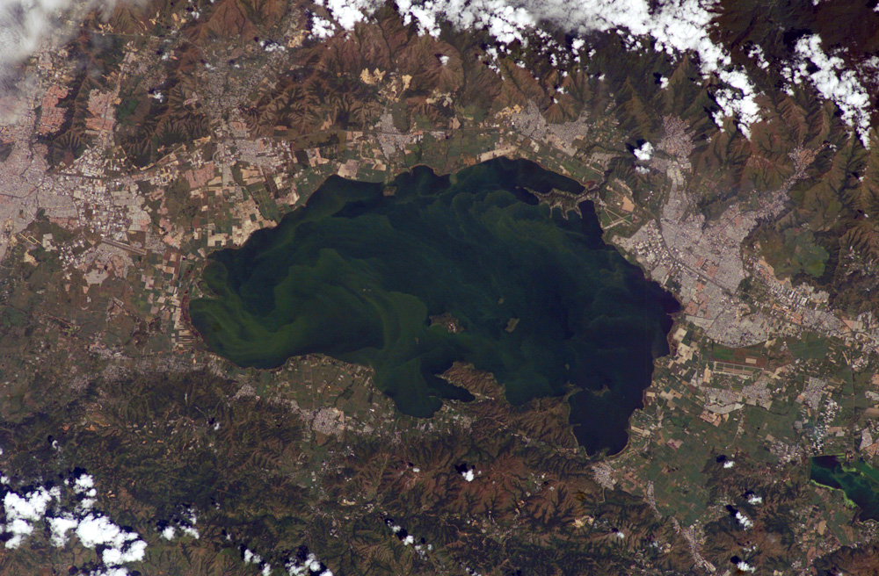

Satellite Photograph of Lake Valencia, Venezuela ca. 2004
What Humboldt determined was more concerning and problematic
for those farming in the area. On his return to Europe, he would write the following:
“When forests are destroyed, as they are everywhere in America by the European planters, with an imprudent precipitation, the springs are entirely dried up, or become less abundant. The beds of rivers, remaining dry during a part of the year, are converted into torrents, whenever great rains fall on the heights.... the waters falling in rain are no longer impeded in their course: and instead of slowly augmenting the levels of the rivers by progressive filtrations, they furrow during heavy showers the sides of the hills, bear down the loosened soil, and form those sudden inundations....”

What he describes is much like the flash floods the desert Southwest of the United States experiences - damaging stormwater that can carve paths that funnel water into rapid speeds, with no true outlet. The trees and shrubs had initially helped to trap the water in the soil and made the surrounding area fertile. Over the rest of his travels, he noticed the pattern of how human influence affected nature around settlements replay multiple times. His reactions and comments on the matters inspired others to think about our place in nature, in a variety of ways.
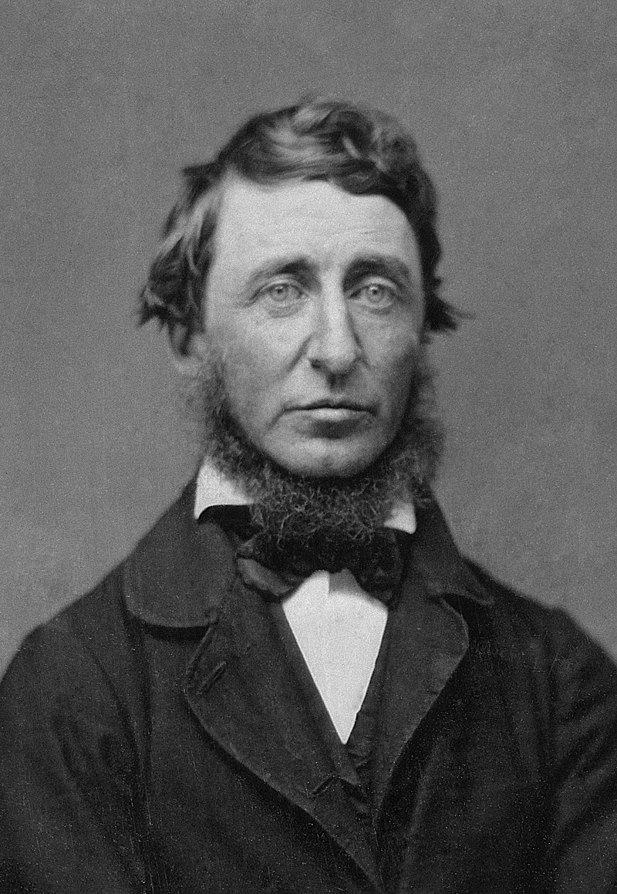 | 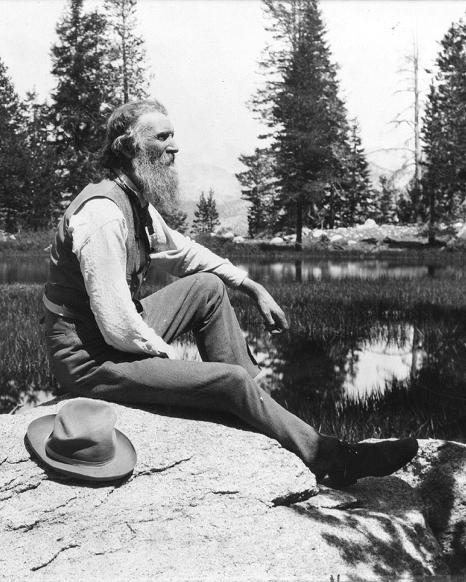
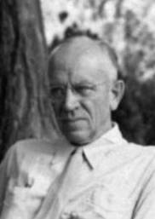 | 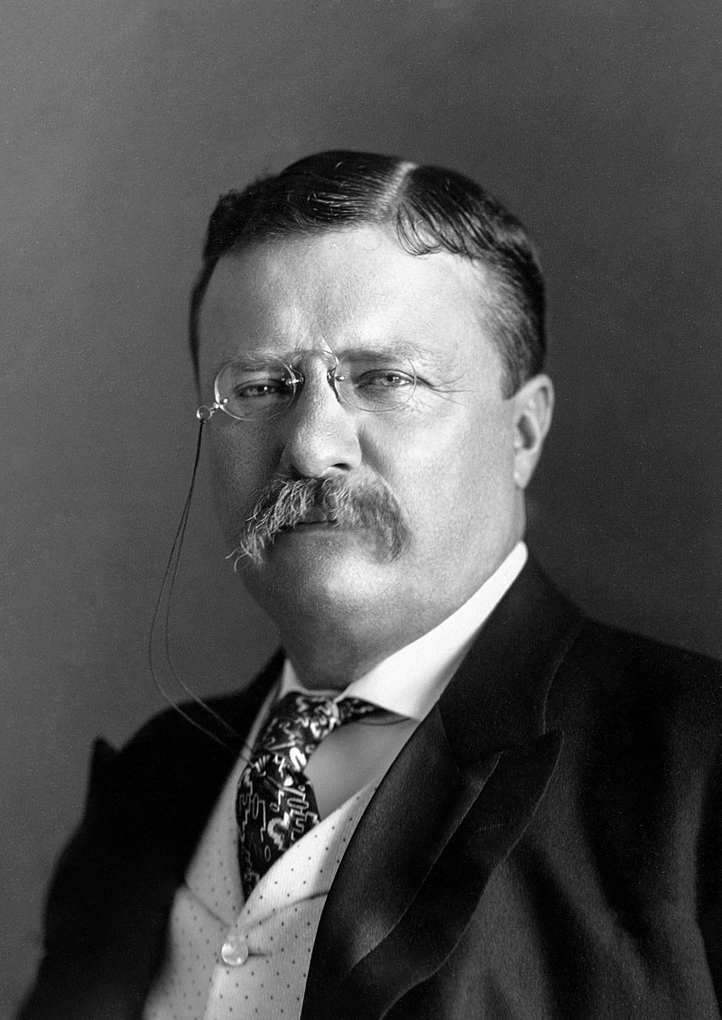

(Clockwise from top left) Henry Thoreau ca. 1856, John Muir ca. 1902, Theodore Roosevelt ca. 1904, Aldo Leopold ca. 1946

Nature Movements in the U.S.
When we think of people who influenced the discussion about natural places in the United States, there are a few names that always come to mind: Henry David Thoreau, John Muir, Theodore Roosevelt, and Aldo Leopold. Even though they all influenced the discussion of humanity’s place in nature, they had different views.
Henry Thoreau is best known for his books such as Walden, assorted poetry, and his statements on nature. However, even though he promoted and supported conservation of resources on private land, and the setting aside of wilderness as public land, that was not his preference for land use. His ideal type of wilderness was pastoral, “partially cultivated country.” In fact, after traveling through the pristine wilderness of Maine, he was thoroughly convinced that nature and humanity needed to have a balance. In other words, he felt that nature and humanity should coexist, without one being more powerful than the other.
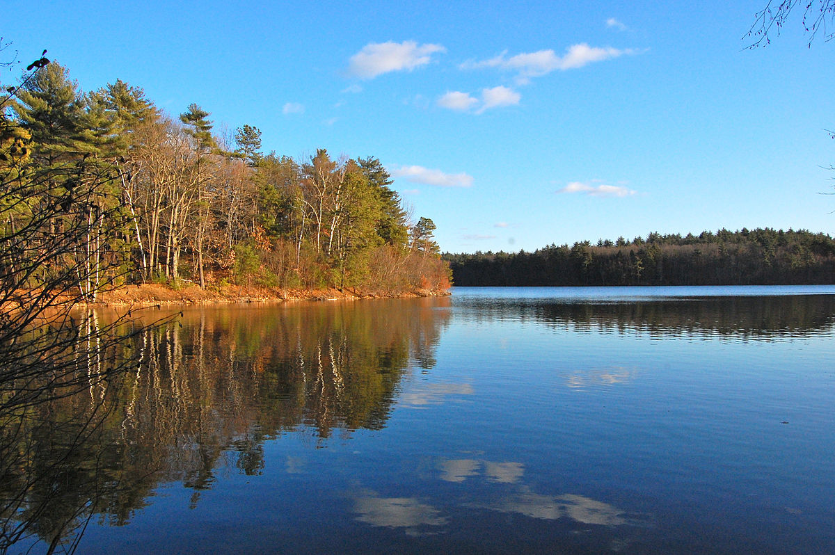

Walden Pond, ca. 2010, where Thoreau spent most of his time outdoors.
John Muir, on the other hand, took another approach. Muir was of the opinion that all land should be left wild, that no human being deserved nature.
However, he also believed that nature was the perfect “temple” in which to relax, recuperate, and reconnect spiritually. His focus was to bring people to these natural places and to let them roam free.
Theodore Roosevelt’s presidency saw the formation of the United States Forest Service, five new National Park units, and many other federal public lands. In the national forests, his agenda was the sustainable development of economic resources. In national parks and monuments, he wanted to preserve those lands for cultural and natural resources. But primarily, he still considered the land economically. Further, his concept of conservation, at least for wildlife, included some degree of taxidermy, rather than letting them live in their natural settings.
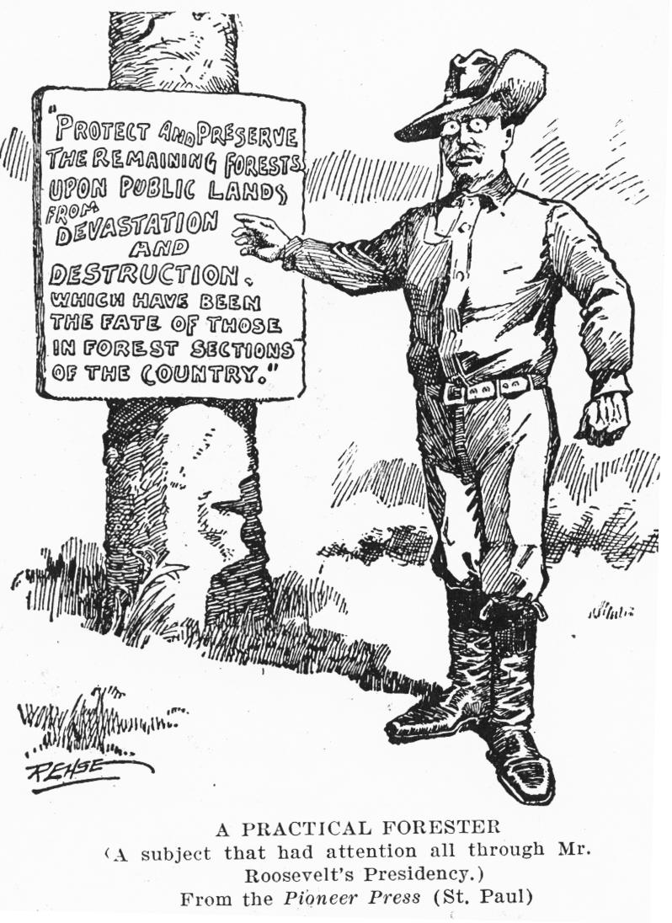

Political Cartoon of President Roosevelt ca. 1908, outlining his stance on forests.
While Aldo Leopold is listed last, the reason is certainly not because he is the least influential. In his posthumous book, A Sand County Almanac, Leopold looks at this concept in depth by enlarging the idea of what community is to “include soils, water, plants, and animals or collectively: the land.” His particular branch of land ethics was for the ecologically based land ethic, but he shed light on all branches: economics; utilitarian; libertarian; egalitarian; and ecological.
These five branches represent the major schools of thought about how land should be used, and how humans should interact with nature.

